Pipes & Wires

THE UTILITIES & INFRASTRUCTURE COMMENTARY FROM UTILITY CONSULTANTS

Issue 21 – September 2003

From the director…

 | After 20 issues I decided it was time to change Pipes & Wires …. a few minor changes to the format such as color photos, but primarily the content to give more detailed discussion on some of the more pressing global utility & infrastructure strategy, policy and regulatory issues. I’ll also throw in my ideas on what the industry and individual utilities might do to address those issues.  The other big change will be that instead of emailing Pipes & Wires as an attachment in Word, you will receive a link to down-load it from my website in Word. Please take a few seconds to pick one of the reader reply links at the end to tell me whether you prefer this format or the previous format.

A few global thoughts on gas infrastructure

The increasing role of gas

Gas consumption is expected to double in volume in the next 30 years as world energy demand increases. In this article we examine what is driving the demand for gas, and what some of the key issues for the gas infrastructure industry are.

What’s driving the global gas markets ?  Key issues driving the global gas markets are…  - Increasing retail consumption of gas as a quick, convenient fuel.  - Increased industrial consumption as market economies gain traction in the former Soviet-bloc countries.  - Substitution of gas for coal and oil to reduce emissions.  - Increasing popularity of gas-fired combined cycle electricity generation to improve efficiency and electricity market responsiveness.  - Substitution of gas-fired electricity generation as nuclear power plants are decommissioned, particularly in the former Soviet-bloc countries as a condition of entry to the EU.  - Depletion of existing gas sources. |  | 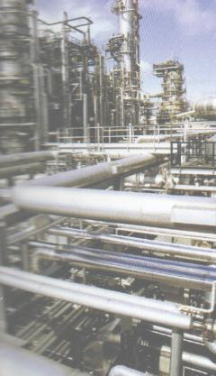
Key issues for the gas infrastructure industry

Key issues facing the gas infrastructure industry are….

- Building more pipelines to connect retail markets and new electricity generation to new gas fields as existing reserves deplete. Key issues with this are…

- Getting the regulatory framework right so that a fair risk-adjusted return on investment is made. The Epic Energy third party access determination in Western Australia has highlighted this issue recently (pick here to download a research report).

- Developing new transmission corridors in potentially hostile regions. As the EU seeks gas from the Middle East, access to transmission corridors in the former Soviet-bloc states may prove less than straight forward (refer to Pipes & Wires #14).

- Encouraging industry wide investment to secure individual countries economic growth. This is thought to have prompted the German government to ease the way for Ruhrgas to have been acquired by a German company (E.On) rather than a foreign company, and is also thought to have made the Spanish government look unfavorably on Gas Natural’s bid for Iberdrola (the concern being that capital investment might have been reduced under a merger scenario).

- Access to gas to fill the pipelines will become a key issue as existing reserves deplete, an issue that has recently become apparent in New Zealand. Ruhrgas’ small stake in Gazprom was thought to be another key reason for the German government to encourage E.On’s interest in Ruhrgas.

- Security of energy supply, particularly of electricity is a hot current issue, and it is likely that security of supply concerns will inevitably move upstream into gas. It sounds rather trite but the recent blackouts in the eastern US (and in a few other places) have “made the world a different place”. One of the issues I suspect we will see emerge is an increase in the “statutory rights” enjoyed by transmission utilities whereby the avenues for objection to new pipelines (and electricity lines) that are so common under current environmental laws may be diminished.

 | For more information  To contact Utility Consultants about how your company could play a part in the globalisation of gas, pick here. Pick here to contact PricewaterhouseCoopers and order a copy of their recent paper “Going global – change & challenge in the gas market”.

Managing asset stranding in the New Zealand context

What is stranding ??

Stranding occurs when an assets’ revenue stream is curtailed before its cost stream ie. its economic life is shorter than its physical life.

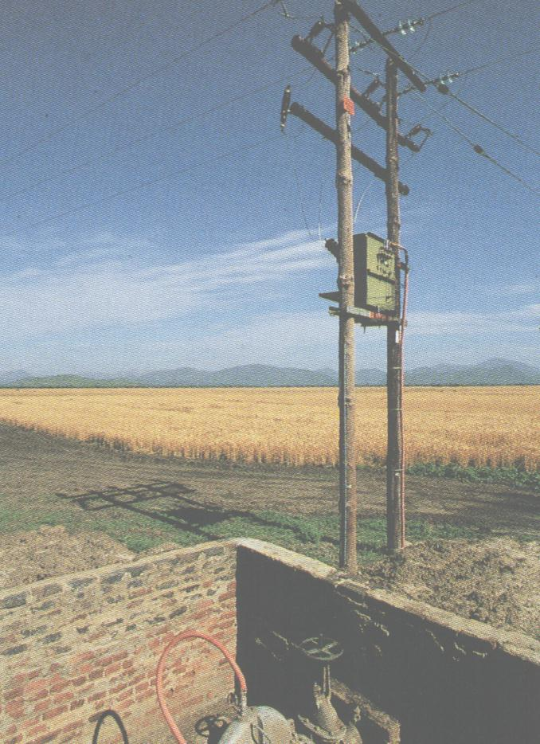 | How do assets get stranded ??  There are many issues that can curtail an assets’ revenue stream ahead of its’ cost stream…  - Optimisation out of the regulatory asset base.  - Substitute products.  - Competitor entry.  - New technologies.  - Shifting demographics and land use.  - Minimum component ratings.  The most likely stranding scenario is where a large fraction of an assets’ capacity becomes redundant due to reduced demand but the asset must remain in service to supply a few remaining customers. Shifting demographics and land use are probably the biggest stranding threat in the New Zealand context.
Who carries the risk of stranding ??

The risk of stranding is the risk that an assets’ revenue stream will curtail before its cost stream. This risk is not so much related to what causes the stranding, but to what the regulatory regime will allow the revenue to do (either continue to match the assets agreed physical life, or be curtailed).

Let’s just imagine for a moment two different types of regulatory regime ….

- A regime focusing on assets which allows a fixed return on all assets in the regulatory asset base (RAV) until those assets are written out of the RAV. Under such a regime the revenue base is allocated amongst the remaining customers to guarantee the return on the RAV ie. the remaining customers bear the stranding risk.

- A regime focusing on customers which allows the utility to gather a fixed amount of revenue per customer. If a customer defects, their revenue contribution cannot be simply allocated amongst the remaining customers to guarantee a return on the RAV ie. the shareholder bears the stranding risk and should therefore be compensated by a higher return.

The global trend toward incentive regulation embodies many risk-reward issues which are outlined below…

- Risk should be borne by the most appropriate party – the party that can bear it at least economic cost, thus benefiting the economy as a whole. This would be the utility, which can diversify its risk profile through its investment decisions, rather than the customers.

- The party bearing the risk must be appropriately compensated. Under an incentive regime the customer effectively holds an option (“the right but not the obligation”) on receiving supply. This right without the obligation commands an “option fee” to compensate the counter-party for the risk that the option might be exercised. In simple risk-reward terms, the presence of this option should allow the shareholder to receive a higher reward commensurate with the risk of customer defection. Research indicates that this reward could be as high as a 2% premium over and above existing returns.

Getting it right in the New Zealand context  Historically the industry was not subject to price control but it was run on a kind of “rate of return” basis. Pre 1990s most line companies were run as co-operatives or were local body owned, which in the pure case would yield efficient prices. The rate of return was probably very low (close to the risk free rate) but only because there was no entry allowed. One of the features was that remaining customers bore the stranding risk. From the early 1990s entry has been possible and light-handed regulation has been in place. Ownership has still limited the profit motive but this has gradually changed, accelerated by the enforced split of lines & energy. With the move toward incentive regimes represented by light-handed regulation and potentially lines-specific regulation that promote more efficient investment it is necessary to acknowledge the shift in stranding risk from remaining customers to shareholder, and to reward the shareholder accordingly. |  | 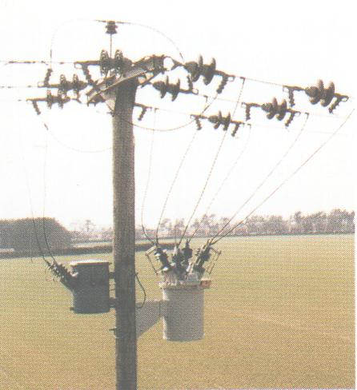
The present situation in New Zealand is a price control regime that broadly prohibits an electricity lines company from increasing its prices over the period 8 August 2001 to 31 March 2004 to a level greater than the prices prevailing at 8 August 2001 with the added criteria of no material reduction in SAIDI from the average of the 5 years to 31 March 2003 (refer to Pipes & Wires #13, #14 and #16). There is also the underlying expectation of a WACC between 6% and 8% which is hopefully still open to debate.
The Commerce Commission released its initial “Draft Decisions – Resetting The Price Path Threshold” on 5 September 2003 which is proposing an X compiled form 2 factors including total factor productivity (TFP). Many New Zealand lines companies have assets that have a high implicit risk of stranding from the cyclic nature of their load (dairy conversions or forestry cutting), loads that have always been well below minimum component ratings (many lines are only a step away from “wet string”), changing demographics (“urban drift”), and substitute products (bottled gas in particular). In the particular case of dairy conversions and forestry cutting it is possible that the economic life of an asset might only be 25% of the physical life. Unless the emerging price controls recognise such issues and allow correct allocation of the stranding risk, New Zealand runs the risk of stunted economic growth – a unique “Kiwi Can Do” approach to asset stranding might be required to ensure a willingness to investment to support such cyclic bursts of economic activity.

For more information

Aspects of this article have been drawn from “Asset stranding is inevitable in competitive markets” with the author’s permission - pick here to visit the Institute for the Study of Competition & Regulation. Pick here to email Utility Consultants about electricity price control,

Improving the value of the customer relationship

 | What about the customer relationship ?  Many internal, and indeed external, matters divert management attention away from a company’s sole source of value … the customer relationship. Many companies undoubtedly have well-intentioned processes intended to treat the customer as king, but - let’s face it - over time these processes become less aligned to customers’ needs and wants and become cluttered with exceptions and quick-fixes.  At a time when price control threatens to reduce the value of the
of the customer relationship, it may be timely to examine a model of the customer relationship and how this interfaces with a company’s internal processes (and although this is written primarily from the perspective of regulated assets, many of the concepts are just as applicable to the content stream of utility businesses).
The model  The following model on the following page contains three elements….  - It depicts the issues that seek to improve or erode the value of the customer relationship.  - Secondly it presents the customer interface with the company.  - Thirdly it outlines the companies internal processes that make the interface happen. |  | 
Improving the value

The value of the company as a whole depends on both the revenue derived from the customer relationship and from the costs incurred in converting that revenue into service levels.

Aside from the obvious price control, many other factors can erode value from the customer relationship – competitive markets, additional costs in resolving customer complaints, lobby groups seeking to reduce tariffs etc. Conversely, other factors can improve the value of the customer relationship, such as developing a premium brand. In the context of regulated assets this will firstly mean shifting a service outside of the jurisdiction of the price control framework.

At the cost end of the business (which probably consumes most of managements attention), a clear view of how all costs contribute to the revenue generation process (ie. service levels) is essential. Pivotal to this are robust investment policies and efficient implementation processes.

For more information

Pick here to contact Utility Consultants about improving the value of customer relationships or reshaping the cost part of your business.

Customer relationship
Factors that improve the value
Factors that erode the value
Service levels
Revenue
Revenue

Internal policies, processes & procedures
(costs)
Service levels

Reader response

Please pick one of the links below to tell me what you think of the format of this issue of Pipes & Wires…

- I like this format better

- I like the old format better

Please pick one of the links below to tell me what you think of the quality of this issue of Pipes & Wires…

- Excellent

- Very good

- Good

- Average

- Poor

If you get this is a hard-copy, your comments can be emailed to issue#21@utilityconsultants.co.nz

Conferences & events

Performance benchmarking, 29 September – 2 October, Perth, Western Australia

