Pipes & Wires

THE UTILITIES & INFRASTRUCTURE COMMENTARY FROM UTILITY CONSULTANTS

Issue 22 – October 2003

From the director…

 | First up thanks to those who responded to the reader reply links in Issue #21 – 93% of respondents indicated a preference for the new format of Pipes & Wires.  Starting with this issue, I will be profiling some of Utility Consultants recent client projects (with their approval of course). We will then take a look at how regulated pipes & wires businesses can be rewarded by incentive regulation, and then we’ll take a look at Scottish & Southern Energy’s failed bid for Aquila Networks in the UK (which is likely to be followed by a bid from E.On subsidiary Powergen). Finally we examine the flurry of activity in the Australian gas transmission industry that includes the not-so-surprising sale of the Dampier to Bunbury pipeline.

Utility Consultants advises the Counties Power Consumer Trust

Utility Consultants recently advised the Counties Power Consumer Trust in the matter of its five-yearly ownership review. Similar to many other New Zealand energy trusts, the Counties Power Consumer Trust deed requires the Trustees to review its ownership of the lines company (in this case Counties Power Ltd, a lines business valued at about $92m) at regular intervals. |  | 
The broad scope of work included the following…

- An overview of the electricity industry, including a summary of legislative changes.

- Benchmarking the Trust’s performance against other New Zealand energy trusts.

- An analysis of the advantages and disadvantages of trust ownership.

- A detailed analysis of 28 ownership options.

- An analysis of Counties Power performance compared to its 2 peers using Utility Consultants benchmarking methodology.

- Preparation of public discussion documents and critiquing of a written submission.

 | Based on the analysis performed and an overwhelming level of public support, the Trustees unanimously resolved to continue with 100% ownership of Counties Power Ltd.  Profiles of Utility Consultants other recent projects can be downloaded by picking here, or contact Phil Caffyn on +64-7-8546541 or by email.

Rewarding regulated businesses

Introduction  A key purpose of regulating any business is to promote free market outcomes …. to emulate Adam Smith’s “invisible hand”. The specific free market outcome that economic regulation of pipes & wires businesses seeks to create is prevention of excessive return on capital through monopoly pricing. As New Zealand progresses along the path of electricity price control and also considers whether gas price control is necessary, we will examine how pipes & wires businesses might be rewarded (or |  | 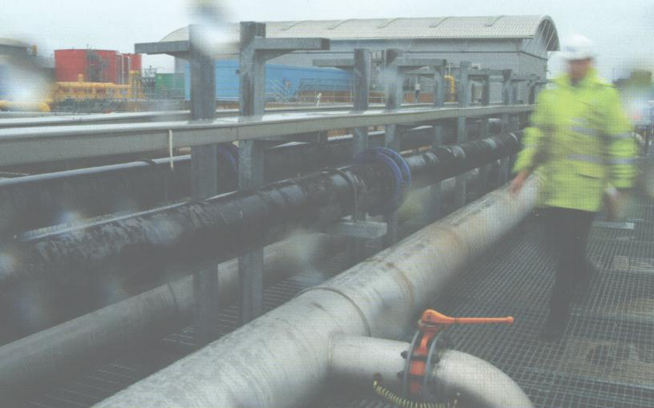
sanctioned) if they meet or fail to meet regulatory targets … “carrots & sticks” as OFWAT calls them.

The free market comparison

Consider homogeneous widgets offered for sale in a free market by a large number of competing firms, each making about the industry average return on capital. Any firm that tries to improve its return by increasing its prices significantly above its competitors will almost certainly lose customers and therefore will probably make a reduced return (depending on the price elasticity of demand for widgets). Conversely any firm that tries to improve its return by decreasing its costs significantly below its competitors will probably make an increased return (again depending on the price elasticity of demand, and also on how sustainable the decreases in cost are). A key factor in setting prices is that it occurs in real time through a large number of people each making small decisions.

Bringing these concepts into the pipes & wires sector

So what does all this free market economic theory mean in the context of monopoly pipes & wires businesses ?? A pipes & wires customer is not confronted by a large number of competing firms that will set a price through the interaction of supply & demand but is instead confronted by a single supplier that probably sets its prices on a cost-plus basis.

Most of us will be fully aware that this is where the regulator enters the picture … to emulate the free market outcome of no monopoly pricing. Emulating this outcome has been the subject of about 130 years of price control, with probably the only major breakthrough being the development of incentive regulation in the late 1980’s.
 | Setting the prices in a regulated market  In contrast to price setting in competitive markets, regulators tend to set prices in non-real time (usually on an ex-ante basis) through the activity of one person making large decisions that primarily focus on the prevention of excessive profits (and precisely what constitutes an excessive profit is always likely to be arguable).  The work streams involved in setting prices include estimating the WACC of a pipes & wires business, identifying what classes of assets can be included in the regulatory asset base, what are reasonable levels of CapEx (usually based on asset management plans) and OpEx, and what efficiency gains the business should be able to make compared to the economy as a whole. Most regulators then use these cost inputs to build up a price path for the regulatory control period, and the implicit cost structures then become that businesses “regulatory targets”.
Rewarding or sanctioning performance relative to the “regulatory targets”

If a business is able to spend less than the estimated costs implicit in the price path that surplus can be captured by the shareholders as additional profit. Similarly, spending more than the estimated costs results in a decrease in the surplus captured by shareholders. This forms the basis of incentive regulation - the incentive is to improve profitability by “out-performing” the regulatory targets.

A key element of this process is the duration of the reward. Early incentive regulation allowed the rewards to be captured by shareholders for the remainder of the regulatory control period … an obvious tactic would be to with hold initiatives until the start of the next control period so the benefits could be captured by shareholders for (typically) 5 years before being allocated to customers. As incentive regulation evolved into the Third Control Period for the UK water industry, businesses were allowed to retain all the reward on a 5 year rolling basis irrespective of when during the control period the reward began.

Such certainty of allocation of rewards is essential for encouraging initiative and investment in the pipes & wires sectors, and a big step towards emulating Adam Smith’s “invisible hand”.

Scottish & Southern fails in bid for Aquila Networks

The UK pipes & wires industry

The last 2 or so years have seen the exit of US utilities from the UK …. GPU (now First Energy), Mirant, AEP, TXU, Xcel Energy and Enron. The main reason for these withdrawals was not so much the declining fortunes in the UK but domestic troubles as the US utilities came unstuck in newly deregulated markets. This article examines Scottish & Southern Energy’s failed bid for 100% of Aquila Networks as the embattled parent company Aquila tries to raise US$1b by exiting its Australian and UK businesses.

Aquila Networks history  Aquila Networks began life as the Midlands Electricity Board, supplying about 2.4m customers in Birmingham and in the neighboring counties of Staffordshire, Gloucestershire, Shropshire, Hereford and Worcester. The MEB was vested as Midlands Electricity plc in March 1990 and floated on the LSE later that year.  Midlands was acquired by Avon Energy Partners in June 1996, a 50:50 |  | 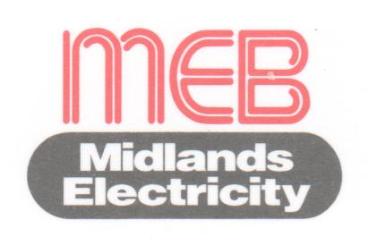
joint venture between Cinergy & GPU, who then bought out Cinergy’s stake in July 1999. The supply business was sold to National Power (which was subsequently re-named Innogy and then acquired by RWE) in June 1999, resulting in a slimmed-down wires business that was re-named GPU Power (UK) Ltd.

Then in October 2000 Utilicorp (since renamed Aquila) offered to buy out GPU’s (since merged into First Energy Corp) 100% stake in Avon Energy Partners, and in May 2002 finally acquired a 79.9% stake for ₤180m cash and assumption of ₤1,159m of debt.
 | Aquila Networks capital structure  Not surprisingly, Aquila Networks capital structure was heavily geared, with ₤360m variable bonds due in 2006, US$250m of senior notes due in 2007 and US$250m of senior notes due in 2008 as well as ₤502m in bank debt. This left Aquila and First Energy with their respective stakes in ₤43m of equity.  Scottish & Southern Energy’s offer for Aquila Networks  As Aquila’s domestic fortunes declined, Aquila Networks was offered for sale along with Aquila’s Australian investments (pick here for a research report), and in May 2003 Scottish & Southern Energy made an offer of ₤1,112m for 100%
  Color | Company | 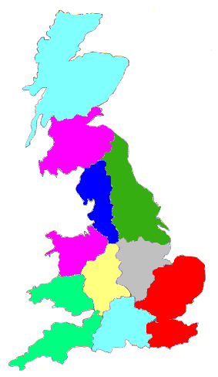Market share
   | LE Group (EdF) | 28%
   | Northern Electric | 13%
   | Scottish & Southern  Energy | 12%
   | ScottishPower | 12%
   | Powergen (E.On) | 9%
   | Aquila Networks | 9%
   | Western Power  Distribution | 9%
   | United Utilities | 8%
of Aquila Networks holding company subject to bond-holder approval. This offer comprised the following….

- Assumption of ₤502m of bank debt.

- Payment of ₤43m in cash to Aquila and First Energy (upon which Aquila would have an obligation to pay First Energy US$95m, so the overall exit deal would actually cost Aquila).

- Payment of ₤567m to the Avon Energy Partners bond-holders, which represented about 86% of the face value of bonds that were trading at about 78% to 80% of face value.

Negotiations with the bond-holders representatives in late September proved unsuccessful, leaving Scottish & Southern free to abandon the deal (pick here to download a research report). Speculation is that E.On subsidiary Powergen will make an offer in the region of ₤1.2b in the immediate weeks ahead – such an offer would certainly seem to be a good fit with E.On’s “on top” strategy.

Gas under pressure down under

Introduction  Recent months have seen the gas transmission industry in Australia placed under increasing financial pressure … it would probably be fair to say that “the dark clouds were gathering”. That storm broke in early October as the embattled Epic Energy put its assets up for sale in two blocks amidst speculation that other gas pipeline owners were seriously pondering their own futures down under.  As we saw last year with Aquila’s exit from New Zealand, the sale of such large chunks of market share significantly changes the strategic positioning of those who are able to buy a piece of the action (estimated at about A$4b in this case). |  |  | 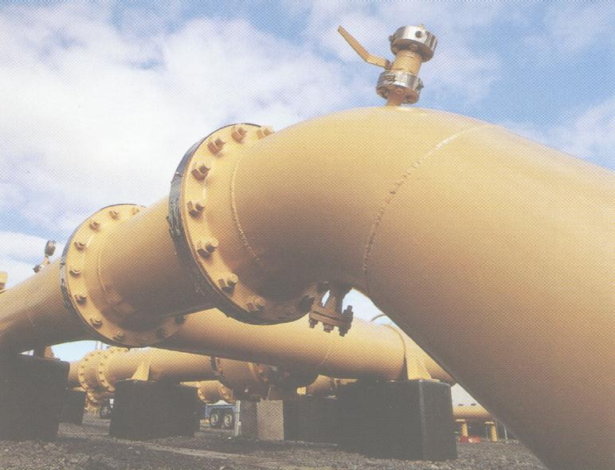
Who are the key players ??

The map (reproduced courtesy of the Australian Gas Association) on the back page shows an expanding network of transmission pipelines. Probably the most common feature is that most of them run in a north-west to south-east direction such as the Cooper Basin to Sydney and Melbourne, and the Carnarvon Basin to Perth. The key exception is the northwards flow from the Amadeus Basin to Darwin.

This network of pipelines is owned by a handful of companies which may well shrink in number, many of which operate across state boundaries and a few of which are also vertically integrated into the distribution sector. The significant players are….

Those likely to go  - CMS Energy – signaled their intention to exit Australia.  - Duke Energy – seriously thinking about their Australian future to the extent of identifying possible exit options.  - Epic Energy – selling the Dampier-Bunbury, Moomba-Adelaide, South-East and South-West Queensland pipelines and the Pilbara pipeline system.  - TXU – considering an IPO of 49% of its Australian investments. | Those likely to stay  - Alinta Gas – may backwardly integrate by acquiring the Dampier-Bunbury pipeline, possibly in conjunction with Wesfarmers and Macquarie Bank.  - Australian Pipeline Trust – “seeking to double its share market capitalisation to A$1.4b”.  - Envestra – may expand current limited exposure to transmission and gain further geographical diversity to its existing operations in SA, NT, NSW, Victoria and Queensland.  - GasNet Trust – “seeking to grow its assets where appropriate investment opportunities emerge”.  - Cheung Kong Infrastructure – “interested in investing in regulated gas businesses like those of Epic Energy”
It is also possible that one or more new entrants such as Enbridge will emerge from the reshuffle.

 |  | What is driving the reshuffle ??  On the face of it, there appears to be two predominant drivers of the reshuffle…  - The declining fortunes of the US parent companies, perhaps best exemplified by Aquila. This certainly seems to be the common thread amongst those who are likely to go.  - Some recent tough regulatory determinations.
Key regulatory decisions

Two particular regulatory determinations merit some detailed comment….

- OffGAR’s final tariff determination for the Dampier to Bunbury pipeline resulted in a per GJ tariff of about 75% of that originally sought by Epic. Readers of Pipes & Wires will be familiar with the privatisation process that indicated (but did not give binding assurance of) a tariff of A$1 per GJ to Perth and A$1.08 per GJ to Bunbury for which bidders were to base their bid on. The final decision of the Full Court of the Supreme Court of Western Australia identified some pivotal issues that sadly don’t appear to have influenced regulatory thinking (pick here to download a research report).

- The ACCC’s recent determination that tariffs on the Moomba – Sydney pipeline be cut from A$0.66 to A$0.52 per GJ on a pre-inflation basis. Not surprisingly, two of the ACCC’s three key concerns were the age-old dispute over “what is an acceptable WACC” and “what is an acceptable asset valuation”.

Conclusion

The Australian gas transmission industry is certainly an exciting place to be for owners, advisors and commentators alike as remaining players seek to raise an estimated A$4b to replace that which seems likely to exit. How the recent regulatory determinations might facilitate this capital raising and work in the long-term interests of customers who require increasing investment levels is far from clear. Photos in this article appear courtesy of Orion and for illustrative purposes only.

Research reports & conference papers

- “E.On’s acquisition of Ruhrgas – a study of competition issues & regulatory concessions”

- “Gas Natural’s unsuccessful bid for Iberdrola”

- “Alinta Gas’ acquisition of United Energy, MultiNet and Ikon Energy”

- “Electricity lines price control in New Zealand”

- “Reforming the pipes & wires industries – what could it mean for asset management in the water sector” – a conference paper presented in Auckland in April 2001.

Conferences & events

- Dutch energy – Amsterdam (5 – 6 November).

- Liberalising the Dutch electricity market – Amsterdam (7 November).

- Second annual utilities & infrastructure conference – Wellington (10 – 11 November).

- Infrastructure asset management & economics – Wellington (10 – 11 November), Auckland (13 – 14 November).

- Irish energy – Dublin (26 – 27 November).

- Implementing the new Irish electricity market – Dublin (28 November).

- Second re-building Iraq conference – Arlington (3 – 4 December).

- Wideband code division multiple access – London (16 – 17 February).

- Italian energy – Milan (1 – 2 March).

Reader response

Please pick one of the links below to tell me what you think of this issue of Pipes & Wires…

- Excellent

- Very good

- Good

- Average

- Poor

If you get this is a hard-copy, your comments can be emailed to issue#22@utilityconsultants.co.nz If you receive this second-hand, you can receive Pipes & Wires directly by picking here.
