Pipes & Wires

THE UTILITIES & INFRASTRUCTURE COMMENTARY FROM UTILITY CONSULTANTS

Issue 23 – November 2003

From the director…

 | First up this month is a profile of a client project, in which Utility Consultants provided due diligence advice for an acquisition bid.  Next is a re-print of a 3-part article from Issues #13, #14 and #15 on re-thinking electricity transmission. As the US power industry progresses toward regionalisation it is probably timely to re-examine some of the issues. This is followed by a review of E.On’s bid for Aquila Networks via its UK subsidiary Powergen.  This month’s closing article discusses the asymmetries of over and under-investment, and how the risks of either can be reduced.

Utility Consultants advises Aurora Energy

 | Utility Consultants provided due diligence services to Aurora Energy (formerly Dunedin Electricity Ltd) in the matter of its bid for the network assets of Otago Power Ltd that sold for $109m. Building on a long relationship with both Aurora and its network
management company, DELTA Utility Services, Utility Consultants was able to provide the following services to Aurora…

- Assessment of line and substation physical condition.  - Examination of capital expenditure estimates.  - Identification of cross-boundary capital and operational synergies.  - Identification of alternative bulk supply options.  “The quality and depth of Utility Consultants analysis enabled us to confidently increase our final bid by several million dollars” said John Walsh, chief executive of DELTA. To download a profile of Utility Consultants recent projects, pick here or contact Phil Caffyn on +64-7-8546541 or by email |  | 

Rethinking electricity transmission

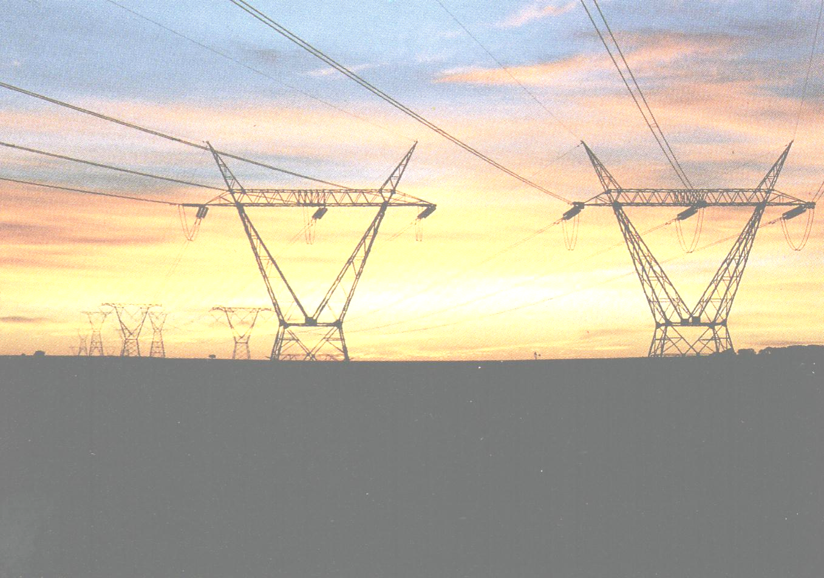 | Introduction  Transmission can be competitive in many cases - multiple transmission paths exist between many nodes, many with surplus capacity. This suggests a whole new paradigm from thinking of transmission as a simple one-way down-hill path from the generator to the customer that should be run on a cost-plus basis.  Policy shifts & structural changes  A few policy and regulatory level happenings provide a good context for this discussion…
- The FERC’s wishes for control of utility transmission grids to be operated on a regional basis to streamline operations and facilitate transparent access.

- Increased attention to transmission grid characteristics that contribute to wholesale price variations, including better signaling of congestion.

- Interconnection of localised grids providing better utilisation of generation and greater supply security.

- An increasing willingness of many state-owned transmission utilities to let private sector players take the risk of new capacity as markets become less certain.

- A lack of understanding of the true value of emerging transmission products by incumbent owners.

A few examples of re-thought transmission businesses

Trans-Elect has recently acquired a transmission grid in Michigan from CMS Energy (plans to acquire one in Illinois from Dynegy have encountered a few difficulties). Trans-Elect intended to operate both grids within the Midwest ISO.

Trans Energie has recently built the 180MW Direct Link between NSW and Queensland (a 50:50 JV with Country Energy’s predecessor NorthPower) and the 200MW Murray Link between Victoria and South Australia. Trans Energie takes all the commercial risk in both of these links, making their involvement very attractive to the other parties. The |  | 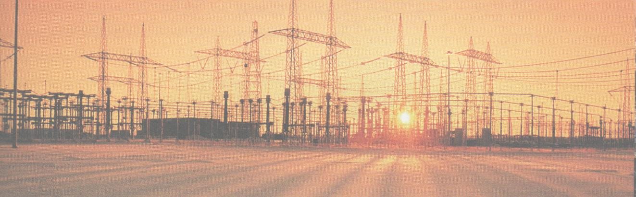
Direct Link is unregulated because there are alternative connections between NSW and Queensland, and because it is DC (asynchronous), security of supply is enhanced (Editors note - this link recently became regulated – refer Pipes & Wires #18). First Energy has transferred ownership and control of it’s’ subsidiaries transmission grids into a single entity called the American Transmission Systems Inc. ATSI provides 37 connection points with 6 neighboring transmission control regions such as PJM and AEP.

Some of the key issues outlined above that have been addressed by these re-thought businesses are….

- A move toward coordinated regional control of transmission grids to streamline operations.

- Improved utilisation of generation capacity.

- Shifting the risk away from state-owned utilities to the private sector.

Strategies & business models for re-thinking the transmission business

The previously identified drivers for re-thinking transmission have mostly been based around regulatory and government policy issues. Probably the most significant drivers, however, are market deregulation (commercial), technical and environmental (which we deliberately avoided introducing above).

These drivers are creating arbitrage opportunities between low cost generation and high value markets, which forms the basis of the strategies and business models of utilities such as Trans-Elect, Trans Energie and ATSI.

The concept that the cost of energy delivered to a distribution grid equals the cost of generation plus the cost of transmission is the leap in logic that re-thinks the transmission business. It also broadly defines the maximum revenue of the re-thought transmission business.

The tactics articulated by the three utilities above are all different, yet they all achieve a similar outcome…

- Acquire under-valued transmission assets that directly connect arbitrage opportunities (Trans-Elect). This may require several assets to be acquired and cascaded to connect opportunities.

- Construct new transmission assets that directly connect arbitrage opportunities (Trans Energie).

- Re-configure existing transmission assets into a consolidated entity and then operate those assets to exploit arbitrage opportunities instead of operating them as simple one-way down-hill paths (ATSI).

A further tactic is to shift the re-thought transmission business outside of conventional regulatory (price control) boundaries by ensuring that the re-thought transmission business competes with existing transmission assets.

E.On gets “On Top” of Aquila Networks

Background

Last months Pipes & Wires examined Scottish & Southern Energy’s unsuccessful attempt to acquire Aquila Networks for a total consideration of ₤1,112m. We now examine a similarly structured bid from E.On via its UK subsidiary Powergen for a total consideration of ₤1,146m that is conditional on bond-holder acceptance and approval by the EU and the Kansas Corporation Commission. The principal concession required by OFGEM is a one-off reduction in regulated revenue of ₤32m over 5 years to compensate for a reduced ability make inter-company comparisons.

E.On’s bid for Aquila Networks  E.On’s bid comprised the following components, and as such is very similar to Scottish & Southern Energy’s recent bid as shown on the right. |  | * Powergen press release, 21 October 2003  ** Presentation to AEPH bond-holders, 4 September 2003  *** S&SE news release, 25 September 2003
   | E.On’s bid | S&SE’s bid
  Equity | ₤36m | ₤43m
  Assumption of debt | ₤484m | ₤502m
  Payment to bond-holders | ₤626m | ₤567m
  Total consideration | ₤1,146m | ₤1,112m
  RAV multiple | 1.13x * | 1.08x **
  Bond-holder payout | 96% * | 86% ***
 | 
E.On’s strategy – “On Top”

E.On’s recently announced “On Top” strategy aims to generate double-digit percentage growth in dividend payout over the 2003 to 2006 period. The five goal areas which may involve up to €28b of acquisitions by the end of 2005 are…

- Pan-European gas transport and storage which will be overseen by Ruhrgas, and will focus strongly on privatisation of gas transmission utilities in the former Soviet bloc.

- Consolidation of the central European distribution & retail energy markets that will be overseen by E.On Energie.

- Strengthening of the Scandinavian market position primarily through Sydkraft which is already in the process of acquiring Graninge.

- Strengthening of the UK market position through Powergen.

- Expansion in the US mid-west through Powergen subsidiary LG&E Energy, although a more long-term view is being taken of this market.

A guiding principle of “On Top” is to systematically capture the synergies implicit in all acquisitions and ensure those synergies are returned to shareholders. The acquisition of Aquila Networks with its obvious synergies to East Midlands Electricity represents a robust fit with “On Top” – pick here to download a presentation by E.On. To request a slide-show on UK distribution market share, pick here

Getting the CapEx right

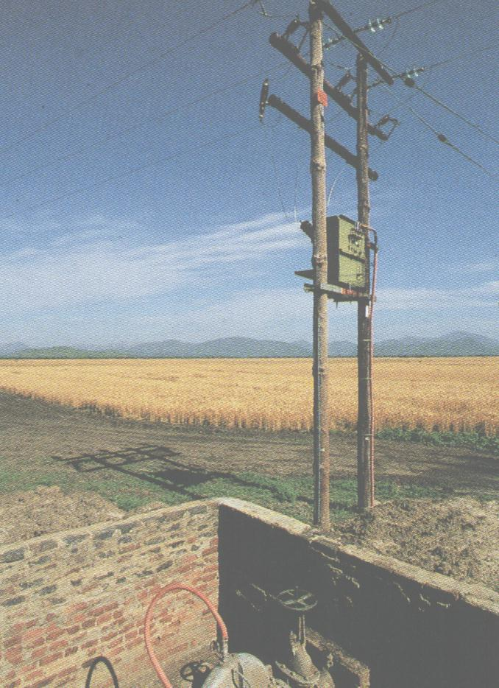 | Is it possible to get the CapEx wrong ??  The answer to this has to be a very clear “yes”. Some brief reflection on this whole issue does, however, reveal that the measure of “right” and “wrong” has been, still is, and probably always will be a very fluid and dynamic concept.  Measuring the “rightness” of CapEx  There are two ways to get any investment decision “wrong” …. over-investment or under-investment. The fuzziness of the real world with the added impact of regulation
dictates that the point of “right” CapEx will need to be a band or tolerance of finite width rather than a single point (and defining this tolerance should be subject to the same cost-benefit criteria as any other business decision).

What does complicate the “getting it right” issue is that the consequences of getting it wrong are highly asymmetrical. It is easily appreciated that under-investment can lead to declining network reliability and eventual asset failure, which in many circumstances will be over-shadowed by the consequential losses. In contrast, over-investment means that an asset might cost a bit more (with the costs possibly spread over a wider customer base), but in many instances such over-investment is common to an entire industry so no one company became uncompetitive from over-investing.

So perhaps the most obvious measure of how “right” CapEx has been is whether an asset performs to its intended levels over its entire life. Expressing this more eloquently as “optimising the life cycle investment level” introduces an element of financial discipline to the whole CapEx process.

CapEx processes within industry structures

The following table summarises the consequences of over- and under-investment in the three more prominent industry models that network utilities have existed within…

Industry structure | Investment level | Business driver
Nationalised | Generally over-investment, but with some significant examples of under-investment. | Service levels with little thought of profit.
Unregulated private | Generally under-investment. | Profit with little thought of service levels.
Regulated private | Emerging picture of large-scale under-investment. | Optimising service levels with a view to making a fair, reasonable and certain profit.

Getting the CapEx right in the era of regulation  The threat of excluding over-investment from the regulatory asset value (RAV) provides a strong disincentive to over-invest. Minimising such over-investment whilst avoiding the quite logical alternative of under-investment requires a structured approach to optimising life cycle investment to deliver defined service levels. This requires robustly structured policies and processes for each phase of the asset lifecycle that follow through from robust investment criteria that are founded on the ability to make a fair, reasonable and certain profit.  To discuss aligning of your company’s policies and processes to get the CapEx “right” pick here or call Phil Caffyn on +64-7-8546541. Refer to Pipes & Wires #21 to examine this issue in the wider context of customer relationships. |  | 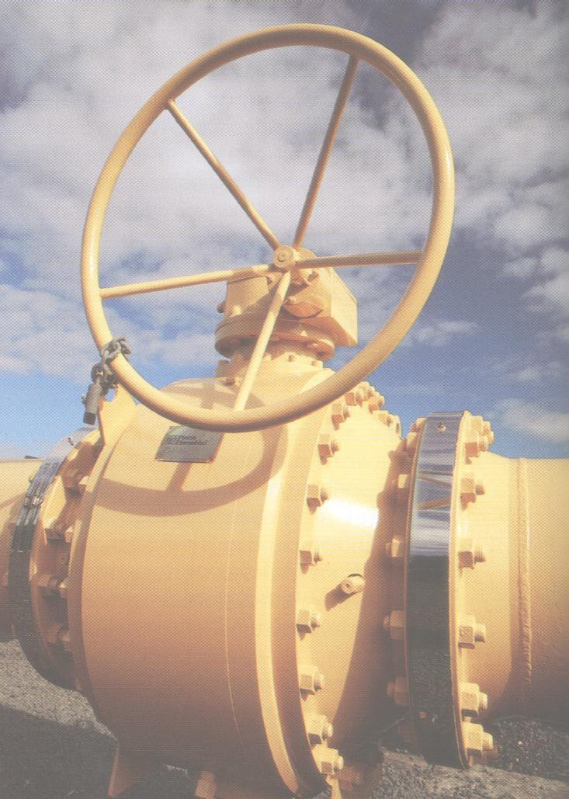

Reader response

Please pick one of the links below to tell me what you think of this issue of Pipes & Wires…

- Excellent

- Very good

- Good

- Average

- Poor

If you get this is a hard-copy, your comments can be emailed to issue#23@utilityconsultants.co.nz If you receive this second-hand, you can receive Pipes & Wires directly by picking here.

Conferences & events

- Understanding electricity markets – Wellington (25 – 26 November, 2 – 3 December 2003).

- Irish energy – Dublin (26 – 27 November 2003).

- Implementing the new Irish electricity market – Dublin (28 November 2003).

- Second re-building Iraq conference – Arlington (3 – 4 December 2003).

- Middle East Electricity (includes exhibition) – Dubai (15 – 18 February 2004).

- Wideband code division multiple access – London (16 – 17 February 2004).

- Italian energy – Milan (1 – 2 March 2004).

