Pipes & Wires

THE UTILITIES & INFRASTRUCTURE COMMENTARY FROM UTILITY CONSULTANTS

Issue 24 – December 2003

From the director…

 | Welcome to Pipes & Wires #24. This month’s client project profile discusses a network risk assessment for a medium-sized New Zealand lines company. This is followed by a reminder about the electricity lines thresholds that apply to all New Zealand lines companies including Transpower.  We also examine whether energy trading was behind the spate of bankruptcies in the US. We then conclude with a short summary of Pipes & Wires geographical circulation.  The family and I wish you all a merry Christmas, a well earned break with family and friends, and a happy New Year.

Utility Consultants advises Electra

Utility Consultants recently undertook a comprehensive network risk assessment for Electra using a methodology based on NZS 4360:1999.  The methodology considered all of Electra’s 33kV sub-transmission lines and zone substations, and estimated the likelihood and consequences of each asset being | 
affected by hazards ranging from wind and flooding to opportunist vandalism and runaway vehicles to termites. The consequences of each hazard can include loss of supply, property damage and public safety which can be weighted to suit individual utilities risk profiles. From all of this data a prioritised schedule of risks is developed that identifies the assets most at risk and which hazard they are at risk from. This schedule can then be included in the asset management plan along with risk mitigation tactics.

To discuss how this methodology can be applied to your utility assets or broader business processes, pick here or call Phil Caffyn on +64-7-8546541 or +64-21-606670.

Lines threshold compliance in New Zealand

Just a reminder that all New Zealand electricity line companies including Transpower must comply with the following requirements of the Commerce Act (Electricity Lines Thresholds) Notice 2003 promulgated in the New Zealand Gazette issue #62 dated 6 June 2003…

- Section 6(1)(a) and (b) of the Notice requires each line company (other than Transpower which is addressed separately) to have a SAIDI and SAIFI for the year ending 31 March 2004 that is less than the average of the SAIDI and SAIFI for the 5 years ending 31 March 1999, 2000, 2001, 2002 and 2003. Two options are available for calculating the SAIDI and SAIFI for the year ending 31 March 2004 – full year figures, or figures pro-rated from 7 June 2003 to 31 March 2004. Compliance or otherwise must be disclosed, audited and certified in a similar manner to the price path thresholds. | 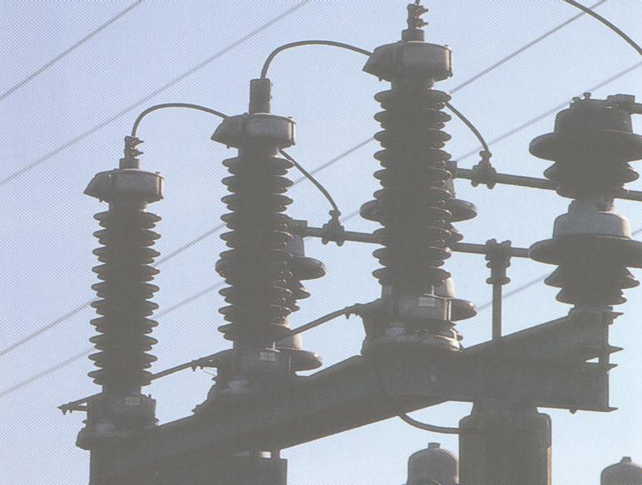
- Section 6(1)(e) of the Notice broadly requires each line company to engage with their customers on the issue of price and supply quality trade-offs, consider the views of customers and adequately take these views into account when making asset management decisions. Evidence of the above work must be disclosed, audited and certified in a similar manner to the price path thresholds. Utility Consultants has had extensive discussions with the Commission on what an appropriate level of consultation might be, and has developed a methodology to implement those requirements.

To discuss or implement your compliance requirements, pick here or call Phil Caffyn on +64-7-8546541 or +64-21-606-670. This article is general in nature, and is not intended as specific advice.

Was energy trading behind the bankruptcies ??

Introduction

In a slight departure from a strict pipes & wires focus, this article examines whether exposure to the down-side risks of energy trading might have been a significant contributor to the recent round of bankruptcies in the US power industry.

What characterised the bankrupted companies ??  We can all probably name at least a couple of prominent companies that have been either bankrupted or left wounded and bleeding seemingly by energy trading activities (but many of us might struggle to name as many that focused on the regulated businesses and survived). All of these companies had a historical bias toward regulated businesses but then made the foray into energy trading which seemed to be a sure fire way of improving earnings growth beyond what the regulated businesses would permit. So what went wrong – was exposure to the downside risks of energy trading a significant contributor to these woes or would these business models have failed even under favorable market conditions ?? |  | 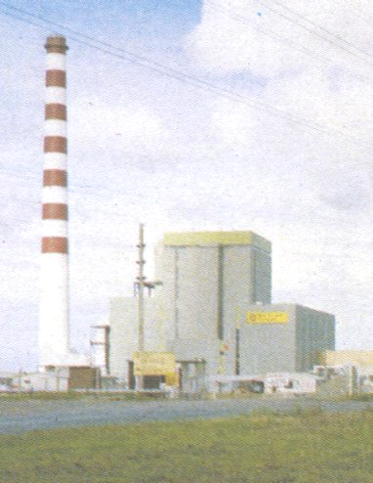
Some analysis of the key factors

Our analysis of the key factors will examine the risk profile of each component of the value chain to see what the overall energy trading risk profile looks like (refer to the final page). On the face of it the risk profile of each component of the value chain (and hence of the entire value chain) should be symmetrical
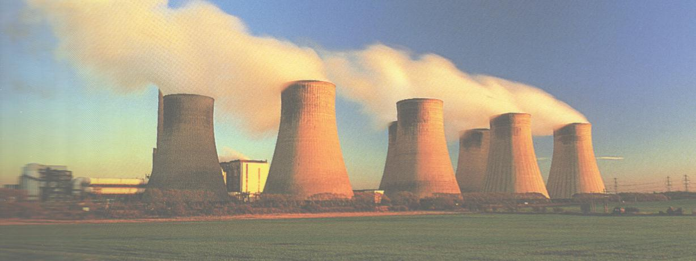 | making the most likely outcome “in the middle” (like a normalised Gaussian curve). Various real world factors such as low hydro inflows, gas supply constraints, lack of new generation capacity, transmission constraints and retail price capping can add a negative skew to the overall risk profile making the most likely outcome “unfavorable”.
Concluding remarks

The analysis presented above suggests that in a circumstance where factors such as low hydro inflows, constrained gas supply, a shortfall in generation capacity, transmission constraints or retail price capping prevail, the down-side risks of energy trading become very apparent. The corollary appears to be that in the absence of such factors energy trading would have probably succeeded. Hence we draw the conclusion that it was almost certainly the coincident exposure to the down-side risks rather than the energy trading models per se that caused the industry’s woes.

Pipes & Wires geographical spread

Lately a few people have asked how widely Pipes & Wires is being read, so I’ve compiled a geographical summary below….
Region | Number of recipients
New Zealand | 531
Australia | 286
North America | 187
Europe | 155
Africa | 36
Asia | 35
South America | 11
Pacific | 1

Reader response

Please pick one of the links below to tell me what you think of this issue of Pipes & Wires…

- Excellent

- Very good

- Good

- Average

- Poor

If you get this is a hard-copy, your comments can be emailed to issue#24@utilityconsultants.co.nz If you receive this second-hand by email, you can receive Pipes & Wires directly by picking here.

Conferences & events

- Middle East Electricity (includes exhibition) – Dubai (15 – 18 February 2004).

- Wideband code division multiple access – London (16 – 17 February).

- Retail Power Market Summary – Orlando (25 – 26 February).

- Italian energy – Milan (1 – 2 March).

- Land pipeline engineering – Wellington (1 – 2 March)

Primary energy supply
Generation capacity
Transmission capacity
Wholesale market
Retail market
Nett risk profile
Risk profile will be negatively skewed because upward price spikes tend to be bigger in magnitude than downward price spikes. Negative skew will be increased if hydro inflows are low or if gas supply is constrained.
Risk profile will be negatively skewed if construction of new capacity has not kept up with demand
Risk profile will be negatively skewed because unconstrained transmission does not have an equivalent up-side gain.
Risk profile will be symmetrical in the purest sense, but real-world imperfections may create slight asymmetries.
Risk profile will be negatively skewed due to retail price capping.
Curves are for illustrative purposes only and do not depict actual risk profiles

