Pipes & Wires

THE UTILITIES & INFRASTRUCTURE COMMENTARY FROM UTILITY CONSULTANTS

Issue 25 – January 2004

From the director…

 | Welcome to 2004 !! This issue of Pipes & Wires begins with an overview of a recent client project, which ties in strongly with an article on disclosing (electricity) asset management plans in New Zealand.  We then begin a three part series examining gas transmission pipeline access determinations in Australia, and the various grounds for appeal that have arisen.  We then consider the plans to introduce competitive water supply in the UK and complete this issue with a discussion of the electricity line price thresholds that will apply in New Zealand for the 5 years from 1 April 2004.

Utility Consultants advises ElectroNet

Utility Consultants recently assessed Westpower’s disclosure asset management plan for compliance with Section 25 of the Electricity (Information Disclosure) Regulations 1999 on behalf of Westpower’s contracted asset manager, ElectroNet Services Ltd.  If you would like your asset management plan reviewed for compliance, or would like assistance with enhancing your plan, pick here to email us, or call Phil Caffyn on +64-7-8546541 or +64-21-606670. Also refer to the article below on “Disclosing electricity asset management plans in NZ” for further information. | 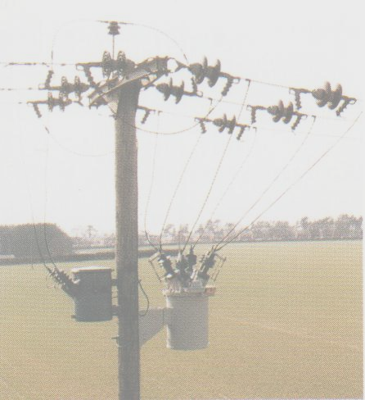

Gas … still under pressure in Aussie (Part 1)

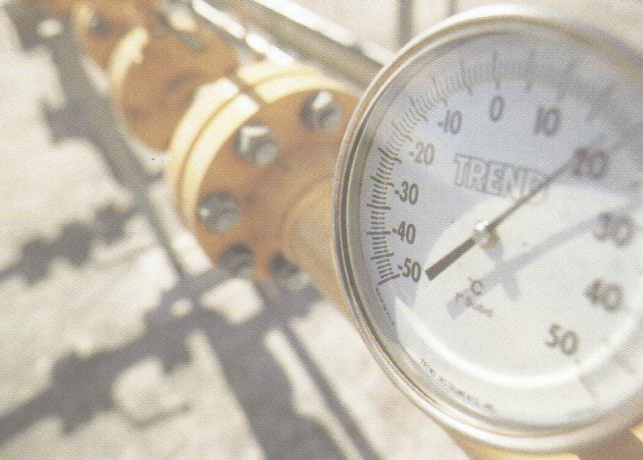 | Introduction  This article is the first of three that examine three recent gas access determinations that are subject to the ACCC’s jurisdiction. Part 1 examines the Australian Pipeline Trust’s (APA’s) Moomba – Sydney Pipeline (MSP) determination, whilst Part 2 will examine Epic Energy’s Moomba – Adelaide Pipeline (MAP) determination. Part 3 will examine the ACCC’s recent determination in respect of GasNet.
Just by way of detail, the MSP supplies gas to Sydney from the Cooper Basin in north-eastern South Australia, and is owned by APA subsidiary East Australia Pipelines Ltd (EAPL). The MSP comprises a 1,299km mainline from Moomba to Wilton (south-west of Sydney), and four laterals – Young to Lithgow, Young to Wagga Wagga, Junee to Griffith and the Canberra Lateral.

The approval process

In response to the ACCC’s determination on the MSP in early October 2003, EAPL submitted a revised access arrangement three weeks later. Because the ACCC formed the view that this revised access arrangement did not comply fully with its requirements, the ACCC drafted and approved its own access arrangement as required under the Gas Code. This arrangement came into force on 1 January 2004 but will not materially impact on the MSP’s revenue until existing contracts expire in 2006.

In what may prove to be a very significant decision for the industry and an immediate victory for APA, the Federal Minister for Industry, Tourism & Resources removed the Moomba – Marsden section of the MSP from the ACCC’s jurisdiction effective 11 December 2003 on the basis that the mainline MSP is being progressively exposed to network competition. However on 5 December 2003 three gas users and two user groups filed an appeal of the Minister’s decision, effectively suspending the Minister’s decision until the appeal is heard before the Australian Competition Tribunal. Consequently, the ACCC’s determination will continue to apply to the entire MSP.

Draft and final tariff determinations  In keeping with other recent infrastructure access determinations, regulators and owners seem to be differing on what an acceptable tariff is by several tens of percent. In this case the ACCC sought to reduce the MSP tariff from the present $0.66/GJ to $0.43/GJ in the draft decision (December 2000) and $0.50/GJ in the final approval (December 2003). |  | 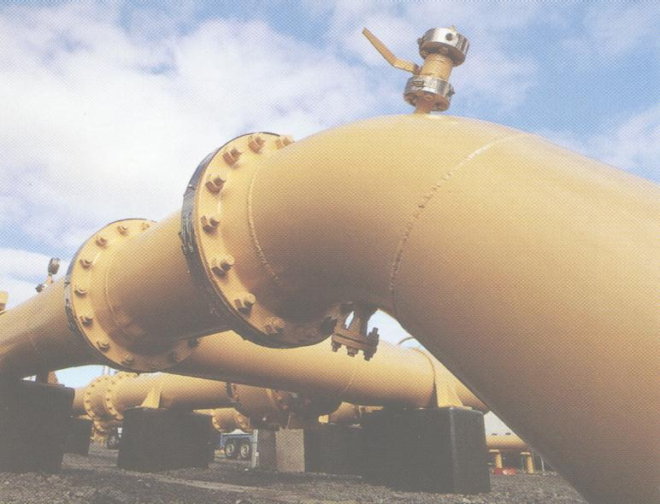
Key components of the final approval

Recent infrastructure access determinations have disputed the following…

- What an acceptable WACC is.
- What valuation methodology and component values should be used.
- How the defined valuation methodology should be applied (in particular how depreciation should be calculated).
- What assets should be included in the valuation base.
- What are reasonable estimates of OpEx and CapEx.

In the case of the MSP the following parameters were disputed…

 | Value sought by APA | Value approved by ACCC
WACC | 14.8% | 11.3%
OpEx | $23m | $18.8m
Valuation | $779m | $559m

As the Minister’s decision is suspended and the ACCC’s tariff determination applies to the whole of the MSP asset effective 1 January 2004, APA has decided it must appeal the determination to the Australian Competition Tribunal. The story of “Gas … still under pressure in Aussie” will continue in Pipes & Wires #26 with a discussion of the Moomba – Adelaide Pipeline System.

Disclosing electricity asset management plans in NZ

Disclosure requirements

This is the 5th year that electricity lines asset management plans (AMP’s) will have to be publicly disclosed (by 30 June 2004 in this instance). Up until now disclosure has been required by Section 25 and Schedule 2 of the Electricity (Information Disclosure) Regulations 1999 made pursuant to Section 170 of the Electricity Act 1992. The Regulations were subsequently amended by Regulations SR 2000/118 and SR 2001/178.

The Electricity Information Disclosure Requirements 2004 were released in draft form late last month pursuant to Section 57T of Part 4A of the Commerce Act 1986, with Section 24 providing for disclosure of asset management plans. The AMP content requirements are virtually identical to the previous requirements, with the only significant change being that the Commerce Commission will oversee the disclosure process instead of the Ministry of Economic Development (MoED).
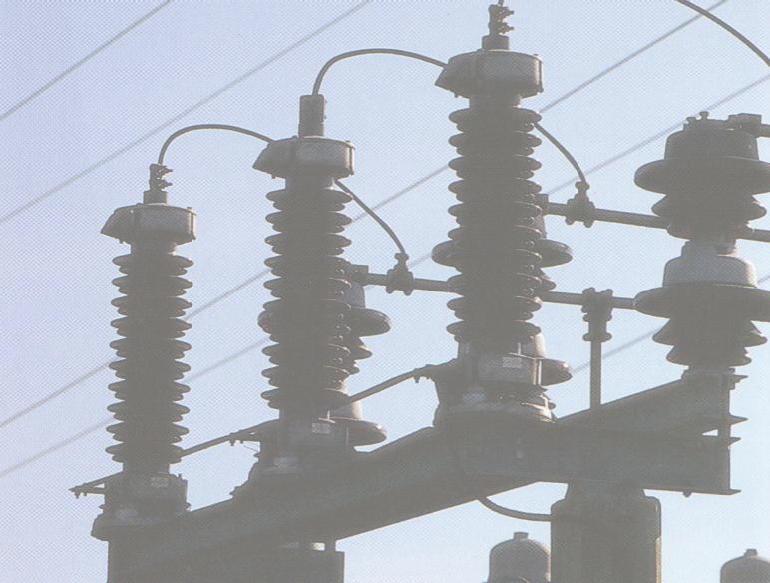 | MoED concerns over AMP content  Our discussions with the MoED revealed a general concern that two of the required aspects “could use a bit more attention”. These aspects are…  - Part (f) – “Details of risk policies, assessment, and mitigation”.  - Part (g) – “Details of performance measurement, evaluation, and improvement”.
Our concerns over AMP content

In addition to the MoED’s concerns, our review of several AMP’s to date indicates that inclusion of policies and plans for distributed generation under Parts (e)(iii) and (e)(vi) “could use a bit more attention”.

Ensuring compliant plans

To ensure your asset management plan is compliant Utility Consultants can either review your plan from an independent perspective, or advise on improving your Parts (e), (f) and (g) compliance. Pick here to email us, or call Phil Caffyn on +64-7-8546541 or +64-21-606670.

Competition gets wet in the UK

Introduction

Competition in the UK is about to get wet … from around autumn 2005, water customers with an annual consumption greater than 50m liters at an individual premise will be able to choose their water supplier. It is estimated that there are about 2,000 such customers.

Policy objectives & legal framework

The Government’s broader policy objectives are…

- Protect public health by ensuring that safe and secure water supplies continue.
- Protect and improve the environment.
- Ensure the affordability of water and water services.
- Safeguard customer service levels.

These policy objectives have been embodied in the Water Act 2003 which amends the Water Industry Act 1991 by providing a framework for common carriage and wholesale & retail supply competition. OFWAT will play a leading role in making it all happen.

Making it all happen  New entrants will be able to obtain one of two classes of water supply licenses in order to compete with a “water undertaker” (undertakers are appointed under the Water Industry Act 1991)…  - A “retail” license which enables the entity to purchase water from a water undertaker and retail that water to an eligible customer.  - A “combined” license which enables the entity to inject its own water into an undertaker’s distribution network and then retail that water to an eligible customer. | 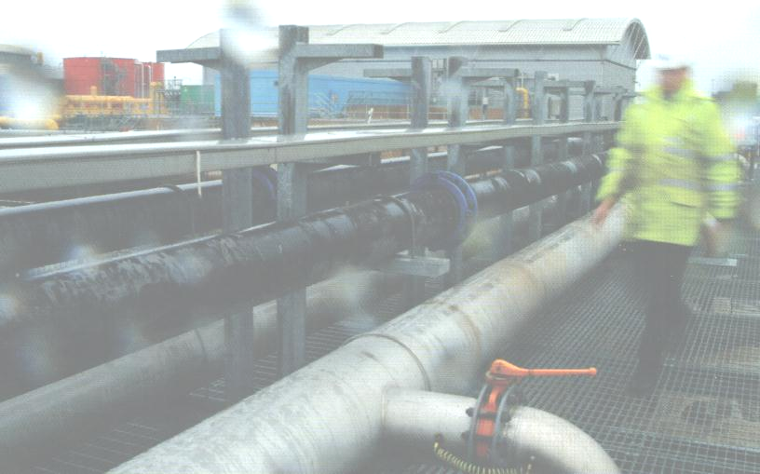
Some issues that will need to be addressed

Just a few issues that spring to mind that will need addressing, both from experience in other sectors, and some peculiar to water itself…

- The seeming advantage that an incumbent undertaker would have from retailing on its own network will be reduced through OFWAT providing guidance on both access terms and charging. OFWAT believes that this will provide a level playing field for all new entrants.
- The consolidation and streamlining of metering and reconciliation functions will also be subject to guidelines from OFWAT, and is not expected to be significant due to the low number of eligible customers.
- Again, identifying and accurately allocating water leakage and pumping costs fairly and consistently to all parties will be covered by OFWAT’s guidelines.
- Maintaining standards for chemical and biological contamination, either from the distribution network or by another water supplier, will be covered within OFWAT’s access terms with all licensees being subject to the same regulations.

We’ll revisit the introduction of competitive water supply as matters progress.

Electricity line price thresholds in NZ

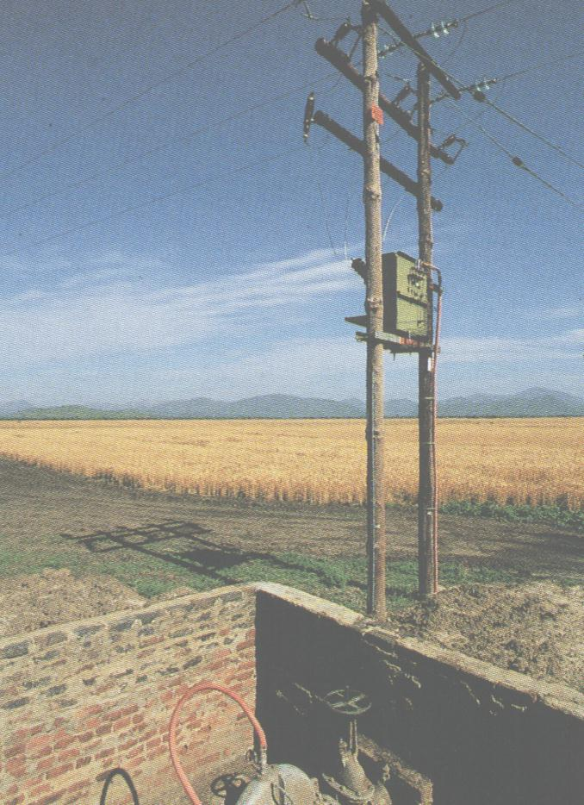 | Price control to date  The price control regime released on 6 June 2003 established the following thresholds…  - Three price thresholds that have the nett effect of prohibiting any increase in notional revenue from 8 August 2001 to 31 March 2004, effectively setting X = CPI for this period for all lines businesses.  - SAIDI and SAIFI for the year ending 31 March 2004 to be no greater than the average SAIDI and SAIFI over the five years ending 31 March 1999 to 2003.  - The requirement to adequately consult with customers on the price & supply quality tradeoffs available to them, and take customers views into account when making asset management decisions. Pick here to email us or call Phil Caffyn on +64-7-8546541 or +64-21-606670 to discuss.  Slightly different requirements apply to Transpower for both the existing and proposed thresholds, which are outlined in the Gazette.
Draft thresholds for 2004 to 2008

The draft thresholds for the 5 year control period from 1 April 2004 to 31 March 2008 are as follows…

- Notional revenues will be constrained by a CPI-X upper bound for each of the 5 years. Each lines company has been allocated to one of eight groups depending on its relative productivity and profitability (referred to C₁ and C₂ respectively). In addition, a B factor to reflect the expected industry-wide average efficiency gains has been calculated at 1%. The final form of the price path is therefore CPI – (B + C₁ + C₂) with the added criteria that (B + C₁ + C₂) will be capped at 2% to acknowledge the limited ability to improve the efficiency of a business based on long-life assets. The X factors applying to each lines business for each year of the control period are presented below (the shading is for illustrative purposes only and does not represent any official classification) – a few lines companies have moved around since the initial Meyrick report in September 2003. The now familiar process of disclosing, auditing and certifying compliance or otherwise will apply to each of the 5 years within the control period.

 | 1 | X = 1  Horizon Energy  Nelson Electricity  Network Tasman | X = 2  Centralines  Counties Power  Electra  Powerco  The Lines Company  WEL Networks | X =3 (capped at 2)
C₂ | 0 | X = 0  Electricity Invercargill  ScanPower  Vector | X=1  Alpine Energy  Orion | X = 2  Eastland Network  MainPower  Marlborough Lines
 | -1 | X = -1  Northpower  OtagoNet  Waipa Networks | X = 0  Network Waitaki  The Power Company  Top Energy  Unison | X = 1  Aurora Energy  Buller Electricity  Electricity Ashburton  Westpower
 |  | -1 | 0 | 1
 |  |  | C₁

Northpower, OtagoNet and Waipa Networks will be allowed to increase their notional revenue at the rate of CPI + 1% (dark green) for each of the 5 years of the control period, whilst all other lines companies must either maintain their notional revenue at CPI (light green) or reduce their notional revenue at a rate of either CPI – 1% (yellow) or CPI – 2% (orange).
- In a rather curious move, the SAIDI and SAIFI for the year ending 31 March for each year of the control period must not be greater than the averages for the 5 years ending 31 March 1999 to 2003. Again, the process of disclosing, auditing and certifying compliance or otherwise will apply to each of the 5 years within the control period.
- The requirement to adequately consult with customers on the price & supply quality tradeoffs available to them, and take customers views into account when making asset management decisions (the Commission notes many lines companies may already be doing this). The Commission notes that disclosing an appropriately modified AMP or disclosing a dedicated report describing the engagement process and justifying the classes of customer engaged with are both acceptable ways of providing evidence of customer consultation (we would note that the AMP method of disclosure effectively leads to disclosing the AMP earlier than the required 30 June). The Commission recognises the onerous nature of the engagement requirement and is therefore not specifying any particular frequency or method of customer engagement, but only that disclosure, auditing and certification occur at the end of the second and fourth years of the 5 year control period (in addition to 31 March 2004 discussed above).

Process from here on in

Following circulation of the Final Threshold Decisions (subject to finalization of technical detail) on 23 December 2003, the following process will be applied…

- A draft Gazette notice will be issued on 9 February 2004 for industry comments.
- Industry submissions on the draft Gazette notice will close on 23 February 2004.

The final version of the Gazette notice that gives legal effect to the Final Thresholds Decisions paper will be published on 12 March 2004 along with a revised version of the Final Thresholds Decisions paper that will reflect any amendments to the technical detail of the version released on 23 December 2003.

Your turn to have a say…

Please pick one of the links below to tell me what you think of this issue of Pipes & Wires…

- Excellent

- Very good

- Good

- Average

- Poor

If you get this is a hard-copy, your comments can be emailed to issue#25@utilityconsultants.co.nz If you receive this second-hand by email, you can receive Pipes & Wires directly by picking here.

Research reports & conference papers

- “E.On’s acquisition of Ruhrgas – a study of competition issues & regulatory concessions”

- “Gas Natural’s unsuccessful bid for Iberdrola”

- “Alinta Gas’ acquisition of United Energy, MultiNet and Ikon Energy”

- “Electricity lines price control in New Zealand”

- “Reforming the pipes & wires industries – what could it mean for asset management in the water sector” – a conference paper presented in Auckland in April 2001.

Conferences & events

- Water India 4 – New Delhi (3 – 4 February).

- Middle East Electricity (includes exhibition) – Dubai (15 – 18 February).

- Wideband code division multiple access – London (16 – 17 February).

- Retail Power Market Summary – Orlando (25 – 26 February).

- Italian energy – Milan (1 – 2 March).

Disclaimer

These articles are of a general nature and are not intended as specific legal or consulting advice. They are correct at the time of writing. Utility Consultants Ltd accepts no liability for action or inaction based on the contents of Pipes & Wires including any loss, damage or exposure to offensive material from linking to any websites contained herein.

