Pipes & Wires

THE UTILITIES & INFRASTRUCTURE COMMENTARY FROM UTILITY CONSULTANTS

Issue 26 – February 2004

From the director…

 | Welcome to Issue #26 of Pipes & Wires. This month starts with a profile of a regulatory compliance project for ScanPower as the completion date for compliance with customer engagement requirements rapidly approaches.  We then take a quick look at some of the factors driving electricity price volatility in the US, and do a preliminary analysis of National Grid Transco’s intention to sell some of their local gas networks. We then consider the rumored functional consolidation of energy regulators in California in the 1st of a 2 part series, and conclude this issue with the 2nd of a 3 part series on gas transmission access determinations in Australia.

Utility Consultants advises ScanPower

Utility Consultants has recently assisted ScanPower in meeting the customer engagement requirements of Section 6(1)(e) of the Commerce Act (Electricity Lines Threshold) Notice 2003. The methodology | 
chosen was to present a group of ScanPower’s largest customers with an option of increased supply reliability (at an additional monthly cost) based on providing a back-up supply fed from a separate feeder within ScanPower’s network via a remotely-actuated air-break. Utility Consultants also prepared the compliance statement required by Section 7(1) of the Notice.

To discuss how your company might meet its customer engagement obligations, or for assistance in compiling your compliance statement pick here or call Phil Caffyn on +64-7-8546541 or +64-21-606670.

US – fuelling electricity price volatility

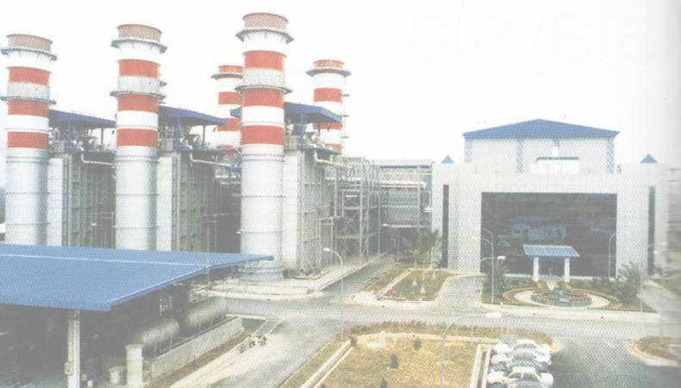 | Introduction  Most of us are only too aware of wholesale electricity price volatility … just two months ago wholesale prices in New Zealand’s North Island rocketed from about $50/MWh to $900/MWh after three towers on the HVDC link in Marlborough were blown over by high winds. Transmission outages are just one of many classes of events that can increase wholesale prices (refer back to Pipes & Wires #24 – “Was energy trading behind the bankruptcies”.
Volatility of key generation inputs

A new source of wholesale price volatility is now emerging in the US … that of wholesale gas price volatility. As generation in the US shifts from ageing coal and nuclear plants to gas-fired combined cycle plants, and the gas market itself moves away from hedging toward spot markets, wholesale electricity prices are likely to become even more volatile. The volatility of gas prices may in turn be further exacerbated by volatility of crude oil prices (to which gas is closely pegged).

Managing the volatility risks

In a sense the electricity industry may actually move to a “less risk managed” position as the gas industry moves more toward spot pricing. Additionally, as electricity prices become more volatile, sellers of risk management instruments will probably need to include a higher premium in their prices. A possible emerging scenario is one where the price risk at each step in the value chain gets shunted to the very end to consumers who are prepared to take a punt on the spot market rather than pay high premiums to transfer their exposure to other parties.

UK – selling the local gas networks

Introduction

In May 2003 National Grid Transco (owner of the UK’s gas transmission and distribution networks) announced it would consider selling one or more of the local distribution businesses if this were to maximise shareholder value. NGT has since confirmed that it is now considering the sale of up to four of these businesses.

Regulatory issues associated with any sale  Aside from issues of economic regulation, there are also structural and safety regulations to be complied with.  Under the Gas Act 1986 and the terms of its Gas Transporter License, NGT is required to obtain the consent of the Secretary of State, OFGEM and the Health & Safety Executive before selling any of its local distribution businesses. A key initiative on NGT’s part in this regard is to retain a single, unified public safety framework covering the entire national gas infrastructure regardless of any resultant changes in industry structure.  OFGEM’s preliminary regulatory impact assessment concluded that customers were likely to benefit from the sale of some of the local distribution businesses due to lower distribution charges. Although the concerns expressed by some respondents during the consultation process seem to doubt this conclusion, OFGEM maintains its view that any sale will most likely be beneficial. | 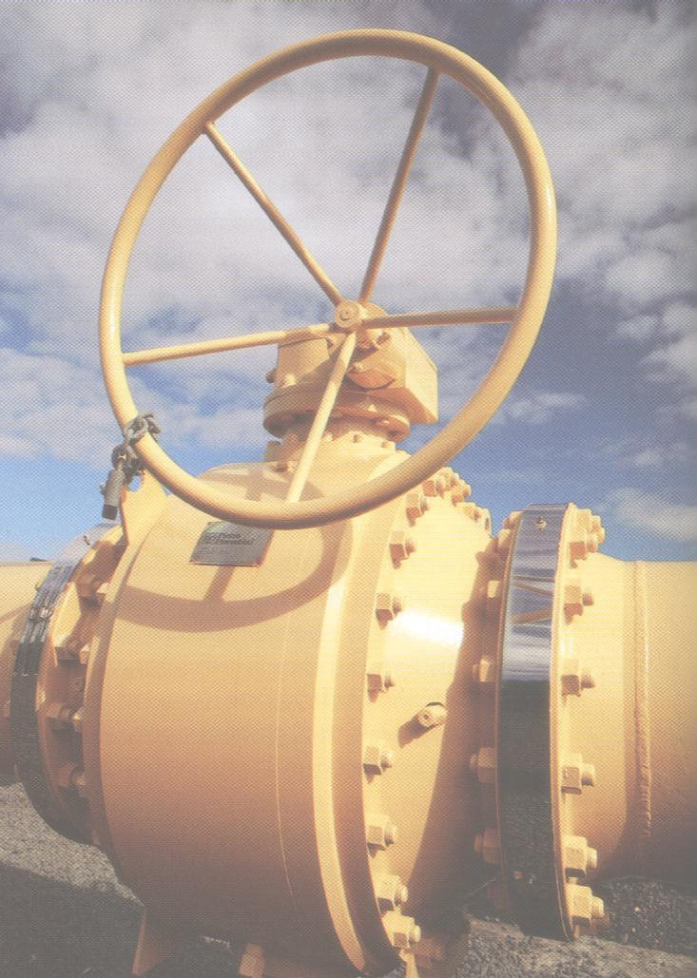
NGT’s motives for selling

As outlined above, NGT’s motive for selling the local distribution businesses is maximising shareholder value. This merits an examination of how such value maximization might occur.

In many (probably most) M & A scenarios, a premium over and above the intrinsic value of a business will be paid. This premium arises from a range of synergies that an acquiror would be able to make, and usually varies between acquirors. In this particular case, synergies could arise from increased operational efficiencies if the acquiror already owns geographically contiguous networks, and also from OFGEM being able to apply more accurate price controls from having a greater number of separate businesses to compare.

A further possible reason for NGT to consider selling the local distribution businesses was to raise cash in anticipation of acquiring gas transmission assets in Australia, although this now seems an unlikely scenario. These assets would form a useful and diverse synergy with NGT’s existing electricity transmission assets in Australia.

Horizontal integration opportunities

The sale of local gas businesses will undoubtedly provide horizontal integration opportunities for electricity and water network operators from which operating efficiencies could be extracted, and possibly also service bundling opportunities. Further opportunities may also exist for water and electricity distributors to migrate capital toward less regulated businesses.

As this possible sale process could significantly alter the industry structure we will make further comment as events run their full course.

Consolidating the energy regulators (Part 1)

Introduction

Consolidation of energy regulators to reflect convergence of electricity and gas markets has already occurred (the amalgamation of OFFER and OFGAS in the UK to form OFGEM is a prominent example). In this two part article we examine firstly the functional consolidation of energy regulators in California, and secondly the geographical consolidation of energy regulators in Australia.

Background

“Energy regulation” seems so dominated by economic regulation that it is easy to forget the other significant aspects of energy markets that are also regulated by various government agencies (often at both state and federal levels) … allocating access to primary energy resources, coordination of infrastructure planning, and overseeing technical standards. This is in addition to other non energy-specific aspects such as ensuring adequate competition, ensuring compliance with capital market requirements, enforcing public health and safety, and enforcing environmental compliance.

 | California’s plethora of energy regulators  A recent speech by Governor Schwarzenegger stated that California has 13 different state energy agencies, whose functions range from approving access terms & prices (the California Public Utilities Commission), ensuring sufficient generation capacity to avoid repeats of the 2000 and 2001 crises (the California Power Authority), overseeing state-wide energy planning (the California Energy Commission), overseeing the wholesale market and the ISO (the California Energy Oversight Board). This is in addition to the FERC which has jurisdiction over interstate electricity and gas transmission.  The Governor’s recent budget announcement indicated that some sort of consolidation of these agencies would be “sensible” …
A sensible structure for a functionally consolidated energy regulator

Looking beyond California’s machinations we might well ask what a sensible structure for a single functionally consolidated energy regulator could be, and indeed whether all the regulatory functions outlined above could be comfortably accommodated within a single agency without any conflicts of interest. A matrix model similar to the following in which the functions currently performed by the 13 California regulatory agencies plus the FERC are indicated by grey shading might work…

 | Primary energy | Electricity generation | Gas & electricity transmission | Gas & electricity distribution | Wholesale & retail markets
Policy
Capacity planning
Access terms & conditions
Operational oversight

The entire agency could be overseen by a Chief Energy Commissioner, with Deputy Energy Commissioners (DEC’s) responsible for each shaded cell in the matrix. Each DEC could have a small team of specialist staff and would be supported by a general pool of engineers, economists and attorneys.

Part 2 of this article will examine the geographical consolidation of energy regulators in Australia.

Gas - still under pressure in Aussie (Part 2)

 | Introduction  This article is the second in a three part series discussing recent gas access determinations, in this case Epic Energy’s successful appeal to the Australian Competition Tribunal (ACT) in regard to the ACCC’s final approval for the Moomba – Adelaide Pipeline System (MAPS) which includes laterals to Pelican Point, Port Pirie, Whyalla and Angaston.
The access arrangement approval process

On 1 April 1999 Epic sought the ACCC’s approval of its access arrangements for the MAPS for the regulatory period ending 31 December 2005. The ACCC released its draft decision on 16 August 2000 and its final decision on 12 September 2001, which required Epic to modify its proposed access arrangement. The Gas Code then requires the ACCC to assess whether the modified access arrangement substantially incorporates the amendments specified in the final decision or otherwise addresses the reasons for amendments being required. This assessment is promulgated by way of the final approval which occurred in July 2002. In this case the ACCC took the view that Epic’s modified access arrangements did not incorporate the amendments specified in the final decision or otherwise address the reasons for amendments being required, hence the ACCC drafted and approved its own access arrangement for the MAPS as provided for in the Gas Code which took effect from 15 August 2002.

Key components of the ACCC’s final approval

Following on from the theme of disputed parameters outlined in Part 1 of this series (refer Pipes & Wires #25), the major components of the ACCC’s final approval were inter alia…

 | Value sought by Epic | Value approved by ACCC
Asset beta | 0.58 | 0.5
Valuation | $423m | $360.4m

It should be noted that the asset valuation sought by Epic excluded an expansion and lateral built in 2000 (Pelican Point Expansion), so the two values above are not strictly comparable.

Epic’s appeal of the final approval  Epic considered that the ACCC was wrong or unreasonable in the circumstances including that it did not give sufficient consideration to the issues in section 2.24 of the Gas Code. Accordingly, Epic made application to the Australian Competition Tribunal under the Gas Pipelines Access (South Australia) Act 1997 on 14 August 2002 to have the ACCC’s final (approved) access arrangement reviewed. Epic did not appeal the reduced asset beta approved by the ACCC. |  | 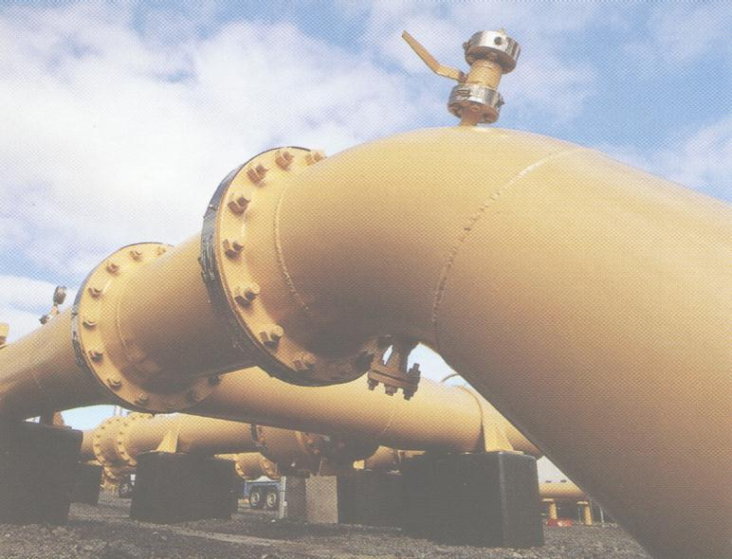
ACT’s final decision

On 10 December 2003 the ACT issued its decision. It ordered that the ACCC’s access arrangement be varied in the following respects…

- That the cost of line pipe (a key input parameter used to calculate the optimised replacement cost of the MAPS) be varied to an exchange rate adjusted cost of $1,302.20 per tonne.

- That the Pelican Point Expansion not be included as part of the regulated pipeline and therefore the capital costs attributable to the additional capacity created by this expansion ($11m of compression costs relating to the optimised pipeline) be deducted from the ACCC’s initial capital base valuation. This had the effect of reducing the firm capacity of the pipeline (known as the system primary capacity) by 25TJ per day.

The nett effect of these variations is that the reference tariff for the access arrangement period (which concludes on 31 December 2005) will be $0.4432 per GJ (referenced to year 2000 $) as opposed to the $0.4052 per GJ set by the ACCC and the $0.4958 per GJ initially sought by Epic.

We will conclude this 3 part series next month in Pipes & Wires #27 with a discussion of GasNet’s appeal of an ACCC determination.

Research reports & conference papers

- “E.On’s acquisition of Ruhrgas – a study of competition issues & regulatory concessions”

- “Gas Natural’s unsuccessful bid for Iberdrola”

- “Alinta Gas’ acquisition of United Energy, MultiNet and Ikon Energy”

Your turn to have a say…

Please pick one of the links below to tell me what you think of this issue of Pipes & Wires…

- Excellent

- Very good

- Good

- Average

- Poor

If you get this is a hard-copy, your comments can be emailed to issue#26@utilityconsultants.co.nz If you receive this second-hand by email, you can receive Pipes & Wires directly by picking here.

Conferences & events

- Italian energy – Milan (1 – 2 March).

- Automatic Meter Reading Technical Study Tour – Philadelphia to San Diego (20 – 27 March).

- Metering America, Billing America and CRM/CIS America – San Diego (24 – 26 March).

- South African Prepayment Week – Johannesburg (12 – 14 May).

- Third annual LNG North America summit – Houston (26 – 28 May).

Disclaimer

These articles are of a general nature and are not intended as specific legal or consulting advice. They are correct at the time of writing. Utility Consultants Ltd accepts no liability for action or inaction based on the contents of Pipes & Wires including any loss, damage or exposure to offensive material from linking to any websites contained herein.

