Pipes & Wires

THE UTILITIES & INFRASTRUCTURE COMMENTARY FROM UTILITY CONSULTANTS

Issue 27 – March 2004

From the director…

 | Welcome to Pipes & Wires #27. This issue starts with a client project review, and then …. a third birthday celebration !! Pipes & Wires turns 3 this month.  We then conclude the 3 part series on gas transmission access determinations in Australia and conclude the 2 part series on consolidating energy regulators, this time focusing on the geographical consolidation in Australia.  We then examine three industry structural changes – the water industry in Wales, the electricity distribution industry in Africa (Part 1 of a 4 part series), and the gas distribution industry in Shanghai.

Utility Consultants advise Buller Electricity

Utility Consultants recently advised Buller Electricity on modifying its asset management plan to include the following aspects…  - Policies on distributed generation as required by Schedule 2 of the Electricity (Information Disclosure) Regulations 1999 and subsequent amendments.  - Customer consultation processes to ensure that the requirements of the Commerce Act (Electricity Lines Threshold) Notice 2003 are suitably integrated into the organisation at a senior level. | 
To discuss how your company might improve its asset management plan compliance, call Phil Caffyn on (07) 854-6541 or pick here to email Phil.

Pipes & Wires turns 3 years old

This issue marks three whole years since Pipes & Wires began in March 2001 as a two-page editorial comment and summary of recent energy, utility & infrastructure events. Pipes & Wires #1 started with an article on California’s woes (hard to believe that 3 years on it is only just coming to an end) and had a circulation of 97 (56 hard copies and 41 by email). Circulation has grown steadily over these three years to reach 1,290 globally.

Gas - still under pressure in Aussie (Part 3)

Introduction

This is the final article in a three part series on recent gas access determinations. This article considers the Australian Competition Tribunal’s (ACT’s) review of the ACCC’s January 2003 determination in regard to GasNet.

GasNet owns and operates 1,935km of high-pressure transmission pipelines throughout Victoria that convey about 200PJ of gas per year from 5 injection points to over 100 off-takes. The ACCC has jurisdiction over all gas transmission pipelines except those in Western Australia.
Background to the ACCC’s initial determination  Prior to the privatisation of the Victorian gas industry in 1998, the ACCC had approved the access arrangements for Victoria’s high-pressure transmission network. In March 2002 GasNet submitted a revised access arrangement to the ACCC for approval that included several substantial amendments that would have significantly increased GasNet’s forecast revenue to an average of $95m per year over the five year determination period. In the end, the ACCC drafted and approved its own determination as provided for under the Gas Code. While this determination included many of GasNet’s requested amendments, the allowable forecast revenue of only $77m per year was substantially lower than that sought by GasNet. | 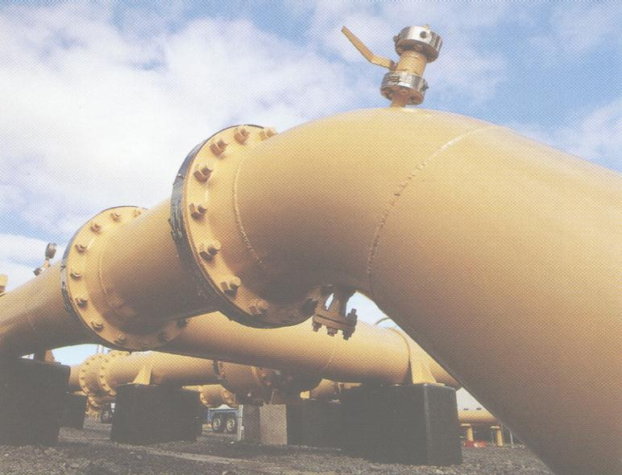
GasNet’s appeal to the ACT

In January 2003 GasNet applied to the ACT for a review of the ACCC’s determination on two counts…

- That the ACCC should have approved GasNet’s proposed access arrangement rather than drafting and approving its own arrangement.
- That the ACCC had made errors in the way it determined five aspects of GasNet’s capital and non-capital costs (equity beta, risk-free rate, asymmetric risks, debt-raising costs, and inflation) totaling $4.4m per year.

Prior to the ACT hearing GasNet withdrew its concern over the equity beta (worth about $2.2m per year), whilst during the hearing the ACCC agreed that additional allowances for asymmetric risks and debt-raising costs were acceptable.

ACT’s decision

The ACT’s decision handed down on 23 December 2003 ordered that the ACCC’s access arrangement be varied with respect to issues accepted by the ACCC and one other issue, resulting in a forecast revenue averaging $79m per year over the five year determination period commencing 1 January 2004. A pivotal component of the ACT’s decision was that the ACCC should accept a pipeline owners’ view of various parameters (provided those parameters are within an acceptable range) rather than impose its own view of specific parameter values.

Consolidating the energy regulators (Part 2)

Introduction

Part 1 of this article considered the proposed consolidation of California’s many functionally separate energy regulators. This article continues the theme by examining the consolidation of Australia’s geographically separate energy regulators into a single Australian Energy Regulator (which also includes the parallel establishment of the Australian Energy Markets Commission).

Australia’s historical energy sector

The highly interconnected and intertwined excitement of Australia’s energy networks industry has really only emerged in the last decade. Prior to this, energy networks were characterised by strong separation of electricity and gas, little inter-state connectivity, and varying degrees of vertical integration. The high degree of government ownership also meant that “economic regulation” as we currently see it was not so significant.

Australia’s plethora of energy regulators

As various states restructured and privatised their energy network industries, the role of economic regulation increased in significance. The transformation of these industries across state boundaries, between transmission and distribution, and between electricity and gas meant that many utilities were forced to deal with multiple energy regulators.

Consolidating the energy regulators

One of the key findings of the Parer Review of the Australian energy market is that the energy sector is over-regulated and that a single, independent national energy regulator should take over the functions of these 13 regulators in order to reduce barriers to new investment.

The new energy regulator

Although the AER will definitely be established, it will vary from what the Parer Review recommended…

- The AER will exist under the ACCC’s umbrella rather than being totally independent from it. It will be governed by 3 commissioners – one from the ACCC, and 2 collectively appointed by the national energy minister’s forum.
- A separate body (the AEMC) will administer the National Electricity Code (NEC).
- The ACCC will still retain jurisdiction over restrictive trade practices under Part IV of the Trade Practices Act. This will include approving competition related changes to the NEC.

The AER will initially have jurisdiction over electricity transmission and wholesale electricity prices, with gas transmission and wholesale gas prices coming under its jurisdiction in 2005, and finally distribution and retail coming under its jurisdiction in 2006.

The transition to a single energy regulator will obviously mean a lot of hard work, but hopefully it will streamline the regulatory processes and prompt the investment that Australia needs.

Water in Wales goes the full circle
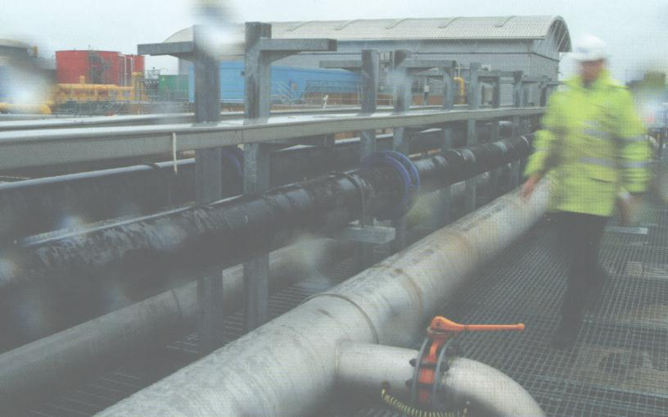 | Introduction  Mergers of pipes & wires businesses in the UK are nothing unfamiliar, however the water & wastewater business in Wales, Dwr Cymru Welsh Water has its own interesting tale to tell. This article examines the acquisition of a consulting company, the acquisition of an electricity business, the sale of an electricity retail business, and the sale of the water business into a ground-breaking ownership structure.
Structural changes to the Dwr Cymru business

Dwr Cymru Welsh Water was one of the water companies formed from the privatisation of the water & wastewater industry in the late 1980’s. Over the last 14 years Dwr Cymru has followed a torturous path…

- Dwr Cymru acquired global infrastructure consultancy Acer Consulting in 1993.
- Dwr Cymru acquired South Wales Electricity (SWALEC) plc in 1996, followed by the formation of Hyder plc as the holding company.
- Hyder sold the SWALEC supply business to British Energy plc in 1999 after which the residual SWALEC distribution business was renamed Infralec in 2000.
- Hyder was acquired by Western Power Distribution in 2000 for ₤3.65 per share after defeating Nomura’s bid.
- The self-styled “peoples’ company” Glas Cymru was established in 2000 and successfully raised ₤2b in debt with which to acquire the equity and assume the debt associated with the Dwr Cymru part of Western Power’s newly acquired business.
- The senior management of Hyder Consulting initiated an MBO which was completed in January 2001 leaving

So there has certainly been plenty of action, and several changes of face for Dwr Cymru as it sampled life as a multi-utility.

What does Dwr Cymru look like now ??

So then - Dwr Cymru is essentially back to where it started in 1990 - a water & wastewater business serving the people of Wales. Perhaps more interestingly, the ownership structure has also gone the full circle. Dwr Cymru’s sole shareholder, Glas Cymru is a debt-funded mutual, which, because it has no shareholders can direct all profits to reinvestment in capital work, amortising debt, or reducing tariffs ahead of regulatory pressure.

Consolidating electricity distribution in Africa (Part 1)

Introduction

Most of us are familiar with consolidation of electricity distribution businesses … after all its’ happened in many jurisdictions such as New Zealand, New South Wales, Victoria, Queensland, England & Wales, Norway and Ontario (refer to Pipes & Wires #7). Consolidation can occur in 2 ways – it can be by political decree, such as in the 3 Australian states, or it can be left to market forces as in the other jurisdictions mentioned.

This 4 part article will examine some of the issues surrounding consolidation and will then examine the politically decreed consolidation of distribution in South Africa, Namibia and Mozambique.
Why consolidate distribution ??  Electricity distribution had its beginnings between 80 and 100 years ago in most countries, and in many instances this was through not-for-profit means (even in the United States). Such industry structures persisted until the 1990’s as Electric Power Boards, Regional Electricity Boards, Public Power Districts and Municipal Electricity Departments (and some of these will continue to live on). A common feature of many of these entities was the very small size, and the lack of commercial discipline. Hence, when the reforms of the late 1980’s came along two of the key outcomes were the corporatisation and amalgamation of such entities. These two key steps occurred in different orders in different jurisdictions (often depending on whether the consolidation was decreed or left to market forces). | 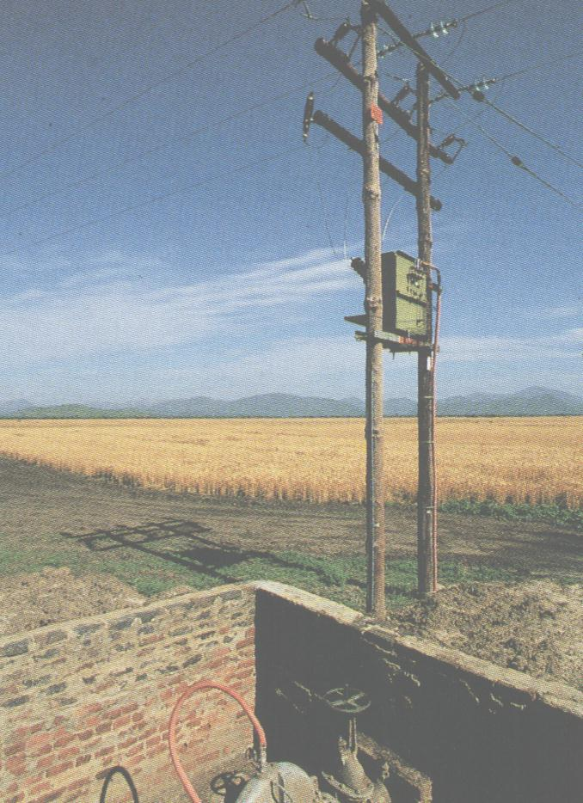
What are the issues involved ??

Certainly in New Zealand the most vexing issue was who actually owned the Electric Power Boards (it was clear from the start that Municipal Electricity Departments were owned by the local council) – it was kind of hard to create limited companies without someone to own the shares. In the end a range of ownership structures emerged such as giving shares to various classes of individuals and giving shares to local councils but by far the most common structure was for shares to be vested in a consumer trust on behalf of consumers. In most other jurisdictions it has been concluded that councils or state and federal governments are the rightful owners of distribution entities and shares were allocated accordingly

The next issue (perhaps more so for politically decreed consolidation) is how many entities should there be ?? The pressure to obtain economies of scale looms large, and pure economic theory would suggest that a single provider would be the most efficient structure (unfortunately, such pure, theoretical arguments rarely if ever consider diseconomies of scale). A more practical consideration is ensuring that there are sufficient distribution entities for a regulator to make robust comparisons of performance. Most instances of politically decreed consolidation seem to result in about 5 or 6 distribution entities.

We will continue this next month with a look at consolidation in South Africa.

Gas – merging the Shanghai distributors

Introduction

The three distributors that supply natural gas to 3.37m customers in Shanghai are likely to be merged during the 2004 calendar year to form a single major gas group with a diverse ownership structure.

The amalgamation proposal

The Shanghai Municipal Engineering Administration Bureau, which oversees the city’s gas operations, proposes to amalgamate the following three gas distributors into a single entity…

- Shanghai Pudong Gas Co Ltd, which is 100% Government owned.
- North Shanghai Gas Ltd which is 100% Government owned.
- Shanghai Dazhong Gas Co Ltd which is a 50-50 joint venture between the Government and locally-listed Shanghai Dazhong Public Utilities (Group) Co Ltd

Policy objectives of the amalgamation  The stated policy objective of the merger is the City of Shanghai’s decision to withdraw from direct oversight of the gas businesses. Probably one of the unstated objectives is to form a strong, viable energy company that will attract external investment to partially relieve the Government of the burden of accelerating growth and the transition from coal gas to natural gas. | 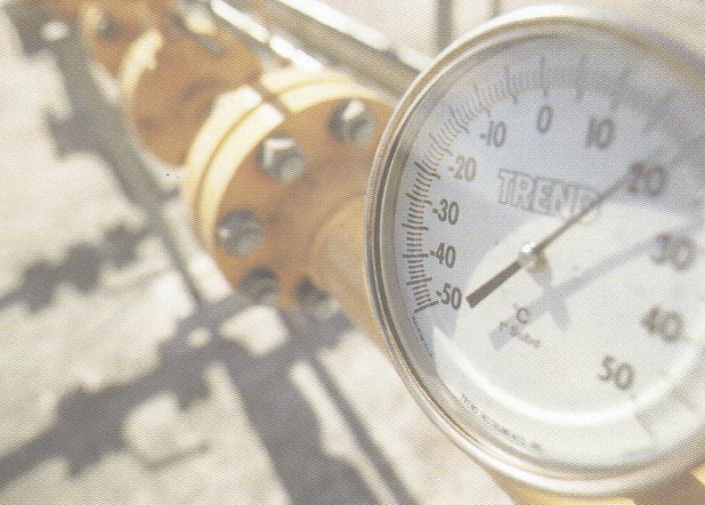
Investment opportunities

The amalgamation process will allow private and foreign investors to invest in the emergent group, although it is widely expected that the major government-owned energy company Shenergy could emerge with a 60% stake in the group.

Tell me how good this issue was…

Please pick one of the links below to tell me what you think of this issue of Pipes & Wires…

- Excellent

- Very good

- Good

- Average

- Poor

If you get this is a hard-copy, your comments can be emailed to issue#27@utilityconsultants.co.nz If you receive this second-hand by email, you can receive Pipes & Wires directly by picking here.

Conferences & events

- South African Prepayment Week – Johannesburg (12 – 14 May).

- Third annual LNG North America summit – Houston (26 – 28 May).

Disclaimer

These articles are of a general nature and are not intended as specific legal or consulting advice. They are correct at the time of writing. Utility Consultants Ltd accepts no liability for action or inaction based on the contents of Pipes & Wires including any loss, damage or exposure to offensive material from linking to any websites contained herein.

