Pipes & Wires

THE UTILITIES & INFRASTRUCTURE COMMENTARY FROM UTILITY CONSULTANTS

Issue 28 – April 2004

From the director…

 | Pipes & Wires #28 starts with a bit of a post mortem on New Zealand’s Project Aqua and also considers what role distributed generation might play.  We then move to a discussion of how regulated utilities might grow their earnings in the face of regulatory price caps, which is followed by a discussion of the impending changes to electricity information disclosure requirements in New Zealand.  Part 2 of the 4 part series on consolidating electricity distribution in Africa looks at the recent establishment of the RED’s in South Africa. We then conclude with the first of a series of interviews on the theme of “Insights Into Strategic Growth” which asks John Roberts from United Utilities plc about their growth strategies.

NZ - new opportunities for DG in the post-Aqua era

I guess the abandoning of Project Aqua shouldn’t have been the huge surprise it was. With complex factors eroding the profitability on many fronts, Meridian Energy was left with no prudent alternatives.  But where does this leave the national interest ?? Although about 840 MW of new capacity is expected to be available for the winter of 2007 will it really be enough to meet dry-year demand ?? It would seem that the shiny black stuff mentioned repeatedly in the flurry of industry comments after the announcement might need to become a reality.  The abandoning of Aqua has created further opportunities for lines companies to consider distributed generation (DG). As well as the benefits of avoiding network investment and increasing supply security, DG will also be valuable for generating GWh. To discuss the technical, commercial and regulatory issues surrounding DG, pick here or call Phil on +64-7-8546541 or +64-21-606670. | 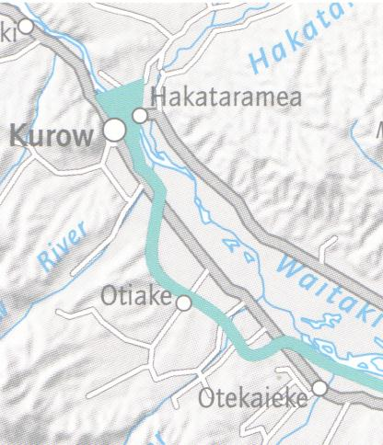

Delivering the earnings growth

Introduction

Earnings growth is a key component of winning the confidence of the equity markets to attract new funding – without it new investment must be funded from revenue or debt (which has its limits). But how can an increasingly regulated utilities sector deliver earnings growth greater than other sectors, and how can individual utilities deliver greater earnings growth than competing utilities ??
Sources of earnings growth

At a theoretical level there are two sources of earnings growth – growing revenues faster than costs, or cutting costs faster than revenue. Unfortunately the cutting costs method usually erodes service potential which then in turn eventually erodes revenue. So cutting costs faster than revenue would seem to be a bad idea except in the specific instance of reducing an assets’ service potential to a level commensurate with sustainable revenue.
The alternative of growing revenues faster than costs

This technique most obviously lends itself to the unregulated activities as it is rare for a regulated utility to be allowed a revenue increase greater than its cost increases. In reality this technique is being played out in very different ways and with very different consequences….
- The high rewards of energy trading lead some utilities to divest their generation and either acquire generation in more lucrative markets or become asset-less traders. Little thought, however, appears to have been given to the downside risks (refer back to Pipes & Wires #24). Many of these utilities are now either wounded and bleeding or totally dead.
- Provision of utility services such as electrical contracting, back-office services and broadband have become very lucrative sidelines, but without the significant downside risks of energy trading. This seems to be an increasingly attractive and sustainable technique.
- Acquisition of pipes & wires businesses in jurisdictions with little or no regulation. Earnings were boosted by revenue increases, by cost reductions through transformational strategies, and by capital gains upon exit (although several utilities have also made capital losses upon exit).

So … how do we get the earnings growth ??

It would seem increasingly difficult (perhaps even impossible) to get sustainable earnings growth from a regulated pipes & wires business. Therefore most utilities’ earnings growth will need to come from unregulated activities, which will then have to subsidise the regulated business as well as reward shareholders for their innovation and risk taking. This doesn’t seem to be the best way of winning the confidence of the equity markets but until the current era of regulatory pressure eases it would seem the easiest way forward.

NZ - changes to the disclosure requirements

Previous disclosure requirements  Disclosures for financial years ending during 2003 were made pursuant to Section 170(k) of the Electricity Act 1992, whilst the targeted control regime was developed pursuant to Part 4A of the Commerce Act 1986 and given legal effect from 6 June 2003 through notification in the Gazette. This led to industry oversight by two agencies within two separate legal frameworks.  New disclosure requirements  The Commerce Commission recently issued the Commerce Act (Electricity Information Disclosure Requirements) Notice 2004 which came into effect on 1 April 2004 and applies to all financial years ending during 2004. With the revocation of the | 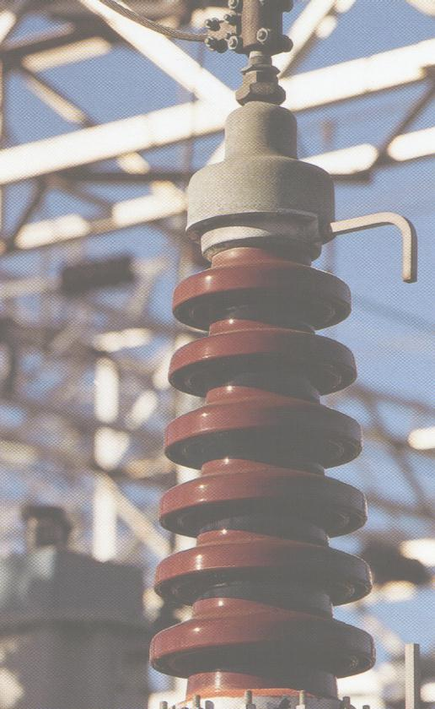
Electricity (Information Disclosure) Regulations, responsibility for overseeing both the disclosure and targeted control regimes will lie with the Commerce Commission within a more streamlined legal framework. The Commission intends to use the 2004 year to reassess the requirements for disclosure.

Consolidating electricity distribution in Africa (Part 2)

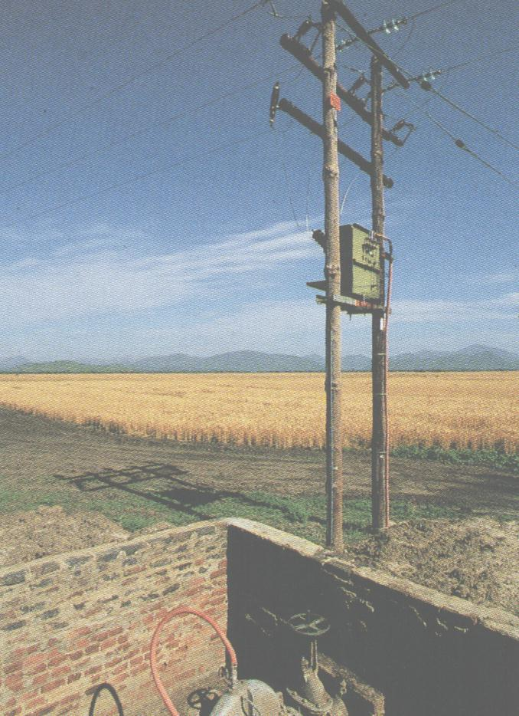 | This article discusses the present restructuring of South Africa’s electricity industry, and focuses on the issues involved in identifying the optimum number of distribution entities. Historically, Eskom distributed about 60% of South Africa’s electricity, with a further 37% being distributed by about 400 municipalities. Most of these municipal electricity entities lacked scale and were facing financial difficulties.  Restructuring objectives  The government had a wide range of objectives for the restructuring program, with universal access being the objective primarily leveled at the distribution segment of the industry.
Defining the number of distribution entities

The initial restructuring framework suggested that between 5 and 15 Regional Electricity Distributors (RED’s) be established. The RED’s would also provide a full range of retail electricity services, with competition initially being in the over 100GWh per year customer class. The issues considered were…

Reasons for decreasing the number of RED’s | Reasons for increasing the number of RED’s
- The need to gain scale, efficiencies and viability. | - The need to provide reasonable inter-company comparisons for regulatory control.
- The need to match each RED’s size against the likely size of emerging generation entities. | - The need to promote a high level of retail competition for when full competition emerges.
- The need to have a significant economic center within each RED to provide managerial skill and support services. | - The need to promote a high level of competition within a wholesale energy market.

Two options were chosen for detailed study – six RED’s with an average of about 930,000 customers and ten RED’s with an average of about 550,000 customers. Although it was recognised that ten smaller RED’s might be a better match with available managerial talent, it was also noted that six larger RED’s would be financially stronger and better able to further the governments’ electrification program.

Valuing the RED’s

Two valuations were applied to each RED…

- A historical valuation of the assets contributed to each RED that will form the basis of share allocations.
- A deprival-based valuation that will be used by the regulator to establish tariffs.

Defining the boundaries of the RED’s

Probably the single issue that has gazzumped mergers everywhere is the allocation of value amongst the owners of the enlarged entity. For this reason it was decided very early on that RED boundaries should coincide with municipal boundaries to minimise disagreement over how much value Eskom and the municipalities brought to each RED. Other issues considered were…

- The mix of customer numbers and classes within each proposed boundary.
- The socio-economic mix within each proposed boundary and in particular the proportion of the national electrification requirement within the boundaries.
- The likely viability of each RED, particularly its ability to fund electrification and the need to avoid cross-subsidies and wide variations in tariffs between RED’s.
- Geographical features that form obvious boundaries.
- Network configurations that form obvious boundaries.

Ownership of the RED’s

Shares in the RED’s will be held by the municipalities and by a state-owned entity called Electricity Distribution Industry Holdings (EDI). EDI has been established to hold the shares that reflect Eskom’s contribution to the RED’s to reinforce the guiding principle that generators must not own shares in transmission or distribution. It is expected that the EDI will be dissolved in about 5 years, with the shareholdings passing to the government. At this point “golden shares” may be established to give the government power of veto over any changes in ownership or capital structure that would be contrary to the intention of the reforms.

Next month we will examine the consolidation of electricity distribution in Namibia.

Insights into strategic growth (Part 1)

This article is the first of several in which we are interviewing utility chief executives who have presided over significant strategic growth. This month we are interviewing John Roberts, chief executive of United Utilities plc.

Pipes & Wires John, the fact that United Utilities is the only REC not to have merged with any other REC might create the impression that United is not growing strategically. Reading your company literature, however, indicates a strong focus on growing unregulated revenues. Can you please tell us about this growth strategy ??
John Roberts Our growth strategy is based on deploying our core utility skills of asset management and customer management in markets which have potential for strong organic growth.  Our asset management business, Contract Solutions, focuses on three sectors - utility infrastructure, connections and metering, and green energy. In utility infrastructure we have an O&M contract to manage the assets of Welsh Water, and last year we signed a contract to work as part of a consortium to manage the asset investment programme of Scottish Water. We also manage water utilities outside the UK, in Poland, Estonia , Bulgaria, the Philippines and in | 
Australia. Our connections and metering business, which operates under the name of UU Networks, provides multi-utility network connections to property developers and house builders across the UK. It also provides metering services to other utilities, which includes installation and maintenance, but excludes meter reading.

Our green energy business is one of the top five developers of renewable energy in the UK. Our portfolio of assets comprises mainly landfill gas and small scale hydro, but in future we are looking to develop onshore and offshore wind.

In total, Contract Solutions had a turnover in 2002/3 of nearly £400m, and net assets of just over £100m.

Our customer management business, Vertex, is one of the leading business process outsourcing companies in the UK. It manages back and front offices for clients with large customer bases, specialising in process re-engineering to enhance customer service and improve efficiency. Its key market sectors are: central and local government, utilities and the private enterprise sector. Examples of contracts currently operated by Vertex include:-

- In the central and local government sector we have a major contract with Westminster City Council in London, to provide back office and customer contact services to the citizens of Westminster. For central government, we are working with the Department of Work and Pensions to transform the payment of state benefits from a cash based system to electronic payment.
- In utilities we provide billing, cash collection and customer contact services for over 5 million of Powergen’s customers in the UK. We provide a similar range of services to Hydro One, a Canadian utility based in Toronto.
- Our private sector clients include household names such as Vodafone, Marks and Spencer and UPS.

Vertex employs over 10,000 staff and in 2002/3 had a turnover of £310m.

Pipes & Wires Can you talk a little more about this strategy in relation to what role United sees its’ regulated pipes & wires businesses playing in growing unregulated revenues??

John Roberts In terms of our wires and pipes regulated businesses, the key role is to provide a source of skills which can be deployed into our asset management business. For example, one of the directors of our regulated multi-utility asset management business has now moved across to Contract Solutions to become Chief Operating Officer of our consortium that manages our contract with Scottish Water.

In addition, the regulated business acts as a reference point for potential clients of Contract Solutions, in which we can demonstrate the extent of our multi-utility asset management skills.

Pipes & Wires United is the only one of three electricity & water utilities in the UK to have lasted the distance. From what you know about the Hyder and ScottishPower multi-utility models, what has made United’s business model more sustainable than theirs ??

John Roberts The United Utilities business model owes its sustainability to two key factors:-

- we stick to our core skills with which we are familiar and do not venture into areas in which we do not have relevant experience;
- we focus on market sectors which have strong potential for organic growth, so we do not need to invest large amounts of capital. Taken together, Contract Solutions and Vertex have a combined order book of £2.5 billion, with only £220m of net operating assets.

Pipes & Wires John - thanks for some really useful insights into making a multi-utility work in an era of heavy price control.

Tell me how good this issue was…

Please pick one of the links below to tell me what you think of this issue of Pipes & Wires…

- Excellent

- Very good

- Good

- Average

- Poor

If you get this is a hard-copy, your comments can be emailed to issue#28@utilityconsultants.co.nz If you receive this second-hand by email, you can receive Pipes & Wires directly by picking here.

Conferences & events

- South African Prepayment Week – Johannesburg (12 – 14 May).

- Third annual LNG North America summit – Houston (26 – 28 May).

Disclaimer

These articles are of a general nature and are not intended as specific legal or consulting advice. They are correct at the time of writing. Utility Consultants Ltd accepts no liability for action or inaction based on the contents of Pipes & Wires including any loss, damage or exposure to offensive material from linking to any websites contained herein.

