Pipes & Wires

THE FREE MONTHLY CLIENT NEWSLETTER FROM UTILITY CONSULTANTS

Issue 29 – May 2004

From the director…

 | Welcome to Pipes & Wires #29. This issue starts with a summary of a recent client project (just for your added comfort, such projects only appear in Pipes & Wires with the clients’ full agreement). I then make a brief comment on the issue of asset investment.  Part 3 of the series on consolidation of electricity in Africa looks at Namibia, and then we examine the New Zealand Electricity & Gas Industries Bill 2003 and what it could mean for the industry.  This issue concludes with the 2nd in a series of insights into strategic growth in which Steven Boulton of Powerco talks about the United Networks acquisition.

Utility Consultants advises Hutt-Mana Energy Trust

Utility Consultants was recently engaged by the Hutt-Mana Energy Trust to examine the feasibility of buying back the former Energy Direct lines business and also the possibility of buying the former Capital Power lines business. Just to jog the memory a bit, a series of transactions following the passage of the Electricity Industry Reform Act 1998 had led to the Trust’s then 20% stake in Energy Direct becoming a 10.3% stake in Natural Gas Corporation.  Utility Consultants performed the following scope of work for the Trust… | 
- Testing the hypothesis that Trust-owned lines companies have lower line charges.
- Provide a summary of then present regulatory regime.
- Provide an opinion on the likely form and extent of the then-pending lines price control regime.
- Identify the measures preventing the owner of a lines business using the non-beneficially-owned areas of the business to subsidise the beneficially-owned areas.
- Estimate purchase prices for the Energy Direct lines business and for both lines businesses.
- Identify structural options for both possible purchases, including comment on the likely capital structure and resultant credit ratings.
- Perform a desk-top analysis of the assets and express a broad view on their condition.
- Identify options for managing and operating a lines business.

If you need any of these issues examining in your business, pick here or call Phil Caffyn on +64-7-8546541 or +64-21-606670.

The director comments
Back in the old days any shortfall of utility capacity was almost always met with an unquestioning response that investing in new capacity was the only option.

Over the last 15, maybe 20, years “marginal solutions” have emerged that range from deferring such investment to avoiding it altogether. These include such techniques as retrofitting forced cooling to transformers and using sophisticated software to increase the thermal rating of transmission lines (in many

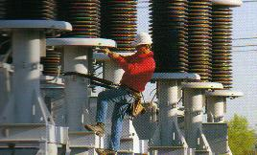 | cases exploiting the generous design margins of bygone eras) through to using demand side techniques such as peak load shedding and conservation.  What concerns me is that in some instances such “marginal solutions” are the only options considered whilst investing in new capacity is shunned … something to be avoided at all costs. By all means keep up the clever thinking behind deferring and avoiding new capacity but let’s also be realistic enough to know when investing in new capacity is the only secure option.

Consolidating electricity distribution in Africa (Part 3)

This article is the third in a four part series discussing the consolidation of electricity distribution in Africa, and this month we are examining Namibia.  Background  Historically, most electricity distribution was through the government-owned South West Africa Water & Electricity Corporation (SWAWEK). Following the corporatisation of SWAWEK, NamPower initially distributed through its subsidiary, Premier Electric. As part of the on-going reform process, the distribution function is currently being devolved to regional electricity distributors (RED’s) through a process of company establishment, asset vesting, and licensing by the Electricity Control Board (ECB). | 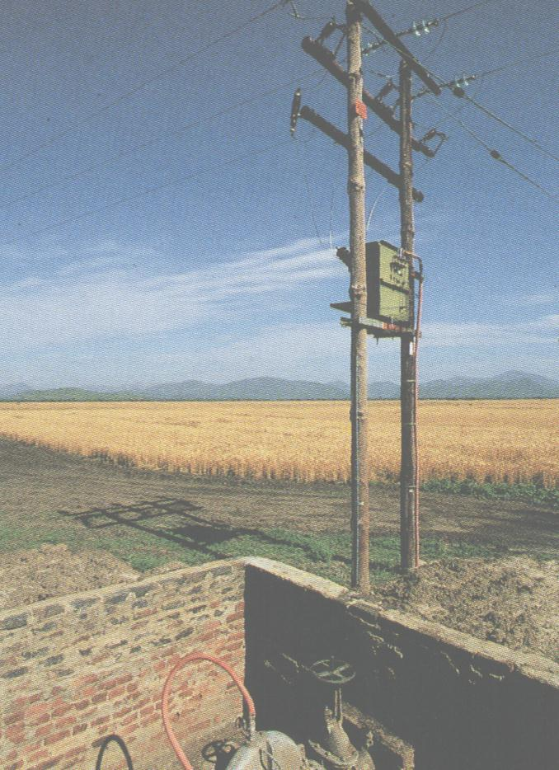
Restructuring objectives

The principal restructuring objective was that NamPower should become a generation and transmission utility and that distribution should be owned and operated by 5 RED’s. Implicit within this is the consolidation of fragmented distribution entities which collectively held 48 supply licenses. A further requirement of the restructuring directive is that all distribution entities within each RED’s coverage area must become part of that RED.

The new RED’s

The 5 RED’s are…

- Northern RED (NORED)
- Central Northern RED (CENORED)
- Central RED
- Erongo RED
- Southern RED

Each RED’s will be jointly owned by NamPower and the municipalities that contributed the assets, and will be governed by a board of directors appointed by the shareholders.

NZ – the Electricity & Gas Industries Bill 2003

The Electricity & Gas Industries Bill 2003 was introduced to parliament on 28 October 2003 with a key focus on electricity supply security and industry governance.

Broad scope of the Bill

The broad scope of the Bill is as follows…

- To ensure a consistent, cross-sector approach to industry regulation that inter alia recognises the need for security of gas supply to underpin security of electricity supply.
- To amend previous legislation to accommodate the functions and powers of the Electricity Commission.
- To allow for the Electricity Commission’s jurisdiction to extend to gas should the gas industry fail to develop a suitable self-governance structure.
- To better facilitate key electricity market features such as retail competition, hedge and contract markets, and distributed generation.
- To allow for more extensive disclosure of information relating to oil and gas reserves to facilitate more efficient exploration and investment and enhance the security of supply in the gas and electricity markets.

Structure of the Bill

The Bill will amend five statutes to implement its broad intentions…

- The Electricity Act 1992 will be amended to reflect the establishment of the Electricity Commission, its rule-making functions and powers, and its key role of ensuring security of electricity supply. The Act will also be amended to allow the Electricity Commission to contract for reserve energy supplies to ensure greater security of electricity supply.
- The Electricity Industry Reform Act 1998 will be amended to relax the ownership separation rules surrounding line companies owning generation and in particular in regard to dry-year reserve generation contracted to the Electricity Commission.
- The Commerce Act 1986 will be amended to better address the interface issues between the Commerce Commission and the Electricity Commission.
- The Gas Act 1992 will be amended to strengthen rule-making powers over the industry and enhance retail competition should the gas industry fail to develop a suitable self-governance structure.

- The Crown Minerals Act 1991 will be amended to increase the information disclosed about oil and gas reserves to enable better investment decisions to be made and to enhance the security of supply in the gas and electricity markets.  Progress of the Bill  The Bill was introduced to Parliament on 28 October 2003, and is currently with the Commerce Select Committee which is due to report on 18 June. The Bill will then be read in Parliament for a second time, any amendments will then be made, and the Bill will then be read a third time. Pending a successful third reading, the Bill will receive Royal ascent and become law. | 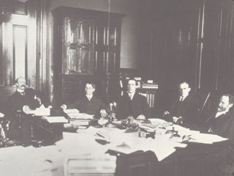

Insights into strategic growth (Part 2)

This article is the first of several in which we are interviewing utility chief executives who have presided over significant strategic growth. This month we ask Steven Boulton, chief executive of Powerco, about the United Networks acquisition. | 
Pipes & Wires - Steven, Powerco has grown very significantly by acquisition over the last 10 years or so. The opportunity provided by Aquila’s global retreat was perhaps a lot less obvious and far more sudden than the systematic acquisition and integration of contiguously arranged networks that Powerco had slowly chipped away at. Can you please
tell us how you went about capturing a piece of the action when Aquila confirmed their exit?

Steven Boulton - UnitedNetworks was too big for Powerco to consider taking on by ourselves given our limited balance sheet capability at the time. However it was also too big an opportunity for Powerco to let slip by. In terms of our broader planning for growth it’s fair to say the Aquila position and hence the asset sale came as a surprise. Despite the unexpected timing of the announcement, however, we believed there would be parties with interest in, and balance sheet capacity for, some components of the UnitedNetworks business.

Powerco invested a great deal of time and resourcing in working with the market participants who we believed had the competency, financial capability and management focus to achieve a result. This is a normal component of achieving any large merger or acquisition where the number of potential purchasers with full take-out capability is limited. At some points during the sale process Powerco was negotiating separately with more than four different parties. In the end we able to structure agreements and contracts with Vector and Hawkes Bay Network (now called Unison) to achieve the outcome where each entity was able to acquire assets.

Powerco ended up almost doubling its size by acquiring a diverse set of electricity and gas assets, more urban in nature than our existing assets. Powerco is now NZ’s largest gas distribution entity and the second largest in electricity in terms of consumer connections – a great result for our business.

Pipes & Wires - Even though Powerco were used to doing big deals, the United acquisition must have been a bit daunting – after all it was about the same size as Powerco was at the time. Can you please tell us what sort of financing and funding issues had to managed, and did the relative size of the acquisition and the impending price control regime make the funding process more difficult or more expensive?

Steven Boulton - The UNL asset acquisition was a major transaction for Powerco, and it required additional funding from external sources. In anticipation of a result we started planning our capital structure requirements early in the transaction, considering an appropriate mix of capital between debt & equity. Our deliberations confirmed that a capital structure mix of 60% gearing on senior debt was appropriate.

We took into account the importance of maintaining a stable investment grade credit rating with Standard & Poor’s – an important attribute for our business. Powerco currently carries a BBB+ long-term rating – a strong investment grade position.

The capital structure we adopted to achieve the UnitedNetworks acquisition required us to raise approximately $150 million of new equity. We raised the balance through senior debt from the financial markets. The equity raising was successfully carried out with the issue of new shares in the market through what was called a “Jumbo Issue” where shares were issued to the wholesale and retail equity markets concurrently. This was the first jumbo issue in New Zealand.

Senior debt requirements were funded through a consortium of NZ banks on the basis of a bridging facility and two term tranches over a total tenure of 4 years, with the provision that the Company could refinance the total at any time. The BBB+ credit rating established at the outset enabled us to achieve very favorable pricing on this senior debt.

Since the acquisition, we have refinanced a large proportion of this senior debt and have spread our exposure to different financial markets in NZ as well as offshore. Approximately $300 million has been placed in the US$ Private Placement market and a further $250 million has been issued to the local markets by way of Guaranteed Senior Bonds (Credit Wrapped Bonds).

Currently the Company’s debt profile spreads through a 0-13 year maturity profile with no more than approximately 15% of debt maturing in any given year. In addition, our total debt of approximately $ 1.1 billion is managed by a strong, board approved treasury policy, which takes a balanced approach to interest rate risk management and has a high proportion of debt at fixed rates in the short term to minimise exposure to interest rate fluctuations.

You’re right to identify the regulatory environment as a consideration. Prior to this acquisition process the Government had embarked on a process of policy changes, which included requiring the Commerce Commission to regulate the lines sector.

During the capital raising process Powerco was quite open about our views on this regime, and about what we expected the regulatory outcomes to be. As it turns out, our expectation and the actual result are not too far apart, although the regulatory methodology which drives the outcome is different. It’s worth noting that Powerco knew there was no legitimate reason for a harsh form of regulatory control. There was no evidence to support the claims from lobby groups about so-called excessive profits - there had been no increases in real line charges over the past five years, existing line charges were amongst the lowest in the world, cost structures of lines companies were amongst the lowest of comparable nations, system reliability had been improving and line charges as a percentage of the average delivered electricity accounts had been falling materially. In fact, most of the increases in charges to consumers had been coming from the Government-dominated generation and retail sector.

Notwithstanding these facts, there was probably a residual concern about regulation in general from various finance providers. It’s difficult to determine from a company perspective whether this resulted in any premium in raising the funds. Our funding was provided by the market in a competitive environment, and regulation was one form of uncertainty and risk.

This is one of the problems with regulation – it creates a self-fulfilling prophecy. Because of concern about regulation, the market may expect a premium, which in turn creates an increased real cost of capital which in turn means consumers pay more as firms must charge more for recovery of the increased risk. Unfortunately, this concept is still not well understood by Government.

Pipes & Wires Steven - thankyou for sharing the depths of Powerco’s growth experiences. I’m sure many of our readers will have appreciated the glimpse of what has gone on behind the scenes at Powerco.

Tell me how good this issue was…

Please pick one of the links below to tell me what you think of this issue of Pipes & Wires…

- Excellent

- Very good

- Good

- Average

- Poor

If you get this is a hard-copy, your comments can be emailed to issue#29@utilityconsultants.co.nz If you receive this second-hand by email, you can receive Pipes & Wires directly by picking here.

Conferences & events

- Third annual LNG North America summit – Houston (26 – 28 May).

Disclaimer

These articles are of a general nature and are not intended as specific legal or consulting advice. They are correct at the time of writing. Utility Consultants Ltd accepts no liability for action or inaction based on the contents of Pipes & Wires including any loss, damage or exposure to offensive material from linking to any websites contained herein.

