Pipes & Wires

THE FREE MONTHLY CLIENT NEWSLETTER FROM UTILITY CONSULTANTS

Issue 30 – June 2004

From the director…

 | Welcome to Pipes & Wires #30. We start this issue with an interview with Mike Morris from American Electric Power who will discuss some of AEP’s growth strategies.  We then examine the vertical reintegration issue arising from Singapore Power’s recent acquisition of TXU’s Australian activities, and then we briefly consider two impending transactions that will very likely bring significant changes to the NZ electricity & gas sectors.  We conclude this issue with a brief re-cap of some global energy & utility trends and a link for further information. So …. happy reading until next month.

Insights into strategic growth (Part 3)

This article is the third of several in which we are interviewing utility chief executives who have been involved in significant strategic growth. This month we are interviewing Mike Morris, the newly-appointed chairman & president of American Electric Power, the United States’ largest electricity generator. | 
Pipes & Wires Mike, you commented in a recent article that you’d “rather put $1 billion on environmental control equipment in the U.S. than $1 billion in a power plant in some foreign country where I don’t know the game…” Does this signal the end of global investment for AEP, or just in markets that AEP doesn’t know well?

Mike Morris Investing in two regional electric companies and 4,000 megawatts of generation in the UK gave us considerable exposure to a new market where AEP
did have some success early on. We learned a lot about that market before deciding, at varying times over the last few years, that it made more sense strategically for us to shed these assets. We anticipate selling our two UK power plants, our only remaining assets there, by year's end. As you know, the UK market became very difficult two to three years ago due to oversupply conditions and very depressed power prices. Those market conditions have eased more recently but remain unfavorable. Given that, our generating facilities in the UK have performed quite well.

I wouldn't say definitively that this signals the end of global investment for AEP, but - practically speaking - I don't look for AEP to make new investments outside the U.S. over the next few years at least. Our focus over the past year, and continuing this year, is our traditional, domestic utility business. Will we look to enter new markets in this country? Perhaps - if we're confident they'll enhance our existing portfolio of utility assets.

Pipes & Wires AEP caught the rising edge of global investment in the early 1990’s and seems to have done quite well from its entry & exit strategies. Do you think that Enron’s difficulties in late 2001 and the consequent credit crunch through the industry prematurely curtailed global investment, or was the sun starting to set on global investment anyway?

Mike Morris I can't specifically address AEP's decisions to enter or leave markets and businesses during the 1990s, but I'm certain we made the decisions we felt were prudent at the time. Enron's implosion and the subsequent tightening of credit put added pressure on those companies with significant foreign investments that already were suffering because of weaknesses in those economies, or other issues negatively impacting those holdings. But it's my impression that many companies had already begun pulling back in foreign markets by the early part of this decade. Fallout from Enron no doubt hastened that withdrawal.

Pipes & Wires Mike, you’ve also recently said that you’re expecting earnings growth over the next 3 years to exceed the industry’s typical 2% or 3% by a “comfortable, if not necessarily wide margin”. You’ve emphasised investment in generation in West Virginia and in T&D in Texas, so is the expectation that AEP’s superior earnings growth will come from both unregulated and regulated activities or will there be a distinct bias ??

Mike Morris Yes, we believe that over the next several years we can exceed the organic growth of 2 percent to 3 percent that the utility business typically provides, possibly by an additional 1-2 percent. But we don't look for this to happen until we've completed sale of assets that don't fit our long-term business strategy and that have been a drag on our earnings. Part of the improvement will be through stronger cost discipline, though cost cutting is not the best route to prosperity.

We expect investment in the utility business to fuel most of our earnings growth. Both generation and wires will contribute to that growth, though in what respective proportions is premature to speculate.
Our investment in generation in West Virginia is to improve the environmental performance of our coal-fired plants there; it is part of a six-year, companywide program in which we will invest approximately $3.5 billion. Ohio and West Virginia are where most of the capital will be spent. One of our main tasks will be to persuade our state regulators that the environment will benefit AND our customers will benefit by extending the life of these cost-effective power plants. I think that's a very sellable notion. I believe we'll get ROI on that activity.
Although we have gotten out of the supply business in much of our Texas territory, we continue to have a wires business in that state. Texas has offered customer choice of energy supplier since deregulating in 2002. We may more vigorously pursue industrial and commercial wires customers there.

Pipes & Wires Mike, thanks for providing these insights into strategic growth.

Aus – prohibiting vertical reintegration

Background

Most jurisdictions that have vertically disaggregated their energy sectors include prohibitions on vertical reintegration. These prohibitions are often implemented at a practical level by establishing licenses for generation, transmission, distribution and retail activities and then prohibiting a single entity from holding certain combinations of licenses.

Relevant legislation

In the case of Victoria, the relevant legislation is Division 3 of the Electricity Industry Act 2000 (Victoria) which has the broad heading “Separation of Generation Transmission and Distribution Sectors” and inter alia makes it unlawful for an entity to “have a controlling interest in one or more other licensees” or “a substantial interest in 2 or more other licensees”.
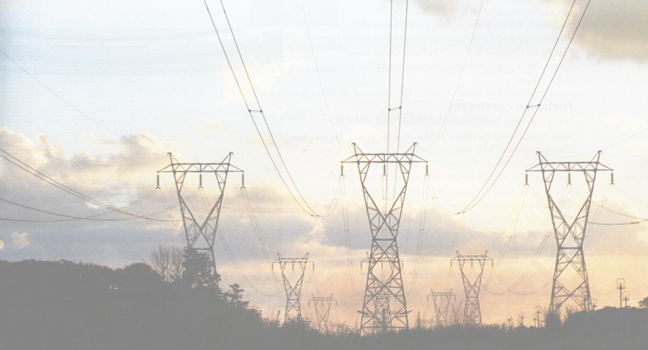 | The transaction that triggered the issue  Singapore Power’s acquisition of TXU’s Australian activities (which is still subject to ACCC approval) has triggered this very issue of vertical reintegration. Singapore Power had previously acquired PowerNet from GPU (now part of First Energy), meaning that completion of the TXU acquisition would effectively leave Singapore Power holding a prohibited interest under Section 68 of the Act.
Obtaining ACCC approval

The most obvious way forward would be for Singapore Power to divest PowerNet, despite having claimed that this will not be necessary. Such a transaction would be likely to attract a high degree of interest including that of fund managers.

Thanks to Phillips Fox for their assistance with the legal aspects of this article.

NZ – reshuffling the ownership

Stakes in two of NZ’s significant utilities are currently on the market….  - The New Plymouth District Council, the Taranaki Electricity Trust and the Powerco Wanganui Trust are jointly selling their combined 53.6% stake in Powerco.  - Edison Mission Energy is selling its 51% in Contact Energy. | 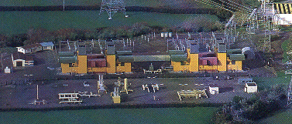
These sales are occurring against a backdrop of very active utility acquisitions in Australia as several US utilities exit their Australian investments and make way for Asian utilities to increase their interests. Pipes & Wires will be watching these transactions closely as some very interesting trends and strategies are likely to emerge.

Global update - supply essentials

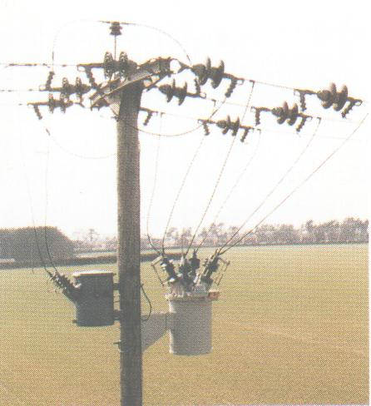 | Recent articles in Pipes & Wires have identified the following global trends and themes…  - Increasing concern over security of natural gas supply as existing reserves begin to deplete.  - Shifts in fuel mix away from nuclear and coal toward natural gas.  - Increasing concerns over transmission reliability.  - Volatility of wholesale prices as the industry moves to a less risk-managed position.  - The exit of US utilities from the third wave of global investment, and the rise of European and Asian utilities in the fourth wave.  - Regional consolidation of distribution utilities across national boundaries.  - The widespread recognition that unregulated merchant trading was not the huge success it was originally touted as.  Increasing regulation and a shift toward centralised planning.
The energy & utilities team at PricewaterhouseCoopers have recently put together their 2004 Utilities Global Survey entitled “Supply Essentials” which covers these issues (and several more) in a lot of detail and includes a survey of utility presidents. To request your copy of Supply Essentials, pick here.

Tell me how good this issue was…

Please pick one of the links below to tell me what you think of this issue of Pipes & Wires…

- Excellent

- Very good

- Good

- Average

- Poor

If you get this is a hard-copy, your comments can be emailed to issue#30@utilityconsultants.co.nz If you receive this second-hand by email, you can receive Pipes & Wires directly by picking here.

Disclaimer

These articles are of a general nature and are not intended as specific legal or consulting advice. They are correct at the time of writing. Utility Consultants Ltd accepts no liability for action or inaction based on the contents of Pipes & Wires including any loss, damage or exposure to offensive material from linking to any websites contained herein.

