Pipes & Wires

THE FREE MONTHLY CLIENT NEWSLETTER FROM UTILITY CONSULTANTS

Issue 31 – July 2004

From the director…

 | Welcome to Pipes & Wires #31. This issue starts by show-casing a methodology for improving confidence levels in the asset management spend.  We then do a brief up-date on the regulatory issues surrounding Singapore Power’s acquisition of TXU, followed by a brief analysis of the regulatory issues surrounding the Contact Energy sale.  This is followed by a summary-level discussion of how industrial and large commercial customers view price & quality trade-offs.  We then take a quick look at where the next electricity price control in the UK is going, and conclude with a quick look at Cap Gemini’s recent global update.

Having confidence in the asset spend

Introduction

Pipes & Wires #23 discussed the issue of getting the CapEx right. This article expands on that theme by considering how we can increase the confidence in all classes of asset spending.

Background

We first need to examine what the investment and reinvestment processes look like in an ideal world – this is shown in Figure 1 below….
Figure 1 – investment in an ideal world

Percent of asset meeting required condition

Deterioration
100%

Restoration
Asset condition relative to required condition

Actual condition
Ideal condition

Figure 1 shows how in an ideal world every component of an asset will start off in the ideal condition ie. there is no under-build or over-build. The asset components will deteriorate over time to some lesser condition, at which point funds are spent to restore the component condition back to the ideal. In this ideal world, all components deteriorate equally from a fully known condition to a fully known condition, from which absolutely certain spend processes restore the components to an ideal condition of no under-build and no over-build.

Unfortunately this ideal world remains beyond the grasp of most of us, and we instead live in a practical world of unknowns and uncertainties. Figure 2 illustrates these uncertainties which are as follows…

- The initial component conditions are spread about some mean position (we have illustrated this with a Gaussian curve) to reflect the inherent under-building and over-building that occurs.
- The deterioration process is not uniform across all components, hence the Gaussian curve above “smears” toward the actual condition. This in itself reveals that the actual condition of any individual component may not be accurately known.
- The restoration processes may have inherent uncertainties that further “smear” the intended return back to the ideal condition. Hence what we might think is a “restored condition” may in fact include a lot of under-build and over-build.
Figure 2 – investment in a practical world

Starting condition

Deterioration
100%
Ending condition
Restoration

Asset condition relative to required condition

Actual condition
Ideal condition

Creating confidence in the spend

Estimates of the confidence in the actual condition of the components and the robustness of the restoration processes can lead to some surprising answers. Consider an asset class such as 33/11kV transformers – we may be 80% confident of the actual condition, and be 70% confident that our restoration processes are robust. This means we are only about 56% confident that the spend plan will actually restore all the transformers to the ideal condition.

If we consider assets such as cables and pipes that are both geographically dispersed and difficult to examine, it is easy to see how these two confidence measures can combine to give a low overall confidence in the asset spend.

To discuss how you can improve the confidence in your asset spend, pick here or call Phil on +64-7-8546541.

Aus – prohibiting vertical reintegration

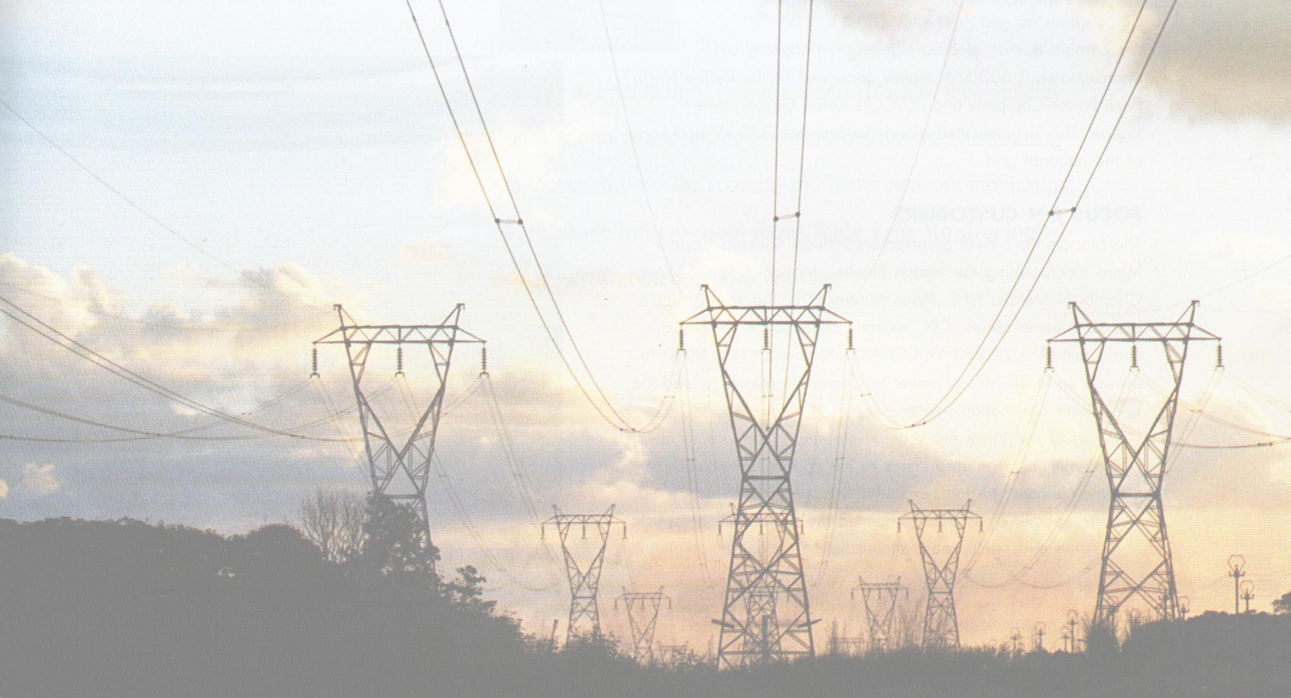 | Background  Pipes & Wires #30 discussed SingPower’s recent acquisition of TXU’s Australian businesses, and how this would breach the prohibition on vertical reintegration in Victoria.  Recent events  As we discussed in this article, one option to obtain ACCC clearance for the acquisition would be for SingPower to divest SPI PowerNet. It is understood, however, that SingPower is negotiating with the
ACCC to retain ownership of PowerNet but possibly distance itself from operational control. We will comment further on this as matter become clear.

NZ – Contact Energy sale hits the competition hurdle
Introduction

Pipes & Wires #30 briefly mentioned Edison Mission Energy’s move to sell its 51% stake in Contact Energy. However two competition issues have recently been identified…

- The possibility of a reduction in the number of industry players controlling the Maui gas market.

- The possibility of increased vertical integration amongst the electricity and gas industries.

The Maui gas issue  The remaining Maui gas allocation is split amongst Contact Energy, NGC, Methanex and Genesis Energy. Any consolidation of ownership would almost certainly breach s47(1) of the Commerce Act 1986, and would therefore either be prohibited or require suitable concessions to be made.  The vertical integration issue  There maybe the potential for some possible buyers of Contact Energy to vertically reintegrate the energy supply chains. While this may not breach any of the line & energy separation requirements of the Electricity Industry Reform Act 1998 it may enable uncompetitive behavior.  This is likely to be a major matter for the NZ energy sector to deal with both in terms of transaction magnitude and regulatory concerns. Pipes & Wires will comment further as this matter progresses. | 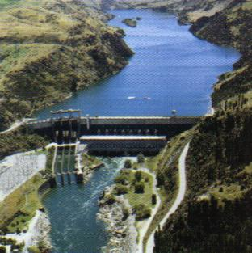

NZ - Giving choice to the customer

 | Introduction  The most recent price path threshold included a requirement for all lines companies to consult with their customers about the supply quality and price trade-offs available to them. This has forced the industry (and its advisors) to have a long hard think about what supply quality really means, and how realistic it is to offer alternatives. The broad conclusion is that quality is a common good, and it is generally not possible to provide differing levels of quality to all but the very largest customers.  Justifying the existing level of supply quality  As part of their asset management plans (AMP’s), line companies are projecting SAIDI
5 to 10 years ahead. As part of advising several lines companies on modifying their AMP’s, we have considered how a lines company justifies a SAIDI of, say, 120 minutes and not some lesser (or greater) figure.

The short answer to this is that historical decisions have contributed to an inherent level of reliability that is not easily changed. For instance the decision by some utilities to reduce the cement content of concrete poles during World War 2 created a lower inherent reliability that persisted for about 50 years. Similarly the decision by some utilities to install the first generation of XLPE cable that was prone to condensation within the insulation created a lower inherent reliability that is still persisting 30 years later.

Hence justifying the existing SAIDI hinges around two factors – the inherent level of reliability that previous investment decisions have created, and the ability to fund the level of reinvestment necessary to maintain the existing SAIDI or conversely to improve the SAIDI.

Justifying variations from the existing level of supply quality

Most of us have all heard anecdotal evidence that various classes of consumers may or may not be prepared to pay more to have more “quality”. It is also starting to emerge that many customers would not be prepared to pay less to have less “quality”, which strongly endorses the status quo combination of quality and price.

As part of advising lines companies on the customer consultation, we were able to gather the views of 167 industrial and large commercial customers. Of these customers, 17% indicated they would “consider” paying more for more reliability, but only 1% indicated a willingness to pay less for less reliability. These two related but distinct issues are outlined on the following chart…

17% would consider moving this way
Price

Only 1% would consider moving this way

Justify status-quo position

SAIDI

If anyone wishes to contribute further data from either industrial and large commercial, or from residential customer groups so this article can be re-run more comprehensively, please pick here to contact me.

UK – the next electricity price control
Introduction

OFGEM’s work on the price control for the 5 years beginning 1 April 2005 is well under way, and it’s very clear that the levels of investment necessary to sustain secure reliable supply will be much greater than for the current control period.

Correctly incentivising the investment  Most of the lines businesses are projecting significant increases in CapEx for the control period over and above current levels, with the exception being Western Power’s South Wales business that is projecting a decrease in CapEx of 14%. These proposed levels of investment suggest that a high degree of renewal is necessary in most areas of the UK hence OFGEM wishes to ensure that this investment is efficient.  One of the key mechanisms that OFGEM is consulting with lines businesses on is the proposed use of a sliding scale return on under and over- investment. This mechanism will also reward lines businesses that can deliver agreed investment outcomes at a lower than projected cost.  The proposed price controls  The previous and current price controls have included a big | 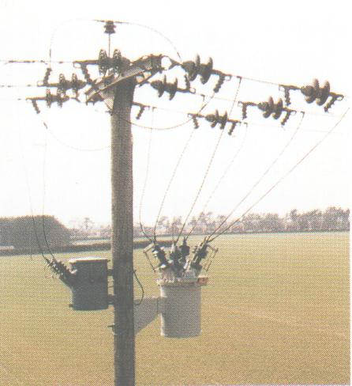
initial re-set that is noticeably absent from the proposed 2005 control (positive numbers represent decreases)…

Control period | Re-set for Year 1 (P₀) | Cap for Years 2 to 5 (X)
1 April 1995 – 31 March 2000 | 25.5% | 3%
1 April 2000 – 31 March 2005 | 24.5% | 3%
1 April 2005 – 31 March 2010 | 2% | 1%

The smaller re-set reflects the higher proposed CapEx for the coming period, although it must be noted that this P₀ is a nation-wide average of widely varying figures. For more information, visit OFGEM’s website.

Global update – deregulation

The energy, utilities & chemicals team at Cap Gemini has recently published its third global utilities survey entitled “Deregulation – meeting the delivery & sustainability challenges”.

This study comprises 130 interviews with utility executives in Western Europe, North America and Asia Pacific who provide a range of views on how well deregulation is serving the customer. Not surprisingly, many of the issues raised center around themes of correctly incentivising long-term investment in both generation and networks. Pick here to obtain your copy of this report.

Tell me how good this issue was…

Please pick one of the links below to tell me what you think of this issue of Pipes & Wires…

- Excellent

- Very good

- Good

- Average

- Poor

If you get this is a hard-copy, your comments can be emailed to issue#31@utilityconsultants.co.nz If you receive this second-hand by email, you can receive Pipes & Wires directly by picking here.

Disclaimer

These articles are of a general nature and are not intended as specific legal or consulting advice. They are correct at the time of writing. Utility Consultants Ltd accepts no liability for action or inaction based on the contents of Pipes & Wires including any loss, damage or exposure to offensive material from linking to any websites contained herein.

