Pipes & Wires

THE MONTHLY CLIENT NEWSLETTER FROM UTILITY CONSULTANTS

Issue 32 – August 2004

From the director…

 | Welcome to Pipes & Wires #32 … this is a slightly longer issue that covers the flurry of activity in this corner of the globe over the last month.  Firstly we examine the regulatory and competition issues surrounding Singapore Power’s acquisition of TXU and International Power’s acquisition of Edison’s assets.  We also discuss the sales of the Contact Energy and the Powerco stakes, as well as examining the proposed bail-out of British Energy.  Finally we examine the electricity lines price determination in NSW and the draft water & wastewater price determinations in the UK.

Aus – prohibiting vertical reintegration

 | The vertical reintegration issue surrounding SingPower’s acquisition of TXU’s Australian business that we have discussed in Pipes & Wires #30 and #31 has drawn to a close, and will allow the transaction to be settled.  Precise details of the arrangement have not been released by the ACCC, but it is thought that the “court-enforceable undertakings” made by SingPower will require separation of the management of its generation (Torrens’ Island and
the Ecogen master hedge) from PowerNet. It was initially thought that some eventual sell-down of a stake in PowerNet was likely, but it now appears that on-sale of the generation and possibly the electricity retail business would be more likely and more in line with SingPower’s focus on regulated businesses.

NZ – Origin Energy captures the Contact stake

The deal  Origin Energy has recently signed a conditional deal to buy Edison Mission Energy’s 51.2% in Contact Energy beating rival Australian Gas Light who are rumored to have lost out by only $50m. Origin will pay Edison a total consideration of $1.675b including $535m in assumed debt that values their bid at $5.67 per share. AGL’s bid is rumored to have represented a total consideration of $5.50 per share. | 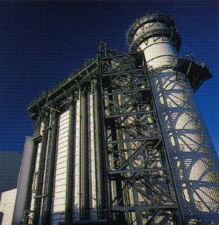
The Takeovers Code provisions

Under the Takeovers Code, Origin must now extend the same $5.67 offer to all of Contact’s 110,000 shareholders, which is expected to occur over the next few weeks. Given that recent trading prices nudged $6.00 and institutional investors valued the shares around $7.00, it
would seem unlikely that any other shareholders will sell – a position that apparently suits Origin’s desired stake holding.

Origin’s likely stance on gas exploration

One of the most immediate issues to arise is whether Contact will continue to explore for new gas reserves, and early media reports certainly indicate that this will happen.

Continuity of gas supply is critical to extracting value from the combined-cycle plants in Auckland and Stratford, and Origin is well placed to strengthen Contact’s exploration activities. Although exploration carries risks of its own, it would seem that the risk of not seeking new gas would be a greater threat to investors.

Aus – funding the CapEx in NSW

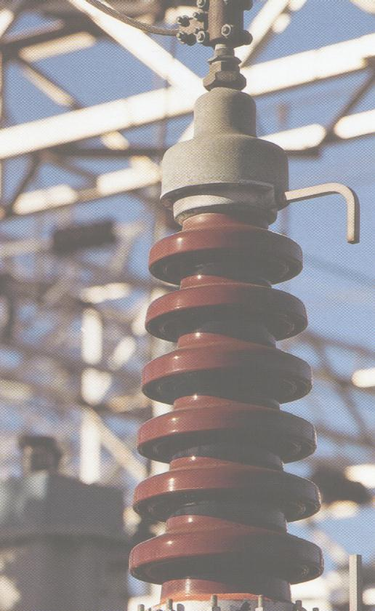 | Introduction  Pipes & Wires #31 discussed the proposed electricity price control in the UK for the 5 years beginning 1 April 2005 in the specific context of the significant increases in CapEx proposed by 13 of the 14 distribution businesses. This article examines similar issues in the recently commenced 5 year price control period that applies to the 4 electricity distribution businesses in the Australian state of New South Wales.
Two key issues

IPART’s final report outlines the following two key issues…
- Average demand in NSW has increased 31% over the last 7 years, with peak demand increasing even more (hence asset utilisation is declining).
- New assets have been funded at the expense of replacing or refurbishing existing assets.

The 4 distribution businesses collectively proposed a CapEx of about A$8b over the 5 year control period which IPART agreed is mostly justified.

The price controls

The price paths sought by each of the 4 distribution businesses and
the price paths approved by IPART are summarised in the table below (positive numbers represent increases). Most of the difference between the price paths sought by the applicants and those approved by IPART relates to the proposed opening asset values and proposed rates of return which IPART believed were excessive.

Distribution business | Re-set for Year 1 (P₀) |  | Cap for Years 2 to 5 (X)
Distribution business | Sought by the applicant | Approved by IPART | Sought by the applicant | Approved by IPART
EnergyAustralia | 19.4% | 7% | 1% | 1.6%
Integral Energy | 11.1% | 5% | 1% | 1.5%
Country Energy | 13.2% | 7% | 5.7% | 2.5%
Australian Inland | 15.6% | 7% | 6.6% | 2.5%

UK – bailing out British Energy

Background

Pipes & Wires #20 examined the key reasons for British Energy plc’s journey to the edge of bankruptcy – declining wholesale prices, lack of retail hedges and high fixed-costs. As wholesale prices begin to climb and British Energy’s equity becomes more attractive, a recovery deal has been proposed that will essentially re-nationalise Britain’s PWR and AGR power stations.

The proposed deal

In a proposed deal worth ₤5b, the UK government would end up holding about 65% of the shares and existing bond holders would assume a 33% shareholding through a debt-for-equity swap. This would leave existing shareholders with a 2.5% stake which has got them understandably angry.

Does nuclear power have a future ??  After considering British Energy’s woes it would be easy to form the impression that nuclear power is not commercially viable. We could probably toss in other examples such as Ontario Hydro’s stranded debt that has been sequestered into a state corporation and will be retired by a levy.  It is difficult to form a clear conclusion, but it would seem fair to say that nuclear plants built by government-owned utilities such as the CEGB and Ontario Hydro don’t appear to be sustainable in a wholesale market. At a time when the convergence of issues such as climate change and new technologies are renewing interest in nuclear power it would seem sensible that the energy policy debate considers some sort of nuclear program that is partially sheltered from wholesale market extremes through subsidies that recognise its likely future benefits. | 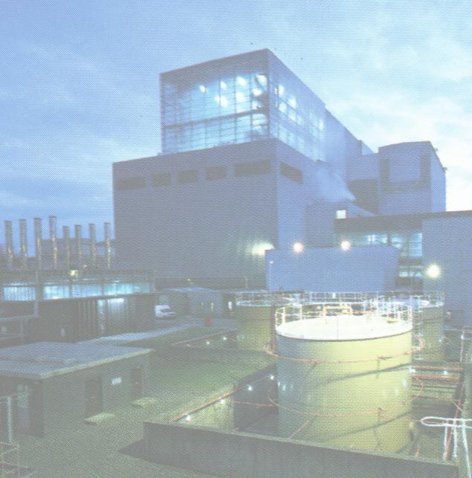

Aus – market dominance in Victoria
Introduction

As the sun sets on the era of heavily-levered global acquisitions by US utilities, the remaining utilities that have both the appetite and the balance-sheet capability for global acquisitions are declining in number. Many of these utilities have already built global investment portfolios on what appear to sustainable bases, so further acquisitions are likely to raise the issue of horizontal and / or vertical reintegration which is generally prohibited in most jurisdictions.
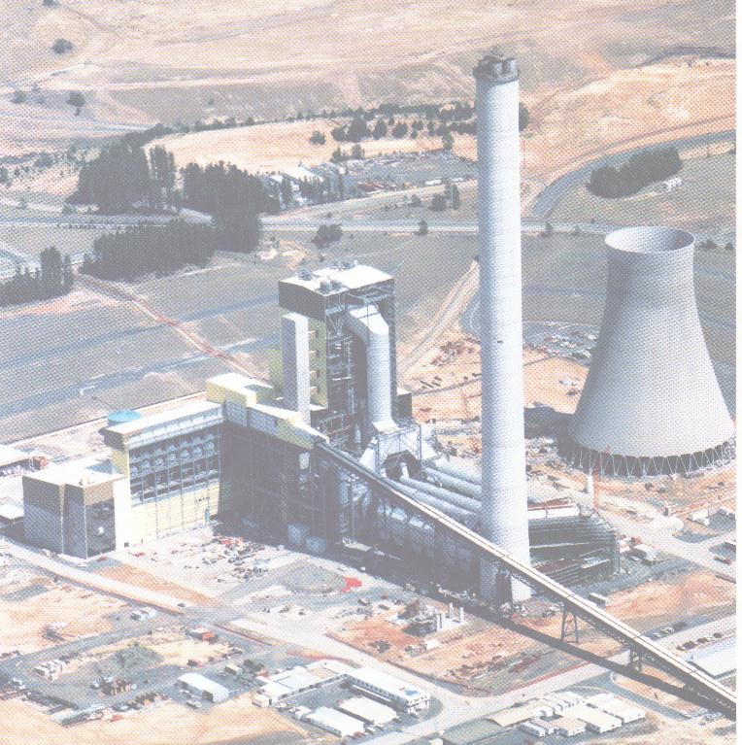 | Background  We’ve already examined the vertical reintegration issues surrounding Singapore Power’s acquisition of TXU’s Australian business, and hot on its’ heels is Edison’s global retreat (which has already been mentioned in this issue) which may raise horizontal reintegration issues in the Australian state of Victoria.  International Power plc which already owns the Hazelwood Power Station in Victoria (and the Synergen and Pelican Point plants in South Australia) was the successful bidder for Edison’s Loy Yang B and a 60% stake in the Valley Power Peaker plant in a 70:30 venture with Mitsui Corporation.  The regulatory issues  International Power’s bid has been examined in two areas…
- By the ACCC for a possible breach of s50 of the Trade Practices Act 1974 that prohibits mergers or acquisitions that would substantially lessen competition (similar to s47 of the New Zealand Commerce Act 1986).

- By the Essential Services Commission for a possible breach of the cross-ownership prohibitions in s68(2) of the Electricity Industry (Victoria) Act 2000. The key issue here is that because International Power already holds a controlling interest in the generation license for Hazelwood, holding a controlling interest in another generation license would be prohibited under the s68(2)(a) of the Act.

If the ACCC is satisfied that the acquisition will not breach s50 of the Trade Practices Act, s68(8) of the Electricity Industry Act allows the Essential Services Commission to make a determination which has the effect that the interest is not prohibited in terms of s68(2).

The determination

The ESC has made a determination that essentially comprises two elements which follow the bullet points above…

- International Power has made certain undertakings (which are confidential) to the ACCC pursuant to s87(b) of the Trade Practices Act. The ACCC is satisfied that these undertakings will ensure that the transaction will not breach s50 of the Trade Practices Act and has advised International Power that it will not take any action.

- The ESC is satisfied that the ACCC has considered the proposal and has indicated that it does not intend to take action under s50 of the Trade Practices Act.

The public policy issues

Perhaps it’s time to ask the “what if” question alluded to in the introduction – “what if the only entities willing to invest in existing and new capacity are those who already hold substantial interests, and they are prohibited from making further investments”.

As many of us talk about the “industry’s need” for new investment, it is often overlooked that customers’ interests are inherently tied to the level of investment the industry is able to attract. The essence of this question is about balancing short and long-term customer needs, and is not to be taken as a criticism of the decisions made to date. Rather it should signal that at some future point the “substantial lessening of competition” wisdom applied to date might need to give way to some other test that better reflects customers’ long term interest in attracting investment.

UK – progress on the next water price control

Introduction

OFWAT has recently released its draft determinations for the 5 year control period from 1 April 2005 to 31 March 2010. In line with OFWAT’s earlier indication that tariffs would need to increase over this control period, the draft determination proposes an increase of ₤33 per year in real terms for the “average customer” by the end of the control period.

The continuing pursuit of efficiency

Water utilities have continued to beat the efficiency targets set in previous control periods, although to a lesser extent as the efficiency gains have been exhausted. However, OFWAT has broadly concluded that water utilities have under-estimated the scope for future efficiency gains relative to the whole economy for the next control period and has accordingly proposed an arrangement of “sticks & carrots” to incentivise efficiency gains.

Issues facing this control period  The issues reflected in this period’s draft determinations include…  - Increased numbers of new connections, particularly in the south and east.  - Maintaining customer service levels.  - Changes to taxation.  - Increased pension costs.  - Improving drinking water quality.  - On-going improvement of discharge quality.  - A slight increase in WACC.  - The need to reduce sewer flooding. | 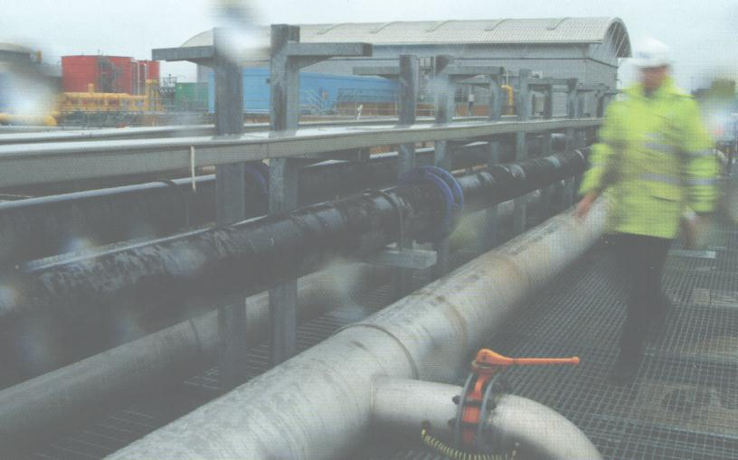
The proposed price controls

In addition to the conclusions reached about the scope for future efficiency gains, OFWAT also believes that the water utilities have over-estimated the costs of delivering their business plans. Accordingly, the draft tariff increases are only about half of those sought by the utilities…

 | Sought by the applicants | Draft determination
Water & sewage utilities | 6.3% | 3.2%
Water only utilities | 5.5% | 2.2%
Industry-wide | 6.2% | 3.1%

The draft determinations are open for consultation, and it is expected that final determinations will be made in early December 2004.

NZ – Prime Infrastructure captures the Powerco stake

The deal  Prime Infrastructure has announced a conditional offer for the 53.6% stake in Powerco that has been offered for sale by the New Plymouth District Council, the Taranaki Electricity Trust and the Powerco Wanganui Trust. Prime will pay a total of $360m for this equity stake (comprising $225m in cash and the balance in bonds paying 8.5%) that equates to $2.15 per share, as well as assuming $868m of existing senior Powerco debt. | 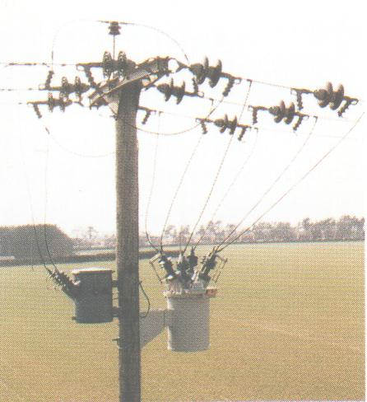
The Takeover’s requirement

The provisions of the Takeovers Code will require Prime to extend the same $2.15 per share offer to all of Powerco’s other shareholders. These shareholders can choose to be paid in cash, in bonds, or in a combination of the two. Prime expects that there will be a high up-take of this offer.

The industry upheaval

So where does this leave the current industry upheaval – there are now two less balls in the air to keep an eye on. The balls that are still in the air are NGC’s negotiations with Vector, and AGL’s possible exit from NZ. Pipes & Wires will be keeping a close eye on these two balls and commenting as events occur.

Just as a closing note – the emerging trend seems to be for energy businesses to be acquired by trade players, whilst regulated businesses are being acquired by investment vehicles.

Get your share of $2 billion of council business !!!
Each year council's publish their plans to spend well over $2b on their local roads, water supplies, wastewater utilities, community facilities, parks and reserves and administrative assets.  The CAPEX Annual is a complete reference source which details all of the major capital works of NZ councils. The listings include all of the projects proposed for which your firm may be interested in bidding. The CAPEX Annual is a valued reference source for many businesses throughout New Zealand.  Further details of CAPEX Annual can be obtained by picking here. Pick here to email the publisher Larry N. Mitchell.  The CAPEX Annual 2004/2005 CD-ROM is available for delivery now - the need for prompt, timely information has been met. We would like to invite you to share in early ordering of this year's CAPEX Annual. | 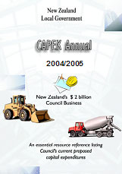

Tell me how good this issue was…

Please pick one of the links below to tell me what you think of this issue of Pipes & Wires…

- Excellent

- Very good

- Good

- Average

- Poor

If you get this is a hard-copy, your comments can be emailed to issue#32@utilityconsultants.co.nz If you receive this second-hand by email, you can receive Pipes & Wires directly by picking here.

Disclaimer

These articles are of a general nature and are not intended as specific legal or consulting advice. They are correct at the time of writing. Utility Consultants Ltd accepts no liability for action or inaction based on the contents of Pipes & Wires including any loss, damage or exposure to offensive material from linking to any websites contained herein.

