Pipes & Wires

THE MONTHLY CLIENT NEWSLETTER FROM UTILITY CONSULTANTS

Issue 33 – September 2004

From the director…

 | Welcome to Pipes & Wires #33 - its’ a busy time for the global gas pipes industry with 3 major transactions on the go which are covered below. We also examine AEP’s exit from the UK in a move that further re-shapes the UK power industry.  On the legislative fronts we examine California’s consideration of re-de-regulation (if that’s actually a word) and progress on the Electricity & Gas Industries Bill in New Zealand. Also on the legislative front I’ve been teaching a class in Energy Policy Reform at the University of Waikato School of Law over the last 2 weeks.  We conclude this issue with a discussion of the review of Australia’s Gas Access Regime. So …. Happy reading until next month.

NZ – Australian Gas Light heads for home

Background  Pipes & Wires #32 indicated that Natural Gas Corporation (NGC) was the ball in the air, and its future was heavily dependent on its 66.05% shareholder, Australian Gas Light (AGL). Most of had our suspicions that AGL would exit the NGC stake after failing to capture either the Contact Energy or Powerco stakes, and this suspicion was confirmed late last month when AGL announced its intended exit. | 
Possible bidders

Interested bidders may include the Australian Pipeline Trust (APA), Prime Infrastructure, Singapore Power, DUET, Alinta, Cheung Kong Infrastructure and VECTOR . However it’s an awkward time as several of these parties already have balls in the air in one corner of the world or another.

Unlocking NGC’s value

A major upside of NGC is the strategic value of its prepaid gas supplies, whilst a possible downside is that because NGC is such a complex business it’s hard to see a total alignment with any one of these bidders’ core competencies. The nature of the component businesses could, however, permit on-selling of assets to occur without too much loss of synergy value, but that would be difficult to achieve without a full takeover (for which an offer must be made under the Takeovers Code anyway).

It’s likely to be a few more days before the sale process really moves ahead, and when it does Pipes & Wires will be watching.

UK – American Electric Power heads for home

 | Background  Earlier last month American Electric Power (AEP) announced the sale of its’ Fiddlers’ Ferry and Ferrybridge power stations to Scottish & Southern Energy plc. Both of these stations have four 500MW coal-fired units and are located in Cheshire and West Yorkshire respectively.
The transactions

AEP purchased the two stations from Edison Mission Energy in 2001 for US$960m, which included electricity, coal and freight contracts. AEP sold the stations to S&SE for a total consideration of US$456m of which the generating plant represented US$248m. This halving of value has undoubtedly been driven by declining wholesale prices.

Industry structural changes

The major structural change in the industry occurred as the retail function shifted from lines to generation – generators all over the world embarked on forward integration strategies to lock in markets for their energy and avoid wholesale price volatility. Now that the issue is for security of both installed capacity and fuel supply, the trend is for retailers to backwardly integrate into generation.

Aus – update on the Dampier – Bunbury Pipeline
Introduction

Most of us are only too aware of Epic Energy’s difficulties with the Dampier – Bunbury Natural Gas Pipeline (DBNGP). The pipeline was recently placed into receivership by a consortium of banks that were owed a total of A$1.85b. Underscoring this were strict instructions to the receiver not to accept lesser bids.

Interested bidders  Three parties submitted acceptable bids by the closing date…  - Australian Pipeline Trust (APA) despite the withdrawal of its Canadian partner Enbridge.  - Investment bank Babcock & Brown.  - A consortium of DUET (60%), Alinta (20%) and ALCOA (20%).  Envestra missed the closing time, and had requested a “short extension” to finalise the details of its bid. | 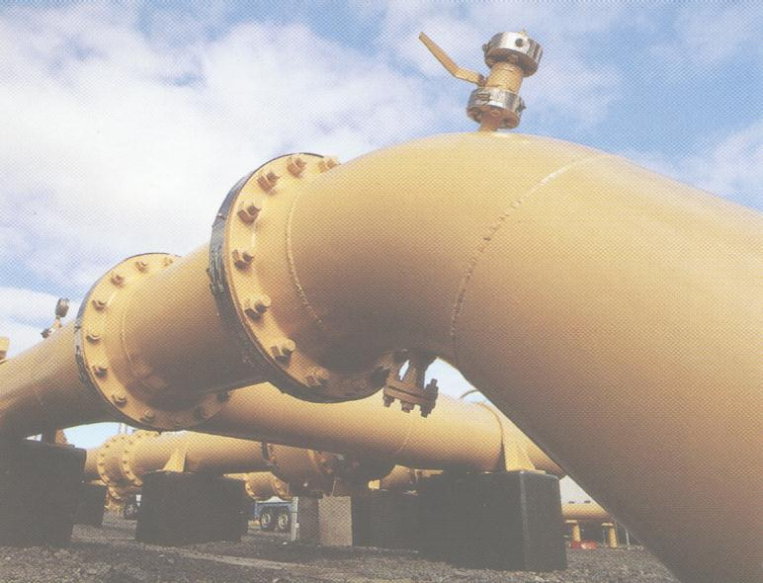
Regulatory issues

Although there are no statutes in Western Australia specifically prohibiting vertical reintegration of gas transmission and distribution, both the state government and the ACCC had expressed concern that a major customer of the pipeline might also become its owner.

Security of gas supply issues

The other issue the state government is watching is the security of gas supply. Expanding the pipeline’s capacity from the current 520TJ per day to about 700TJ per day was one of the key aspects of the original sale which bidders were instructed to make allowance for. Due to the tariff dispute, no expansion has occurred and it is expected that shortfalls in gas transmission capacity could lead to electricity shortages as early as 2005.

A winner emerges

After only several days’ evaluation, the DUET / Alinta / ALCOA consortium emerged as the winner with an offer of A$1.85b. In response to the ACCC concerns the consortium has made several enforceable undertakings including a commitment to expand capacity, a commitment to ring-fence Alinta from commercial negotiations, and a commitment not to seek revocation of coverage under the Gas Code.

And so the Epic journey finally comes to an end….

US – California considers deregulation (again !!)
 | Background  As demand soars toward 46,000MW, Democrats and Republicans slug it out over the exact content of Assembly Bill 2006 which in its present form distinctly favors vertically integrated utilities over merchant generators. Merchant generators such as Calpine have argued that excluding them will fail to create real competition, whilst regulated utilities such as SoCalEd argued that any thought of re-deregulation is simply asking for more trouble.  AB2006’s proposed regulatory framework  The key component of AB2006 that has got Republicans steamed is that customers
with a maximum demand of less than 500kW can only be supplied on a cost-of-service basis either by the utility building its own plant or by that utility purchasing energy from a merchant generator. The Republicans argue that this cost-of-service regulatory framework will lead to inefficient investment, and that putting merchant generators in a secondary position will lead to a shortfall in capacity.

AB2006’s progress

Despite Republican opposition, AB2006 was approved by the Democrat-dominated Assembly in May and passed to the Democrat-dominated Senate where it has been read, amended, re-read, re-amended, and bounced around three sub-committees. The final hurdle is almost certain to be Governor Schwarzenegger who strongly favors allowing merchant generators to enter the industry.

NZ – progress on the E&GIB

Background

Pipes & Wires #29 outlined the objectives of the Bill, and its structure. This article examines the amendments arising from the Select Committee in June.

Amendments to the Bill  Key amendments to the Bill are as follows….  - Trust-owned electricity providers will be prohibited from paying a different (presumably lesser) discount or rebate to customers on low fixed-charge tariffs solely because that customer has chosen to be on a low fixed-charge tariff.  - An insertion to the Bill ensures that the Electricity Commissions powers can only be used as a last resort.  - A recommendation that the Electricity Act 1992 be amended to remove the Minister’s powers to direct the Electricity Commission. | 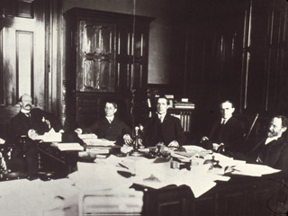
- A requirement for the Electricity Commission to consult industry participants in levying fees.
- The ability to transfer jurisdiction for all large lines businesses except Transpower from the Commerce Commission to the Electricity Commission is to be deferred until 31 March 2009.

Pick here and here to download detailed commentaries on the Bill.

Progress on the Bill

The Bill completed its’ second reading on 10 August, and was debated by the House on 1 September. The remaining steps are the clause-by-clause debate by the full house, the third reading, and royal ascent. Thanks to Phillips Fox for their assistance with this article.

UK – Transco sells regional gas pipes businesses

Background

The long-awaited sale of four of National Grid Transco’s regional distribution networks has finally been announced (subject to various regulatory approvals). NGT will sell these four networks for a total of ₤5.8b.

The sales

The proposed individual sales are as follows…

Regional network | Intending acquiror | Sale price
Northern England | Consortium including Cheung Kong Infrastructure and United Utilities plc. | ₤1.4b
Wales & Western England | Macquarie European Infrastructure Fund. | ₤1.2b
Scotland | Consortium including Scottish & Southern Energy plc, Borealis Infrastructure Management and the Ontario Teachers Pension Plan. | ₤3.2b
Southern England |  | ₤3.2b

NGT will retain ownership of the West Midlands, London, East England and North-West England distribution networks.

NGT’s plans

NGT plans to use the sale proceeds as follows…

- A capital return to shareholders of ₤2b.
- Retirement of ₤2.3b of debt.
- Boost this years’ dividend from 20p to 23.7p per share along with an expected dividend increase of 7% through to March 2008.

NGT has also indicated an interest in increasing its electricity transmission activities in the US.

Strategies of the intending buyers

Geographical penetration with existing water and / or electricity networks would appear to be a major component of United and S&SE’s strategies. My guess is that bundling multi-utility services, synergies from activities such as meter reading and field services, and increasing the scale of back-office services will create synergies worth several tens of millions of pounds per year.

Aus – the Gas Access Regime review

Background

In June 2003 the Productivity Commission was instructed by the Treasurer to conduct a review of the Gas Access Regime and to report back within 12 months. One of the terms of reference of the review was to assess the benefits, costs and effects of the Regime, including its effect on investment in the sector and on upstream and downstream markets. The final report was recently released and forms the subject of this article.

Key findings of the review

One of the key issues raised in the final report is that although competition and interconnection of transmission pipelines has increased and is beginning to limit market power, it has not yet reached the point where an Access Regime is unwarranted. The report does, however, acknowledge the current Access Regime is problematic in the following areas…

- The costs the Access Regime imposes, particularly in gathering and processing the large amounts of information regulators need to fulfill their responsibilities.
- The potential to distort investment patterns toward lower risk projects or delay new investment through uncertainty over various parameters such as the WACC.
- The potential to inhibit innovation.
- The whole legal framework has potentially conflicting objectives.

The report goes on to recommend a range of amendments along the lines of (and these are my words) “the Access Regime was fine while the industry moved from a vertically-integrated state-owned structure but now it needs some tweaking to address future growth and investment requirements and the declining market power of some individual pipelines”.

The next steps

You might want to consider taking the following steps…

- Assess the likely impact of the reports’ recommendations on your key revenue, cost and valuation parameters.
- Persuading state and Commonwealth officials to adopt the favorable recommendations of the report.

Utility Consultants has teamed up with Phillips Fox to provide a full advisory service that includes policy, legal, lobbying, regulatory economics, corporate strategy, financial and asset management experience. Please pick here to email us, or phone Phil on +64-7-8546541 or Simon on +61-3-92745470.

Conferences & events

- NZ 2004 SCADA Summit – Auckland (27 – 28 September 2004)

- NZ Power Summit – Auckland (15 – 16 March 2005)
Tell me how good this issue was…

Please pick one of the links below to tell me what you think of this issue of Pipes & Wires…

- Excellent

- Very good

- Good

- Average

- Poor

If you get this is a hard-copy, your comments can be emailed to issue#33@utilityconsultants.co.nz If you receive this second-hand by email, you can receive Pipes & Wires directly by picking here.

Disclaimer

These articles are of a general nature and are not intended as specific legal or consulting advice. They are correct at the time of writing. Utility Consultants Ltd accepts no liability for action or inaction based on the contents of Pipes & Wires including any loss, damage or exposure to offensive material from linking to any websites contained herein.

