Pipes & Wires

THE MONTHLY CLIENT NEWSLETTER FROM UTILITY CONSULTANTS

Issue 35 – November 2004

From the director…

 | Welcome to Pipes & Wires #35. This issue has a distinct New Zealand and Australian content, but then a lot is happening “down-under”.  We begin with updates on some big deals in New Zealand and Australia, and then have a brief discussion of financial transmission rights as a lead-in to the expected industry consultation period.  We then examine some regulatory matters – a cost of capital issue, the shape of the impending 3 year water price controls in Victoria, Australia, and how the passage of the Electricity & Gas Industries Bill has re-shaped the regulatory and governance boundaries of the New Zealand electricity & gas sectors.

NZ – update on the Powerco and NGC sales

Following on from Pipes & Wires #34, we’ll present a progress update and analysis on the sale of Powerco to Prime Infrastructure and the sale of AGL’s 66.05% stake in NGC to Vector.

The Powerco sale  Prime Infrastructure’s offer to purchase Powerco shares closed earlier this month with a 94.6% acceptance, which is sufficient for Prime to compulsorily acquire the outstanding shares. After a month that sorely tried the Takeovers Panel in regard to share and bond holdings with Australian registered addresses, the Overseas Investment Commission recommended to the Minister of Finance that the deal be approved. It appears, however, that the Minister was reluctant to approve the deal but | 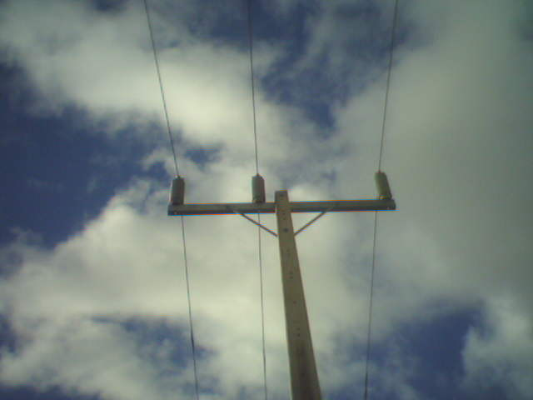
was advised that a decision to decline the deal could probably be over turned by a judicial review.

The NGC sale

Vector’s conditional bid for 66.05% of NGC seemed to be going very well – almost too well - until it hit a slight snag on 2 November. An exemption from the requirements of the Takeovers Code had been sought to enable Vector to acquire AGL’s New Zealand holding company AGL (NZ) Ltd (which holds 64.2% of the shares) instead of actually acquiring the NGC shares, but the Takeovers Panel declined to grant an exemption. Vector subsequently indicated that it will jointly discuss with AGL the alternative ways of acquiring the shareholding that formed part of the initial sale agreement.

Aus – the end of the Epic journey

Background

After a long and drawn-out process a consortium comprising DUET, Alinta and ALCOA has finally been confirmed as the new owners of the Dampier – Bunbury Natural Gas Pipeline (DBNGP) for a consideration of $1.86b.

The underlying gas contracts

The sale process was complicated by the lack of a completed agreement between the DBNGP owner and the key users. A finalised 25 year deal between the consortium and key users (which includes Western Power, Alinta and ALCOA) has ended months of discussions and enabled the sale & purchase to go unconditional. It is understood that the negotiated tariffs are greater than those originally proposed.

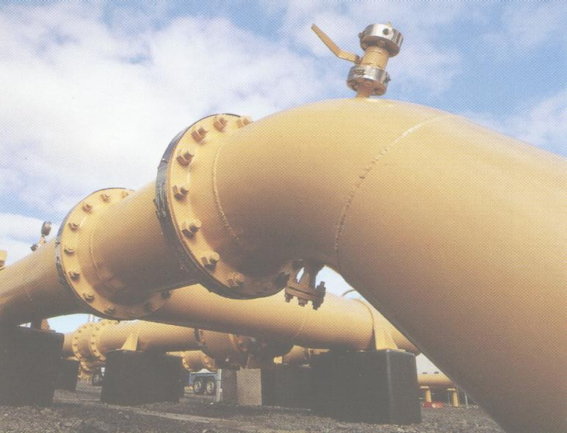 | Plans for the future  The DBNGP’s average daily throughput of 550TJ is currently insufficient to supply all users, even to the point of predicted power blackouts this summer. The consortium has committed to expanding the capacity by an additional 100TJ per day over the next 4 years. It is understood that the state government will provide financial assistance for this expansion.  The end of an Epic journey  So the Epic journey has finally come to an end, the Gas Code has been exhaustively examined and re-examined,
and Epic’s shareholders lost about $500m. Hopefully this won’t dampen investors’ enthusiasm for Australian (and New Zealand) infrastructure.

NZ – moving toward Financial Transmission Rights

What are FTR’s ??

Financial Transmission Rights are financial instruments that entitle the holder to be compensated (or in some circumstances to pay compensation) when the holders ability to transact business between two nodes of a transmission grid becomes restricted. These restrictions are also referred to as “constraints” or “congestion” whilst FTR’s are also known as “Financial Congestion Rights” or “Transmission Congestion Contracts”.

What exactly is a constraint ??  Transmission lines have a finite capacity governed by the physical properties of the conductors which gives rise to “line losses”. Once that finite capacity is reached the line becomes “constrained” and the losses become excessive. Capacity constraints are usually deemed to occur when a line carries more than a certain percentage of its rated current for more than a specified duration.  The complex math that is used to simulate transmission grids models the effect of line losses by assigning different prices for delivered energy to different nodes. These are referred to as “nodal prices” and can be significantly different on either side of a constraint. Intuitively, relieving the constraint by increasing the conductor rating will cause the nodal price difference to collapse to the level of the losses.  What is the effect of losses and constraints ??  Put simply a constraint limits the amount of electricity that can be | 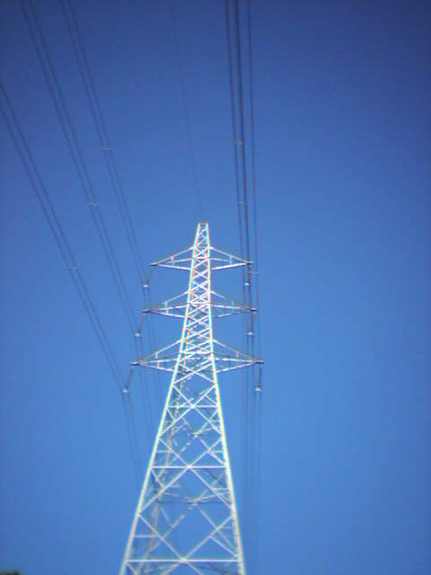
transmitted along a line. Transmitting electricity across a constraint from a low-cost generator may in fact cost more than running a high-cost generator on the same side of the constraint as the load. This distorts the usual least-cost dispatch process as out-of-merit plant may be scheduled to run and gives rise to what in New Zealand are referred to as loss & constraint rentals. This total pool of loss and constraint rentals is rebated to distributors by Transpower in proportion to where Transpower gathers its revenue from.

Mixed hydro-thermal systems such as New Zealand can have very volatile loss & constraint rentals, meaning that a distributors annual Transpower charges can vary dramatically year on year. Although these loss & constraint rentals may only be a few percent of a distributors line charges, they can be very high for individual half-hours.

What can FTR’s do ??

FTR’s are a more precise way of “staking a claim” to the pool of loss & constraint rentals and act as a perfect hedge against transmission losses and congestion. FTR’s are funded from the pool of loss & constraint rentals, and are usually allocated by auction. Being allocated an FTR entitles the owner of the FTR to be compensated for the effects of losses and constraints.

The next part of the Electricity Commission’s consultation on Part F of the Electricity Governance Rules will be coming soon, in which industry participants will have the opportunity to contribute to how FTR’s will operate within New Zealand. For advice on FTR’s including on making any submissions to the Electricity Commission, pick here or call Phil on (07) 854-6541.

Finance - is WACC out of whack ???

Introduction

Not surprisingly arguments over WACC feature prominently in the regulatory determinations we discuss in Pipes & Wires. On the one hand utilities argue that regulators are setting the WACC too low through a rigid adherence to a particular theoretical model, whilst on the other hand regulators argue that the margin that utilities want to add to the regulators estimates of WACC is unjustified.

This article discusses the findings of some recent work by Prof. Glenn Boyle from the Institute for the Study of Competition and Regulation at Victoria University which highlights the important role that the often-ignored unsystematic risk plays in determining WACC and suggests that the “unjustified margins” might in fact be justified.

The CAPM and Asset Beta

Most of us are familiar with the Capital Asset Pricing Model (CAPM) and its dependence on the Asset Beta (which measures the “riskiness” of an individual investment relative to the market as a whole). Most of us would also agree that pipes & wires utilities tend to embody a reasonably low risk (certainly less than the market as a whole) and it is at this point that the divergence of views on the actual “riskiness” emerges.

The industry experience

Most recent regulatory determinations in Australia and New Zealand conclude that the WACC for a pipes & wires utility is about 6% to 6.5% based on the CAPM. Recent research in the pipes & wires sectors, however, has indicated a WACC between 10% and 11.5%, or about 4% greater than that suggested by the “classical” CAPM approach.

The answer seems to lie in the unsystematic risk

One of the assumptions implicit in the CAPM is that investors should not be rewarded (through a higher WACC) for accepting risks that they could diversify through more prudent investment processes. However, the real world imposes many constraints upon the capital raising and investment processes that the CAPM ignores. These constraints include financial market frictions such as transaction costs and imperfect information, investment irreversibility and the investing firms’ finite resources.

Thus the recent research outlined above seems to fit well with an observed margin of about 4%.

Aus – water under pressure in Victoria

Background

Most of us are familiar with price regulation of pipes & wires businesses. This article examines the development of pricing arrangements for the 3 year regulatory control period in Victoria, Australia commencing on 1 July 2005. Average price increases between 1.7% to 14% per annum and a state-wide capital spend of $1.9b are expected over this period.

Industry structure

The Victorian water industry is split geographically three ways, with one of those splits (metropolitan Melbourne) being further split along functional lines….

- Rural Victoria is supplied by 5 Rural Water Authorities.
- Regional urban Victoria is supplied by 15 Urban Regional Water Authorities.
- Metropolitan Melbourne is supplied by a single bulk supplier (Melbourne Water) which supplies 3 distributor / retailers (City West Water, South East Water and Yarra Valley Water).

Broad regulatory framework  The water industry regulatory framework is defined by the Water Industry Act 1994, particularly Part 4D which provides for a Water Industry Regulatory Order to be made. The ESC’s powers and responsibilities are outlined in the Essential Services Commission Act 2001, particularly Section 33 which provides for the ESC to make price determinations. The Water Industry Regulatory Order 2003 provides a further level of detail about what goods and services may be regulated and what approach the ESC can adopt in regulating prices. | 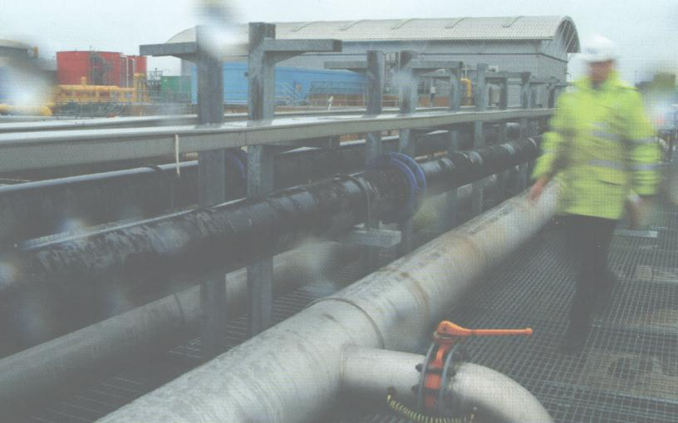
The regulatory process to date

Most Pipes & Wires readers will be familiar with the processes that OFWAT and OFGEM have used in the UK. This process began in Victoria in February 2004 with the publication of Consultation Paper #1 by the ESC. This paper invited comment on key regulatory issues, and outlined the content of the Water Plans which each utility would be required to prepare. Each water utility’s Plan is expected to address 4 reasonably distinct areas…

- The nature and levels of service it expects to provide.
- How it intends to provide those services.
- The expected revenue required to provide those services.
- The prices likely to result from that expected revenue requirement.

These Plans form the starting point for the ESC’s assessment of the expected prices and have been open for public consultation. A draft pricing decision based on the feedback from the consultation period and the ESC’s own analysis is expected to be released in January 2005. Following a consultation on the draft, a final decision is expected in May 2005 which will take effect on 1 July 2005.

NZ – electricity industry consultation

The Electricity Commission has recently released two papers for consultation…

- Group offer and dispatch of interruptible load
- Security of supply policy development

Submissions on both of these papers close on 3 December 2004. For more advice on these issues, or for assistance in preparing your submission pick here or call Phil on (07) 854-6541.

NZ – the Bill becomes law

Introduction

The long-awaited and much-debated Electricity & Gas Industries Bill 2003 received its final reading and most parts were passed into law last month. As outlined in Pipes & Wires #29 the Bill sought to amend 5 statutes to ensure a consistent and integrated approach to industry governance and regulation that inter alia recognised the need for security of gas supply to underpin security of electricity supply.

Final shape of the Bill

Just prior to the final reading the Bill was divided into 5 separate Bills as follows…

- The Electricity Amendment Bill.
- The Electricity Industry Reform Amendment Bill.
- The Commerce Amendment Bill.
- The Gas Amendment Bill.
- The Crown Minerals Amendment Bill.

Key impacts of the enactment

The broad structure of the original Bill and its final form is outlined in the following table…

What the Bill originally sought to do | What the amended Acts do
- The Electricity Act 1992 will be amended to reflect the establishment of the Electricity Commission, its rule-making functions and powers, and its key role of ensuring security of electricity supply. The Act will also be amended to allow the Electricity Commission to contract for reserve energy supplies to ensure greater security of electricity supply. | - The Electricity Amendment Act 2004 came into effect on 17 October 2004 except the sections dealing with Transpower’s provisional pricing methodology which came into force retrospectively on 26 January 2004. A key feature of the Act is rationalising the industry’s governance structure (particularly to reflect the establishment of the Electricity Commission) and to extend regulation and rule making powers over whatever parts of the industry may require regulation.
- The Electricity Industry Reform Act 1998 will be amended to relax the ownership separation rules surrounding line companies owning generation and in particular in regard to dry-year reserve generation contracted to the Electricity Commission. | - The Electricity Industry Reform Amendment Act 2004 came into effect retrospectively on 20 May 2003. The Act exempts generation commissioned after 20 May 2003 and having a capacity up to 20% of the distributors’ maximum demand (up to a maximum of 50MW) from the ownership separation rules. Dry year reserve generation contracted to the Electricity Commission is exempt from the 20% / 50MW ceiling.
- The Commerce Act 1986 will be amended to better address the interface issues between the Commerce Commission and the Electricity Commission. | - The Commerce Amendment Act #2 2004 took effect on 17 October 2004. The Act amends sections 57C, 57D and 57G of the Commerce Act 1986 to clarify the respective jurisdictions of the Commerce Commission and the Electricity Commission.
- The Gas Act 1992 will be amended to strengthen rule-making powers over the industry and enhance retail competition should the gas industry fail to develop a suitable self-governance structure. | - The Gas Amendment Act 2004 took effect on 17 October 2004 except for the amendment to Subpart 2 of Part 4A of the Gas Act 1992 which takes effect on a date yet to be decided by the Minister. The broad focus of the Act is to define the processes by which a gas industry governance regime will be established and bought under the jurisdiction of an enlarged Electricity Commission should the industry fail to develop an acceptable self-governance regime.
- The Crown Minerals Act 1991 will be amended to increase the information disclosed about oil and gas reserves to enable better investment decisions to be made and to enhance the security of supply in the gas and electricity markets. | - The Crown Minerals Act 2004 came into effect on 17 October 2004 and broadly requires the holder of a petroleum license or permit to disclose certain information to the Secretary in a prescribed format. The Secretary may publish any part or all of the information.

For more information

To discuss how the enactment of the Bill may impact on your business pick here or call Phil Caffyn on (07) 854-6541 or Christopher Hayes on (09) 916-3766. Thanks to Phillips Fox for their assistance with this article.

Conferences & events

- Metering, Billing & CRM Middle East – Dubai (1 – 3 February 2005)

This event provides a major networking platform for stakeholders involved in the Middle-East water, gas and electricity utilities sector concerned with customer-end technologies (metering, billing and CRM/CIS systems).

- Principles & Economics of Petroleum Exploration, Production & Development – Wellington (22 – 23 February 2005)

Conferenz announces the two-day Principles & Economics of Petroleum Exploration, Development & Production seminar. This seminar will cover all aspects of the petroleum business, including data acquisition and interpretation, prospect generation and risk analysis, drilling the well, and developing and producing a field. At the end of the course, participants will be able to understand the issues involved and terminology used, which will result in improved communication within and across businesses and agencies. The seminar trainer is Steven O’Connor, Director, DILIGENZ Ltd.

- NZ Power Summit – Auckland (15 – 16 March 2005)

Conferenz is delighted to confirm the dates for our 7th Annual NZ Power Summit, New Zealand's largest power summit for 2005, and the first point of reference for all key decision-makers and executives working within the energy sectors. With an audience of the highest level delegates and speakers, the 2005 NZ Power Summit represents an unprecedented opportunity to network with other senior energy executives and new business contacts.
The 2005 NZ Power Summit will be featuring key regulatory decision-makers, 2 international addresses, 16 chief executives and many other industry experts.

- Metering, Billing & CRM America – Las Vegas (10 – 15 April 2005)

This event provides a major networking platform for stakeholders involved in the North American water, gas and electricity utilities sector concerned with customer-end technologies (metering, billing and CRM/CIS systems).

- Metering, Billing & South African Prepayment Week – Cape Town (June 2005)

SPIntelligent will again be hosting the hugely successful 6th Annual Metering, Billing, CRM / CIS Africa 2004 which will be co-located with the 4th annual South African Prepayment Week (SAPW) conference and exhibition in Cape Town.

This event has been supported by utilities, government bodies and vendors throughout Africa for the last six years and is a calendar highlight for companies involved in metering, billing and CRM / CIS. The event provides a forum for electricity, water and gas stakeholders to discuss pertinent issues on the value of metering, billing systems and CRM / CIS in the revenue cycle chain in utilities.

Co-located is the South African Prepayment Week conference and exhibition, which provides an opportunity for electricity, water and telecommunications prepayment experts to discuss the latest developments affecting the industry in South Africa, while at the same time providing a forum to showcase the vast experience of the industry to an international audience.

Links to cool stuff

- Energy21 News (distributed generation & demand response) – Centre for Advanced Engineering.

Tell me how good this issue was…

Please pick one of the links below to tell me what you think of this issue of Pipes & Wires…

- Excellent

- Very good

- Good

- Average

- Poor

If you get this is a hard-copy, your comments can be emailed to issue#35@utilityconsultants.co.nz If you receive this second-hand by email, you can receive Pipes & Wires directly by picking here.

Disclaimer

These articles are of a general nature and are not intended as specific legal or consulting advice. They are correct at the time of writing. Utility Consultants Ltd accepts no liability for action or inaction based on the contents of Pipes & Wires including any loss, damage or exposure to offensive material from linking to any websites contained herein.

