Pipes & Wires

THE MONTHLY CLIENT NEWSLETTER FROM UTILITY CONSULTANTS

Issue 36 – December 2004

From the director…

 | Welcome to Pipes & Wires #36. This issue starts with an analysis of the long-awaited Gas Pipelines Inquiry in New Zealand. We also examine the implications of possible major shifts in New Zealand’s primary energy sources.  We also consider the stalled re-deregulation in California, some of the issues surrounding reserve capacity in electricity markets, the final electricity distribution price controls in the UK, and conclude by considering the next possible reshuffle of generation ownership in Australia.  I’d take the opportunity to wish you all a very merry Christmas and a relaxing break with family and friends. Pipes & Wires should be back in February 2005…

NZ – gas under pressure

Background to the inquiry  In April 2003 the Minister of Energy directed the Commerce Commission to inquire whether “goods and services supplied by persons in markets related to a gas transmission system or a gas distribution system or both should be controlled”. The Commission was required to report back to the Minister by the end of November 2004.  This article examines the Commission’s final report which was made public last week. The report considers the transmission pipelines owned by NGC, Maui Developments, Todd Petroleum & Shell, Todd Taranaki, Swift Energy and Westech, | 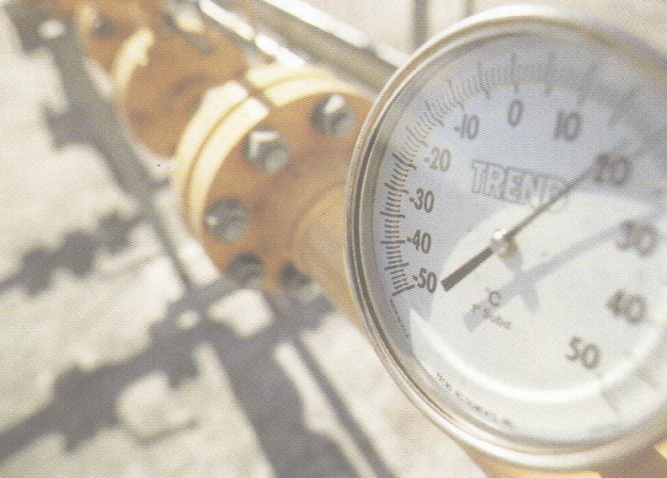
and the distribution pipelines owned by NGC, Powerco, Vector, Wanganui Gas and Nova Gas.

Legal basis for the inquiry

The legal framework for the inquiry derives from the Commerce Act 1986 as follows….

- s52 provides for goods or services to be controlled if they will be sold or purchased in markets in which competition is limited or may be lessened and it is necessary or desirable for the sale and purchase of such goods or services to be controlled in the interests of those selling or purchasing.
- s53 permits the Governor-General, upon the Minister of Commerce’s recommendation, to declare specific goods or services to be controlled.
- s54 permits the Minister of Commerce to require the commission to advise on thresholds that would assist in assessing whether goods or services should be controlled.

Chapter 2 of the inquiry report outlines the legal framework in detail.

The inquiry’s conclusions

The inquiry produced a very mixed bag of conclusions as follows…

- Most of the major transmission pipelines and most of the distribution pipelines are subject to limited competition, and may therefore be controlled pursuant to s52. However, in several of these cases the Commission recommended that controls pursuant to s53 should not be implemented as the cost of controls would outweigh the benefits.
- Nova Gas operates in competitive markets therefore the criteria for control in s52 is not met.
- Several of the smaller transmission pipelines in Taranaki are either subject to competition, or subject to limited competition in which there is unlikely to be any benefit from control. These pipelines may not be controlled pursuant to s52 as the criteria for control is not met.

The following table summarises the recommendations for each pipeline operator…

Pipeline operator | Criteria for control pursuant to s52 is satisfied | Recommendation that control be implemented pursuant to s53
NGC transmission | Yes | No
NGC distribution | Yes | No
Powerco | Yes | Yes
Vector | Yes | Yes
Wanganui Gas | Yes | No
Nova Gas | No | Not applicable
Maui Developments | Yes | No
NGC (LTS) | Outside ambit of inquiry | Not applicable
Westech (Surrey Rd) | Outside ambit of inquiry | Not applicable
Todd Taranaki (McKee to Faull Rd) | No | Not applicable
Swift (Rimu to NGC) | No | Not applicable
Todd Petroleum & Shell (Kapuni to Hawera) | No | Not applicable
Swift (TAW) | No | Not applicable

Those who have followed the inquiry will also be aware of the investigations into appropriate valuation methodologies and WACC that were carried out.

The next steps

Comments on the report are due by 15 February 2005, and the Minister expects to make a final decision in mid-2005. For more information pick here, or call Phil on (07) 854-6541.

California – progress on AB2006

 | Background  Pipes & Wires #33 discussed progress on Assembly Bill 2006 which proposes to re-deregulate California’s electricity market. As initially proposed, the Bill would put merchant generators in a secondary role as all customers with maximum demands less than 500kW could only be supplied on a cost-of-service basis by an incumbent utility. Republicans were concerned that putting merchant generators in such a secondary position would lead to a short-fall in new capacity.  Recent progress on AB2006  After a long and tortuous journey through both the Democrat-dominated Assembly and Senate, Governor Schwarzenegger (who strongly favors allowing merchant generators to enter the industry) finally vetoed the Bill.

NZ – LNG moves a step closer

What is LNG ??

Very briefly, LNG is natural gas that has been purged of impurities and then cooled to -161ºC whereupon it shrinks to about 1/600th of its volume at room temperature. It is then shipped in specially insulated tankers and regasified by passing through pipes immersed in warm water and then injected into existing natural gas infrastructure. This method of transportation is used where pipelines are not feasible.

The global LNG trade is already mature, with key trade patterns being North Africa to France & Spain, and the Indonesian basin to Japan.

What are the plans for importing LNG into NZ ??

About October 2003 Genesis Power and Contact Energy jointly commissioned studies to assess the technical and market feasibility of importing about 60PJ of LNG per year. Those studies have recently been released but any firm decision on constructing a regasification plant seems a long way off.

What would be the cost impact of imported LNG ??

Not surprisingly the cost of regasified LNG was the foremost question in everyone’s mind, with one of the complicating factors being the relatively low Maui wholesale price of around $2.50 per GJ. What must be remembered is that new indigenous gas is unlikely to cost less than $5 per GJ so we need to align our thinking around a future base-line gas price of about $5 per GJ rather than referring back to $2.50 per GJ.

Some indicative investigation performed by Utility Consultants about 12 months ago suggested that with the low scale associated with regasifying only 60PJ per year costs could be as high as $10 per GJ which was broadly in line with other industry estimates of the time. It was also estimated at this time that this could dampen economic growth by over $1b per year. The Contact and Genesis studies however suggest a price somewhere between $6.50 and $7.50 per GJ (which would result in electricity prices of around 6.8 to 7.5 cents per kWh) which has surprised many commentators.

It’s obviously difficult to fully capture the breadth of this issue in a few simple paragraphs, so to discuss further pick here or call Phil on +64-7-8546541 or +64-21-606670.

Markets- how much reserve capacity is enough ??
Background

Most electricity systems have historically included surplus capacity, whether it is reserve generation or multiple transmission circuits. This surplus capacity represents under-utilised capital, but that wasn’t so much of a problem back in the public-service era when the bulk of most electricity systems were built – its’ really only become an issue in the era of corporatisation where many stakeholders want reserve capacity but few stakeholders seem willing to pay for it. And this is about where this story needs to split into two reasonably distinct lines of thought.

Defining the amount of reserve generation capacity

System operators require so much reserve capacity on the system to allow for disruption of normal generation, and this amount varies from system to system and may be articulated in different ways. For instance in the Australian NEM there must be sufficient reserve generation (or transmission interconnection capacity) to limit the amount of unserved energy to 0.002% of the total energy served during that year (which in turn yields specific MW figures for each state). In New Zealand the Electricity Commission has a mandate to operate the system to a 1 in 60 dry year which interestingly enough embodies the increasing global concern about security of primary energy (as opposed to an emphasis on covering for asset failures). Aside from the obvious driver of diminished primary energy, other drivers of the amount of reserve capacity required are the system load factor and the grid topology.

What about reserve capacity in the transmission sector ??  Reserve transmission (and distribution) capacity focuses on restoring immediate-term interruptions to supply caused by asset failure by providing alternative circuits to a given node. Generally the number of circuits supplying a node such as a grid substation or zone substation is based simply on the maximum demand at that node, and gives rise to the security of supply criteria that we commonly know as (n), (n-1), (n-2) etc. | 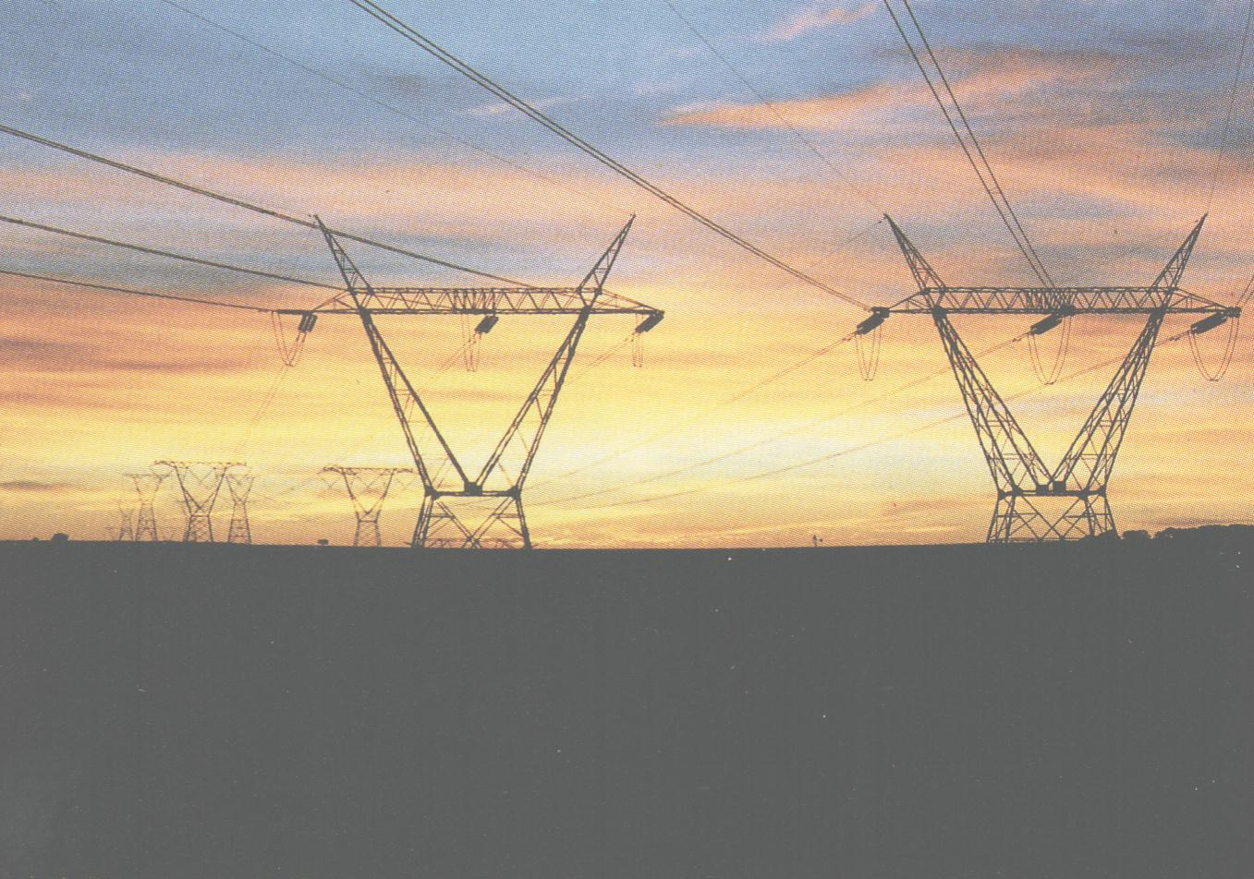
The move from deterministic security criteria to probabilistic

Most of us have probably thought at some time or other that security criteria seem rather arbitrary, just like someone decided one day that all zone substations with a maximum demand greater than 5MW will have (n-1) security of supply and all substations with less than 5MW will have (n) security of supply.

The alternative to these deterministic criteria is probabilistic criteria in which two key parameters are quantified – the energy not served, and the value of this energy. While it might be possible to estimate the energy not served reasonably accurately, quantifying the value of energy not served seems a lot like catching the wind (and that forms the last section in this article). Not being able to assign a value to energy not served obviously makes it difficult to assess the relative benefits of security options (reducing the cost-benefit analysis to the less robust cost-effectiveness analysis).

The elusive value of energy not served

Estimates of the value of unserved energy have risen as high as NZ$20 per kWh, although recent analysis after the August 2003 blackouts is suggesting more moderate figures of around US$3 per kWh. It really comes back to how much value each person would place on having one kWh available. Either way there is a four-fold difference that makes robust cost-benefit analysis difficult.

In a recent submission to the Electricity Commission I postulated that in the New Zealand context the value of unserved residential energy may in fact be low for the following reasons….

- Grids are becoming increasingly summer loaded, hence the likelihood of the “cold wet evening” scenario is substantially lessened.
- We have easy access to ground-level outdoor lifestyles (as opposed to all-electric apartments).
- We have virtually no dependence on electrically-power public transport, and what little we do have is all above ground and is therefore not so dependent on emergency lighting and air conditioning.

It is acknowledged that unserved industrial and commercial energy (eg. the office block full of people who can’t work without electricity) is likely to have a high value but then such customers usually have – dare I say it – (n-1) or (n-2) security of supply.

NZ – big users considers coal

Introduction

As natural gas reserves dwindle and security of energy supply becomes an increasingly hot topic, coal is back in the spot-light. New Zealand has significant reserves of both black coal and lignite and recently two major energy users have publicly stated they will seriously consider coal to meet their energy needs.

The role of coal

Comalco’s electricity contract with Meridian Energy for the Tiwai Point smelter ends in 2012 and although renegotiations have already begun, Comalco is seriously considering building a power station in Southland to burn either local lignite or imported coal.

Fonterra was recently granted land-use consents to build a 250MW coal-fired power station adjacent to the Whareroa diary factory at Hawera (air discharge consents are yet to be approved). This plant is expected to burn about 500,000 tons of coal per year.

What about Kyoto ??

Good question. Comalco has put forward what seems to be a sound multi-faceted answer…

- Tiwai Point is among the most efficient smelters in the world (both in terms of electricity consumption and in burning off carbon anodes). As demand for Aluminum increases in China it makes sense from a global emissions perspective to smelt Aluminum in highly efficient plants in the west rather than in low efficiency plants in China.
- Substituting Aluminum for heavier materials in vehicles leads to a nett reduction in emissions over the life of the vehicle.
- Comalco generates about $1b in annual export earnings for New Zealand.

In Fonterra’s case a large proportion of the proposed coal burn will be to off-set gas so the impact is of a lesser increment.

UK – final electricity distribution price controls

Introduction  OFGEM has recently released the final price controls that will take effect for the 5 year control period commencing on 1 April 2005. As discussed in Pipes & Wires #31 these controls recognise the significant increase in CapEx projected for all the distributors except Western Power’s South Wales business.  Key issues facing OFGEM  In developing this price control, OFGEM has faced the following issues….  - Ensuring that the proposed nation-wide investment in service levels of ₤5.7b over | 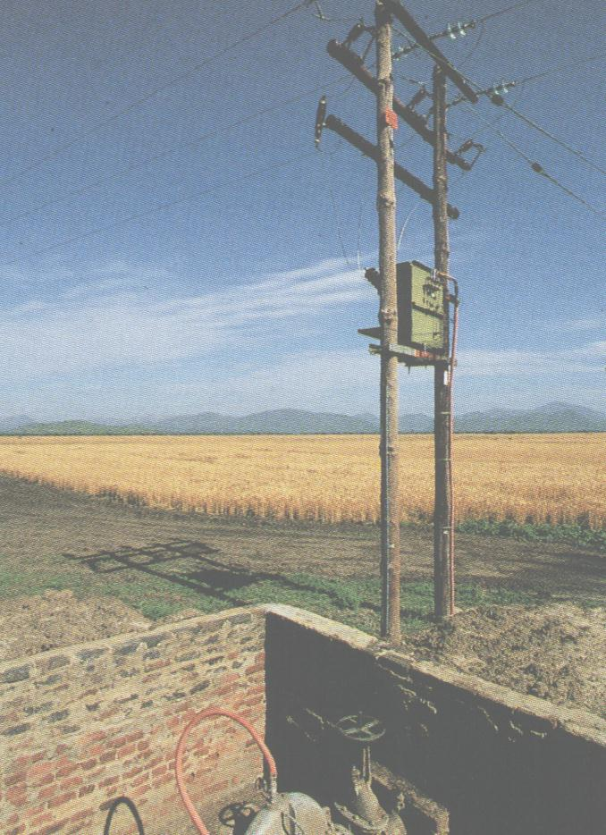
the control period is correctly incentivised, and in particular that innovation and efficiency are rewarded.
- Ensuring that the distributors are correctly incentivised to meet customers’ desires for improved service.
- Ensuring that distributors play an active role in implementing the Government’s renewable energy policy.
- Ensuring that uncontrollable costs such as tax and pension obligations do not distort distributor’s performance or incentives.

The final controls

As OFGEM has developed this price control over the past few months the P₀ for each of the 14 distributors has varied as followed…

Distributor | Legacy name | Initial P₀ | Revised P₀ | Final P₀
CN – Midlands | Midlands Electricity | -6.5% | -4.5% | -2.9%
CN – East Midlands | East Midlands Electricity | -10.8% | -7.5% | -5.7%
United Utilities | NORWEB | -1.8% | 5.6% | 8.0%
CE – NEDL | Northern Electric | -11.5% | -2.9% | -3.7%
CE – YEDL | Yorkshire Electricity | -14.7% | -12.9% | -9.2%
WPD – South West | SWEB | -0.2% | 1.6% | 1.5%
WPD – South Wales | SWALEC | 1.7% | 7.3% | 6.2%
EDF – LPN | London Electricity | -2.5% | -4.2% | -2.4%
EDF – SPN | SEEBoard | -3.7% | 3.0% | 7.2%
EDF – EPN | Eastern Electricity | -4.6% | -2.1% | -0.1%
SP Distribution | Scottish Power | 8.4% | 10.6% | 11.9%
SP MANWEB | MANWEB | 4.0% | -5.5% | -5.9%
SSE – Hydro | Scottish Hydro | -0.1% | 2.7% | 3.9%
SSE - Southern | Southern Electric | 6.1% | 9.2% | 9.3%
National average |  | -2.5% | 0.0% | 1.3%

EDF – SPN’s actual price control will comprise P₀ = 3.1% followed by CPI +2% for Years 2 to 5. All other price controls will comprise the respective P₀ above followed by CPI +0%.

These final P₀’s will allow the 14 distributors to collect an additional ₤187m over the 5 year control period.

Aus – another generation shake-out ???

 | Background  Pipes & Wires #32 discussed Edison’s retreat from Australia which resulted in a substantial reshuffle of generation assets in Victoria and South Australia as International Power plc consolidated its business (although the ACCC is yet to give final approval to the deal).  The recent sale of a 51.4% stake in Contact Energy to Origin Energy has resulted in Contact selling its newly established Victorian retail business Red Energy to Snowy Hydro.
The value of Valley Power

As Contact’s stated strategy is to balance its retail portfolio with generation it’s possible that Contact might sell its 40% stake in Valley Power and its 25% stake in Oakey. This 40% stake may become more valuable if the ACCC requires International Power to divest its 60% stake in Valley Power. Possible buyers may include Origin and AGL.

Competition & vertical reintegration issues

These industry reshufflings are likely to further vertically reintegrate the industry and bring industry players into conflict with competition law.

Pipes & Wires #32 raised the question “what if the only entities willing to invest in existing and new capacity are those who already hold substantial interests, and they are prohibited from making further investments”. As many of us talk about the “industry’s need” for new investment, it is often overlooked that customers’ interests are inherently tied to the level of investment the industry is able to attract. The essence of this question is about balancing short and long-term customer needs, and is not to be taken as a criticism of the decisions made to date. Rather it should signal that at some future point the “substantial lessening of competition” wisdom applied to date might need to give way to some other test that better reflects customers’ long term interest in attracting investment.

Tell me how good this issue was…

Please pick one of the links below to tell me what you think of this issue of Pipes & Wires…

- Excellent

- Very good

- Good

- Average

- Poor

If you get this is a hard-copy, your comments can be emailed to issue#36@utilityconsultants.co.nz If you receive this second-hand by email, you can receive Pipes & Wires directly by picking here.

Conferences & events

- Metering, Billing & CRM/CIS Asia-Pacific – Shanghai (12 – 14 January 2005)

The rapidly emerging Chinese energy industry and its ongoing changes within the water, electricity, gas and heat utilities have created a need for new systems and old meters have to be replaced. With privatisation and competition on its way China offers numerous business opportunities for Chinese and
foreign companies, especially since China became member of the WTO. Join this 3-day event which will give you the opportunity to get an insight of the largest metering market in the world!

- Metering, Billing & CRM Middle East – Dubai (1 – 3 February 2005)

This event provides a major networking platform for stakeholders involved in the Middle-East water, gas and electricity utilities sector concerned with customer-end technologies (metering, billing and CRM/CIS systems).

- Principles & Economics of Petroleum Exploration, Production & Development – Wellington (22 – 23 February 2005)

Conferenz announces the two-day Principles & Economics of Petroleum Exploration, Development & Production seminar. This seminar will cover all aspects of the petroleum business, including data acquisition and interpretation, prospect generation and risk analysis, drilling the well, and developing and producing a field. At the end of the course, participants will be able to understand the issues involved and terminology used, which will result in improved communication within and across businesses and agencies. The seminar trainer is Steven O’Connor, Director, DILIGENZ Ltd.

- NZ Power Summit – Auckland (15 – 16 March 2005)

Conferenz is delighted to confirm the dates for our 7th Annual NZ Power Summit, New Zealand's largest power summit for 2005, and the first point of reference for all key decision-makers and executives working within the energy sectors. With an audience of the highest level delegates and speakers, the 2005 NZ Power Summit represents an unprecedented opportunity to network with other senior energy executives and new business contacts.
The 2005 NZ Power Summit will be featuring key regulatory decision-makers, 2 international addresses, 16 chief executives and many other industry experts.

- Metering, Billing & CRM Australia & New Zealand – Melbourne (15 – 17 March 2005)

The business of utility metering continues to evolve. The rapid convergence of metering, billing and CRM/CIS systems and strategies in a competitive marketplace provides unprecedented opportunities for those players positioned to provide future proof solutions. Metering Australia/New Zealand 2005, together with a collocated event on utility Billing and CRM/CIS provides the opportunity to share your vision with a unique and carefully targeted audience.

- Metering, Billing & CRM America – Las Vegas (10 – 15 April 2005)

This event provides a major networking platform for stakeholders involved in the North American water, gas and electricity utilities sector concerned with customer-end technologies (metering, billing and CRM/CIS systems).

- Metering, Billing & South African Prepayment Week – Cape Town (16 – 19 May 2005)

SPIntelligent will again be hosting the hugely successful 6th Annual Metering, Billing, CRM / CIS Africa 2004 which will be co-located with the 4th annual South African Prepayment Week (SAPW) conference and exhibition in Cape Town.

This event has been supported by utilities, government bodies and vendors throughout Africa for the last six years and is a calendar highlight for companies involved in metering, billing and CRM / CIS. The event provides a forum for electricity, water and gas stakeholders to discuss pertinent issues on the value of metering, billing systems and CRM / CIS in the revenue cycle chain in utilities.

Co-located is the South African Prepayment Week conference and exhibition, which provides an opportunity for electricity, water and telecommunications prepayment experts to discuss the latest developments affecting the industry in South Africa, while at the same time providing a forum to showcase the vast experience of the industry to an international audience.

Links to cool stuff

- Energy21 News (distributed generation & demand response) – Centre for Advanced Engineering.

Disclaimer

These articles are of a general nature and are not intended as specific legal or consulting advice. They are correct at the time of writing. Utility Consultants Ltd accepts no liability for action or inaction based on the contents of Pipes & Wires including any loss, damage or exposure to offensive material from linking to any websites contained herein.

