Pipes & Wires

THE MONTHLY CLIENT NEWSLETTER FROM UTILITY CONSULTANTS

Issue 37 – February 2005

From the director…

 | Welcome to Pipes & Wires #37 (and to 2005). This issue of Pipes & Wires starts off with a review of a client project and a small reminder about further industry consultation. Following that we examine Vector’s progress with the NGC acquisition and then discuss a possible gas find in Taranaki.  This issue then gets radio-active as we move to the UK to comment on what might be the end of British Energy’s woes, and then close this issue with a comment on the increasing recognition of nuclear power as a sensible answer to climate change (which took on special significant today…).  So until next issue - happy reading….

Utility Consultants advises Unison

Utility Consultants is currently assisting Unison Networks Ltd to prepare submissions to the Commerce Commission as part of the current consultation on “Implementing Valuation Choice for System Fixed Assets – Draft Decisions and Discussion Paper” and “Review of the Information Disclosure Regime – Discussion Paper”.  In addition to addressing the specific questions posed by the Commission, Utility Consultants has outlined asset valuation issues arising from some high-profile regulatory determinations in Australia, and has articulated Unison’s strong preference for quantifying parameters such as values, prices and costs through market processes rather than through regulatory intervention. | 
For advice on preparing submissions, pick here or call Phil on (07) 854-6541 or (021) 606-670.

Electricity Commission consultation

The Electricity Commission expects to publish the draft Statement Of Opportunities for consultation next month (March 2005). The Statement Of Opportunities enables interested parties to examine potential opportunities for efficient management of the grid including investment in upgrades and transmission alternatives. As usual the consultation period will be 20 working days.

For advice on preparing your submission, pick here or call Phil on (07) 854-6541 or (021) 606-670.

NZ – progress on the NGC sale

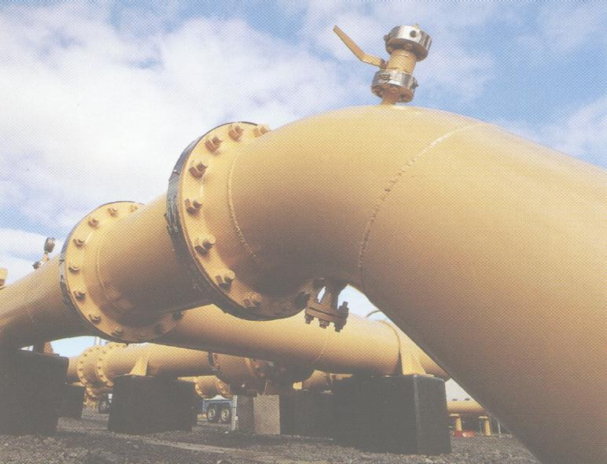 | Background  Readers of Pipes & Wires will be familiar with Vector’s successful acquisition of AGL’s 66.05% stake in NGC and the associated work-out that the Takeovers Code was put through. This article examines progress on the deal since Pipes & Wires #35 in November 2004.  Recent events  Vector’s offer of $2.91 per share closed earlier this month resulting in a
total acceptance of 67.2% - well short of the 90% stake required for compulsory acquisition. Trading prices of around $3.15 per share and a mystery prowler reportedly offering $3.22 per share probably haven’t helped.

Where to from here

So … where could Vector go from here?? Possible options include…

- Sitting tight with their 67.2% stake and foregoing what is thought to be about $160m of capitalised merger synergies.

- Launching a new offer at about $3.15 to $3.20 per share to attempt to reach the 90% threshold for compulsory acquisition.

Hopefully the next month or so will reveal Vector’s plans.

UK – British Energy re-lists

Background  British Energy plc was recently the subject of a government bail-out that saw existing shareholders left with only 2.5% of the equity (albeit with the sweetener of being able to buy shares at ₤0.98 until 2010) after the UK government assumed about 65% of the equity and the bond-holders assumed a 33% stake in a debt-for-equity swap. This also attracted the anger of the anti-nuclear lobby and the attention of the EU in regard to illegal state subsidies. | 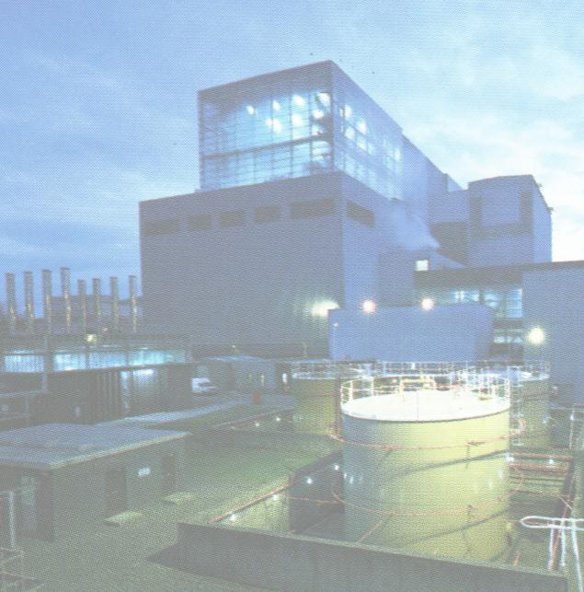
Recent events

Last month British Energy re-listed on the London Stock Exchange at ₤2.86 per share and after heavy trading closed at ₤2.63 which compares well with analysts’ valuations from ₤2.00 to ₤2.40. It seems that the four issues discussed in Pipes & Wires #20 that converged on British Energy to drive it to the brink of bankruptcy have gone away (or at least investors perceive they have).

The future of British Energy

The future should be bright for British Energy – as demand continues to increase and concern over climate change makes nuclear energy look more attractive than ever, the future should be bright indeed.

The future of nuclear energy in the UK as part of the climate change debate is discussed further in this issue.

NZ – new gas finds

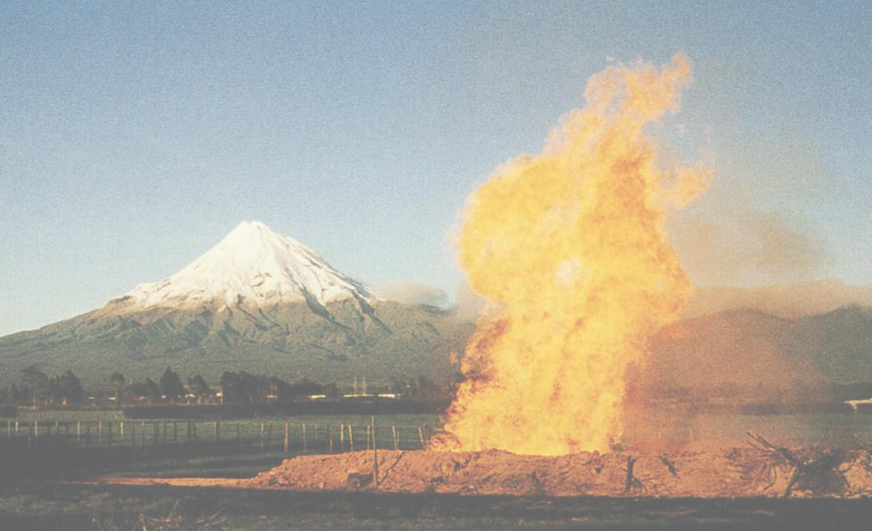 | Introduction  The recent announcement by NZOG that the Mangatoa prospect near the north Taranaki coast could contain about 3,000PJ of natural gas brings a welcome relief to the increasing discomfort most of us are feeling. The reserve is thought to be about 3.8km below sea-level near the town of Awakino.  What does it mean for the gas industry ??  One word – excitement. Given that only a few months ago
the general feeling was that reserves as big as Pohokura (about 750PJ) should be considered the exception rather than the norm, news of a 3,000PJ reserve can only be exciting. If the reserve is confirmed as 3,000PJ, that should last about 22 years at the projected consumption rate (based on the scenario of Methanex ceasing operations).

The close proximity of the field to the Maui pipeline should also be a huge advantage, and needless to say would reduce the need for imported LNG.

Progress to date

NZOG and 50% partner Origin Energy are currently seeking a partner to buy into the prospect and assist with the drilling costs. As the story unfolds, Pipes & Wires will be there.

UK – nuclear may have a future after all

Background

Nuclear power seems to have become increasingly unpopular over the last 25 years or so, and I think it would be fair to say that the facts have been overtaken by the widespread ideology that nuclear power is somehow ”evil” or “unclean”. However the current debate on climate change is now presenting a huge dilemma to the anti-nuclear brigade who don’t want global warming but who also don’t want ideologically incorrect solutions like nuclear power.

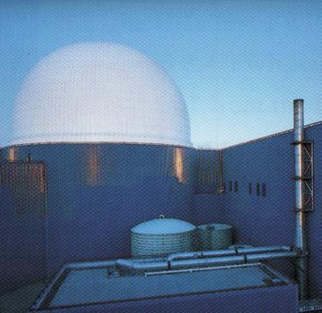 | Which energy is best ??  The emerging problem in the UK is that there are major hiccups in which ever source of primary energy we turn to…  - Burning coal generally produces more CO₂ than burning gas.  - Most of the UK’s gas is imported either from or through countries that are politically unstable.  - Wind farms are facing increasing public objection.  - Nuclear power doesn’t seem viable within the current wholesale market structure.  Meanwhile demand for electricity is showing no signs of declining, so somewhere someone is going to capture market opportunities (and the current market structure is the one thing we can change).
The Labour Government’s plans

News broke recently that Tony Blair’s government is planning to publish a white paper that could pave the way for construction of new nuclear capacity in the UK. However because it is also so politically sensitive, the plan (to publish the white paper) was not intended to be made public unless Labour are returned to power at the next general election.

The future of nuclear power in the UK

Recent news that Tony Blair’s government plans to publish a white paper that could see the construction of several new nuclear power stations (but not unless Labour win the next election) suggests some sanity is returning to the nuclear debate. Figures released by the Nuclear Industry Association earlier this year indicate that opposition to building new nuclear power stations has dropped from 60% to 30% over the last 3 years. This suggests that nuclear power does have a reasonable future.

Making nuclear power viable

Readers of Pipes & Wires will be familiar with British Energy’s woes that stretch back several years. I won’t pretend to have a simple answer to a tough question but the allocation of Emission Reduction Units (“carbon credits”) seems like a good idea.

Recent publications by Utility Consultants

- “Catching the pendulum’s swing – establishing a managed market in New Zealand” – published in Metering International issue 4, 2004. A joint publication with Christopher Hayes from Phillips Fox.

- ”Two thousand and five : a year of energy ??” – published in New Zealand Lawyer, 18 February 2005.

Tell me how good this issue was…

Please pick one of the links below to tell me what you think of this issue of Pipes & Wires…

- Excellent

- Very good

- Good

- Average

- Poor

If you get this is a hard-copy, your comments can be emailed to issue#37@utilityconsultants.co.nz If you receive this second-hand by email, you can receive Pipes & Wires directly by picking here.

Conferences & events

- Principles & Economics of Petroleum Exploration, Production & Development – Wellington (22 – 23 February 2005)

Conferenz announces the two-day Principles & Economics of Petroleum Exploration, Development & Production seminar. This seminar will cover all aspects of the petroleum business, including data acquisition and interpretation, prospect generation and risk analysis, drilling the well, and developing and producing a field. At the end of the course, participants will be able to understand the issues involved and terminology used, which will result in improved communication within and across businesses and agencies. The seminar trainer is Steven O’Connor, Director, DILIGENZ Ltd.

- NZ Power Summit – Auckland (15 – 16 March 2005)

Conferenz is delighted to confirm the dates for our 7th Annual NZ Power Summit, New Zealand's largest power summit for 2005, and the first point of reference for all key decision-makers and executives working within the energy sectors. With an audience of the highest level delegates and speakers, the 2005 NZ Power Summit represents an unprecedented opportunity to network with other senior energy executives and new business contacts.
The 2005 NZ Power Summit will be featuring key regulatory decision-makers, 2 international addresses, 16 chief executives and many other industry experts.

- Metering, Billing & CRM Australia & New Zealand – Melbourne (15 – 17 March 2005)

The business of utility metering continues to evolve. The rapid convergence of metering, billing and CRM/CIS systems and strategies in a competitive marketplace provides unprecedented opportunities for those players positioned to provide future proof solutions. Metering Australia/New Zealand 2005, together with a collocated event on utility Billing and CRM/CIS provides the opportunity to share your vision with a unique and carefully targeted audience.

- Metering, Billing & CRM America – Las Vegas (10 – 15 April 2005)

This event provides a major networking platform for stakeholders involved in the North American water, gas and electricity utilities sector concerned with customer-end technologies (metering, billing and CRM/CIS systems).

- Metering, Billing & South African Prepayment Week – Cape Town (16 – 19 May 2005)

SPIntelligent will again be hosting the hugely successful 6th Annual Metering, Billing, CRM / CIS Africa 2004 which will be co-located with the 4th annual South African Prepayment Week (SAPW) conference and exhibition in Cape Town.

This event has been supported by utilities, government bodies and vendors throughout Africa for the last six years and is a calendar highlight for companies involved in metering, billing and CRM / CIS. The event provides a forum for electricity, water and gas stakeholders to discuss pertinent issues on the value of metering, billing systems and CRM / CIS in the revenue cycle chain in utilities.

Co-located is the South African Prepayment Week conference and exhibition, which provides an opportunity for electricity, water and telecommunications prepayment experts to discuss the latest developments affecting the industry in South Africa, while at the same time providing a forum to showcase the vast experience of the industry to an international audience.

Links to cool stuff

- Centre for Advanced Engineering – subscribe to Energy21 News (distributed generation & demand response).

- Office of Water Policy, Government of Western Australia – request CD/DVD of proceedings from Global Developments in Water Industry Performance Benchmarking conference 2003.

- Centre for Advanced Engineering – download the report on “Energy supply in the post-Maui era” (file size is about 780k).

Disclaimer

These articles are of a general nature and are not intended as specific legal or consulting advice. They are correct at the time of writing. Utility Consultants Ltd accepts no liability for action or inaction based on the contents of Pipes & Wires including any loss, damage or exposure to offensive material from linking to any websites contained herein.

